21st February 2024
YOKOHAMA Eliminates Counterfeit Aluminium Wheels in China
YOKOHAMA today announced the successful completion of its efforts to eliminate counterfeit versions of the Company’s aluminium wheels in China.
YOKOHAMA filed an administrative complaint and submitted information to the Administration for Market Regulation in Foshan, Shenzhen, and Guangzhou, Guangdong Province, regarding six companies engaged in the distribution of counterfeit sports car aluminium wheels imitating YOKOHAMA’s "ADVAN Racing" wheels. The distributors were selling the counterfeit wheels via internet shopping sites and retail shops outside of the Company’s official distribution channels. Acting on the complaint and information provided by the Company, the authorities in each city raided the six companies and seized the counterfeit aluminium wheels on November 2023. YOKOHAMA has confirmed that all six distributors have been fined and the counterfeit aluminium wheels have been destroyed.
Prior to this case, YOKOHAMA had filed a petition for the administrative complaint against distributors of counterfeit versions of the Company’s aluminium wheels in China and succeeded in eliminating the counterfeit products. YOKOHAMA remains resolute in its stance against the infringement of intellectual property rights, including the sale of counterfeit goods, and will strengthen its efforts against such illegal activities in Japan and overseas to ensure that its customers around the world are confident and secure in the knowledge that they are using genuine YOKOHAMA products.
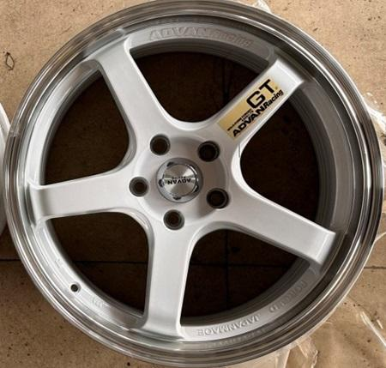
A counterfeit aluminium wheel sold in China by distributors who have been fined by the authorities

