12th November 2021

Bernd Albrecht Thanks YOKOHAMA for 2 decades of Support

The Dodge Viper CC GT3 #13, known as the White Angel Viper, has been competing on YOKOHAMA tyres for years. Team boss Bernd Albrecht trusted the tyres for over 20 years and the Japanese manufacturer has always supported his entries in the 24hr races at the Nürburgring. From 2022, the Viper will be supported by a new manufacturer as YOKOHAMA will focus on other areas of motorsport.
Albrecht has been in motorsport for over 30 years and has competed in the toughest race in the world for 22 years - always for a worthy cause - Charity. He collects donations for charitable organisations, since 2020 for Reiner Meutsch's Fly&Help foundation, which builds and sustainably supports schools in developing and emerging countries. At the last ADAC TOTAL 24hr Race held earlier this year, over 50,000 euros were collected and will be used to build a school in Brazil. Since the foundation was established, over 500 schools have been built around the globe. "A Fly&Help school is now opened every third day of the year and children can enjoy a future with education. This is wonderful and only possible with supporters like the White Angel Viper team!", Reiner Meutsch commented.
"I would like to express my deep thanks to YOKOHAMA for two decades of support!" states Albrecht, adding, "The delivery and support from YOKOHAMA has always been excellent and the tyres of the best quality. They link the race car and the asphalt and we drivers need to have full confidence to be really fast and on the limit, that was always given with YOKOHAMA. I was always met with open ears for my concerns or suggestions."
Two decades of perfect cooperation - The cooperation between YOKOHAMA Europe and Bernd Albrecht began over twenty years ago. Regardless of whether he was on the road in the Green Hell with VW, BMW, Porsche or, as is currently the case, with the Dodge Viper GT3, the Japanese manufacturer reliably supplied the right racing tyres, even in unusual dimensions. According to Thomas Witt, Head of Motorsport, Yokohama Europe: "Though we are now going our separate ways the projects with Bernd Albrecht have always inspired us and been a lot of fun. We have been very happy to support the good cause as much as we could. I got to know Bernd about six years ago and quickly recognised his motivation with the charity missions and the diligence and dedication with which he organised them. So it was an easy decision for YOKOHAMA to support. This time is now coming to an end but we wish the team many more years of success in making children around the world happy."
Reliable at the limit at over 288 km/hr - The white racing car owned by Manfred Sattler, achieved the top speed record at the 24hr race in 2021 with 288 km/hr at the check point. "We even got up to 293 km/h on other sections of the track!" reveals Albrecht with a twinkle in his eye and goes on to explain, "Sebastian Asch, two-time GT Masters champion, drove the Viper incredibly fast, even in adverse wet conditions, and was delighted with the tyres. At times the water was ankle-high on the Nordschleife. The Viper still doesn't have technical aids like traction control and you need more feeling and trust in the rubber to push the limits." "It's a pity that YOKOHAMA will now focus on other areas and end with it our collaboration, which I will miss greatly. I hope that we can continue to successfully race for donations for countless years with our new partner," He concluded.
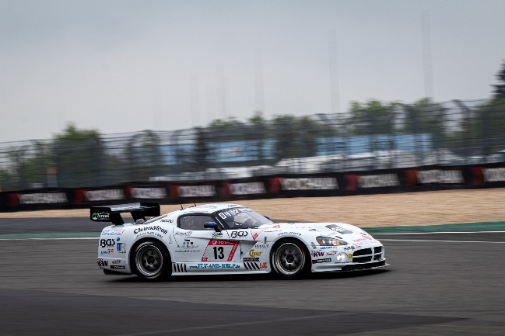
Dodge Viper CC GT3

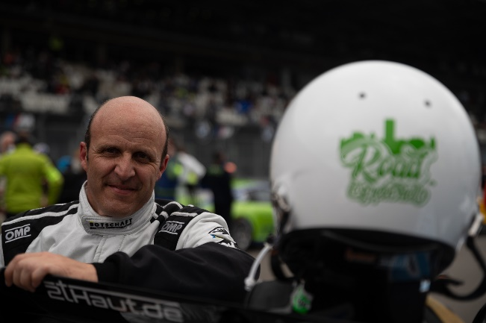
Bernd Albrecht

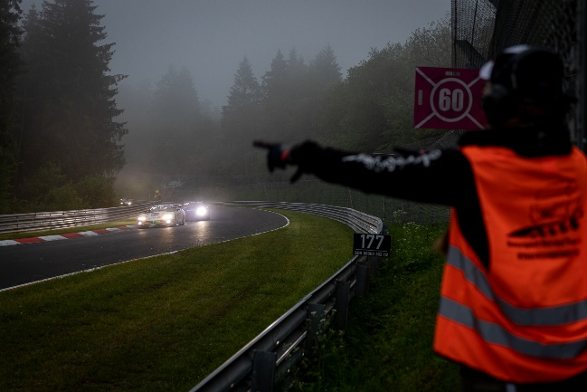
Race Action with the Dodge Viper

