10th November 2022

Car running on YOKOHAMA’s global flagship ADVAN brand tyres wins SUPER GT GT300 class series championship

YOKOHAMA is pleased to announce that a car fitted with its global flagship ADVAN brand tyres captured the GT300 class series championship of 2022 AUTOBACS SUPER GT Series, Japan’s ultimate touring car racing series. A car running on ADVAN tyres also captured the GT300 series championship in 2020. YOKOHAMA’s ADVAN racing tyres’ excellent grip and handling stability provided the strong support from the ground up that contributed to recapturing the class title.

The series championship was won by KONDO RACING’s REALIZE NISSAN MECHANIC CHALLENGE GT-R, with drivers Kiyoto Fujinami and Joao Paulo de Oliveira. After taking the point lead in the series first half by winning the opening round race and finishing third in Round 3, the team endured a tough battle while carrying the heavy burden of Success Weight (a weight handicap imposed according to the points earned in each race) but secured the championship in the final round held at Mobility Resort Motegi (Tochigi Prefecture) from November 5. The REALIZE NISSAN MECHANIC CHALLENGE GT-R steadily accumulated points throughout the series with careful yet aggressive driving by Fujinami and Oliveira and held on to the top spot despite encountering some trouble in the final race, capturing the class championship for KONDO RACING for the first time in two years. In the 2022 SUPER GT series, YOKOHAMA supplied its ADVAN racing tyres to 15 teams competing in the GT300 class and two teams racing in the GT500 class.

Under YOKOHAMA’s three-year (2021–2023) medium-term management plan, Yokohama Transformation 2023 (YX2023), the consumer tyre business aims to maximize the sales ratios of high-value-added YOKOHAMA tyres, namely the global flagship ADVAN brand, the GEOLANDAR brand of tyres for SUVs and pick-up trucks, and various winter tyres. YX2023 also positions participation in motorsports activities as crucial to the company’s effort to develop new tyre technologies that will further strengthen the ADVAN and GEOLANDAR brands. YOKOHAMA therefore is again participating in a wide variety of motorsports events in Japan and around the globe, from top-category to grassroots events.

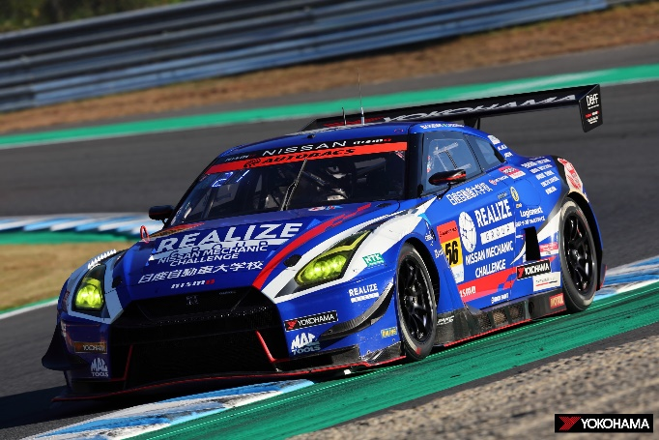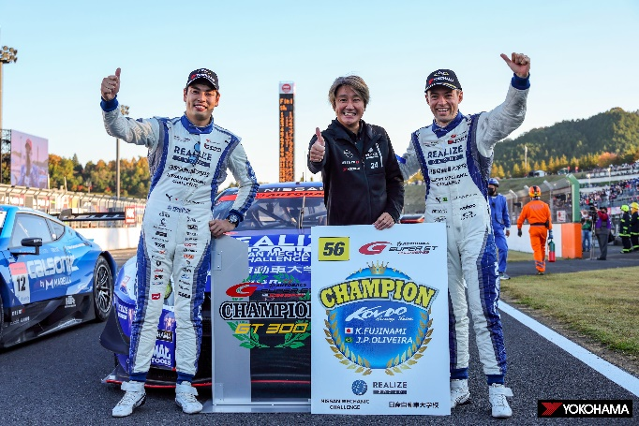
REALIZE NISSAN MECHANIC CHALLENGE GT-R racing to GT300 class series championship

Kiyoto Fujinami (left), Team Manager Masahiko Kondo (center), and Joao Paulo de Oliveira celebrate recapturing the GT300 series championship

