14th November 2023

Car running on YOKOHAMA’s global flagship ADVAN brand tyres wins the GT300 class at SUPER GT’s 8th round

YOKOHAMA is pleased to announce that a car equipped with its global flagship ADVAN brand tyres won the GT300 class in the final race, Round 8 of the 2023 AUTOBACS SUPER GT Series, Japan’s ultimate touring car racing series. Round 8 was held at Mobility Resort Motegi (Tochigi Prefecture) on November 4 and 5, 2023. Many teams equipped their cars with ADVAN racing tyres in the GT300 class this year, and those cars won four out of eight races.

The winner of the final race was the JLOC Lamborghini GT3, whose drivers were Takashi Kogure and Yuya Motojima. In the final, which they reached with second place in the qualifying round, Motojima took the wheel for the first stint, gained the lead early on and then passed the baton on to Kogure. Kogure, who come out on top in close quarters in the middle of the race under the pressure of the second placed machine, gradually increased the distance from his pursuers and took the checkered flag. This was Kogure’s first victory in the GT300 class and Motojima’s first in the SUPER GT. In addition, The DOBOT Audi R8 LMS, which was fitted with YOKOHAMA tyres and driven by Yoshiaki Katayama and Roberto Merhi Muntan, finished third, taking the podium for the third time this season.

Under YOKOHAMA’s three-year (2021–2023) medium-term management plan, Yokohama Transformation 2023 (YX2023), the consumer tyre business aims to maximize the sales ratios of high-value-added YOKOHAMA tyres, namely the global flagship ADVAN brand, the GEOLANDAR brand of tyres for SUVs and pick-up trucks, and various winter tyres. YX2023 also positions participation in motorsports activities as crucial to the company’s effort to develop new tyre technologies that will further strengthen the ADVAN and GEOLANDAR brands. YOKOHAMA therefore is again participating in a wide variety of motorsports events in Japan and around the globe, from top-category to grassroots events.

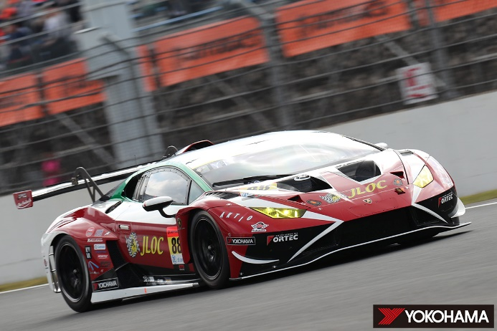
From left: Yuya Motojima and Takashi Kogure
The JLOC Lamborghini GT 3, winner of the GT300 class

