11th November 2021

Cars racing on YOKOHAMA’s global flagship brand ADVAN tyres excel in SUPER GT Round 7
Finishing 2nd in the GT500 class and 1st and 3rd in the GT300 class

YOKOHAMA is pleased to announce another outstanding performance by cars outfitted with its global flagship ADVAN brand tyres in the latest round of 2021 AUTOBACS SUPER GT Series, Japan’s top-level touring car racing series. In Round 7, held on November 6-7 at the Twin Ring Motegi track in Tochigi Prefecture, ADVAN-equipped cars finished second in the GT500 class and first and third in the GT300 class.

Cars equipped with ADVAN tyres dominated the front row in the GT500 class qualifying session. In the race, TGR TEAM WedsSport BANDOH's WedsSport ADVAN GR Supra (Yuji Kunimoto/Ritomo Miyata) started in pole position and remained among the top group in the race’s early stages. The team slipped back to third place but finished strong in the final lap, crossing the finish line in second place. The strong finish put WedsSport ADVAN GR Supra on the podium for the second time this season, following Round 4.

The start of GT300 class final also saw an ADVAN-equipped vehicle in the pole position. After all cars had changed drivers, the Audi Team Hitotsuyama’s Hitotsuyama Audi R8 LMS (Shintaro Kawabata/ Takuro Shinohara), which had placed fifth in qualifying, was in the lead thanks to a quick pit stop during which the crew swiftly changed only the two rear tyres. The team had smooth sailing the rest of the way and captured its first win since Round 6 in 2020. Third-place finisher KONDO RACING's Realize Nissan Automobile Technical College GT-R (Kiyoto Fujinami/Joao Paulo de Oliveira) achieved a spot on the podium for the third time this season, after Round 1 and Round 5. As a result, the team and its drivers head for the final round with both in second place in the season rankings.

Under’s three-year (2021–2023) medium-term management plan, Yokohama Transformation 2023 (YX2023), the consumer tyre business aims to maximize the sales ratios of high-value-added YOKOHAMA tyres, namely the global flagship ADVAN brand, the GEOLANDAR brand of tyres for SUVs and pick-up trucks, and various winter tyres. YX2023 also positions participation in motorsports activities as crucial to the Company’s effort to develop new tyre technologies that will further strengthen the ADVAN and GEOLANDAR brands. YOKOHAMA therefore is again participating in a wide variety of motorsports events in Japan and around the globe, from top-category to grassroots events.
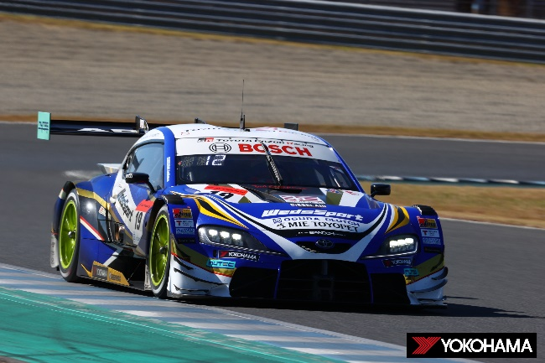
WedsSport ADVAN GR Supra racing to 2nd place finish in the GT500 class

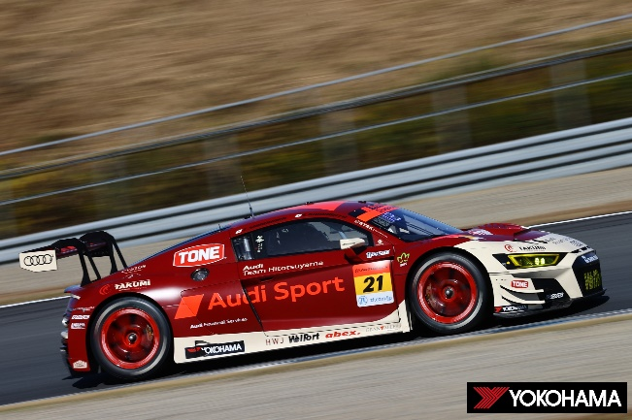
Hitotsuyama Audi R8 LMS racing to 1st place finish in the GT300 class

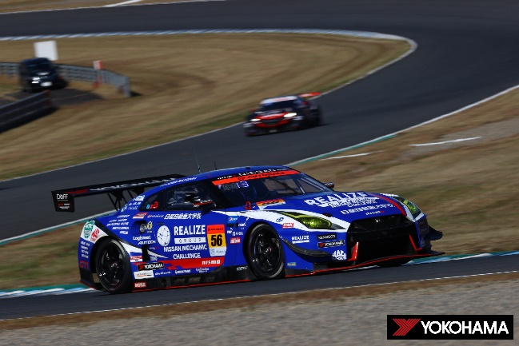
Realize Nissan Automobile Technical College GT-R on its way to 3rd place finish in the GT300 class

