10th February 2020

Icelandic Charitable effort counts with YOKOHAMA support

Currently around 250 cars are participating in an off-road rally from Budapest, Hungary to Freetown, Sierra Leone. The rally is held every other year and brings about 700.000 – 900.000 Euros worth of aid to West Africa.

The team ‘Aurora for Good’ is from Iceland and the family behind the team is on a quest to give their family-owned Toyota Land Cruiser 90 (1997) to UNICEF in Sierra Leone and also to offer as much cash donations as possible at the end of the Rally.

“They have assigned the car to the maternity unit in a rural area in Sierra Leone“, says Thorolfur Gunnarsson who will drive around 9000 km with his wife Margret Jonsdottir. In 17 days, the couple will drive through 10 countries whilst at the same time raising funds for the Childrens charity Unicef.

The Toyota vehicle has been travelling from Iceland and YOKOHAMA and Dekkjahöllin sponsored the team with a new set of Yokohama Geolandar MT tires which will suit them well during the race. Yokohama Geolandar MT G003 is their tyre of choice for this race.

Aurora for Good - https://www.facebook.com/auroraforgood/
UNICEF’s fundraising page: https://unicef.is/safna-aheitum-fyrir-unicef-og-gefa-serutbuinn-fjolskyldujeppa

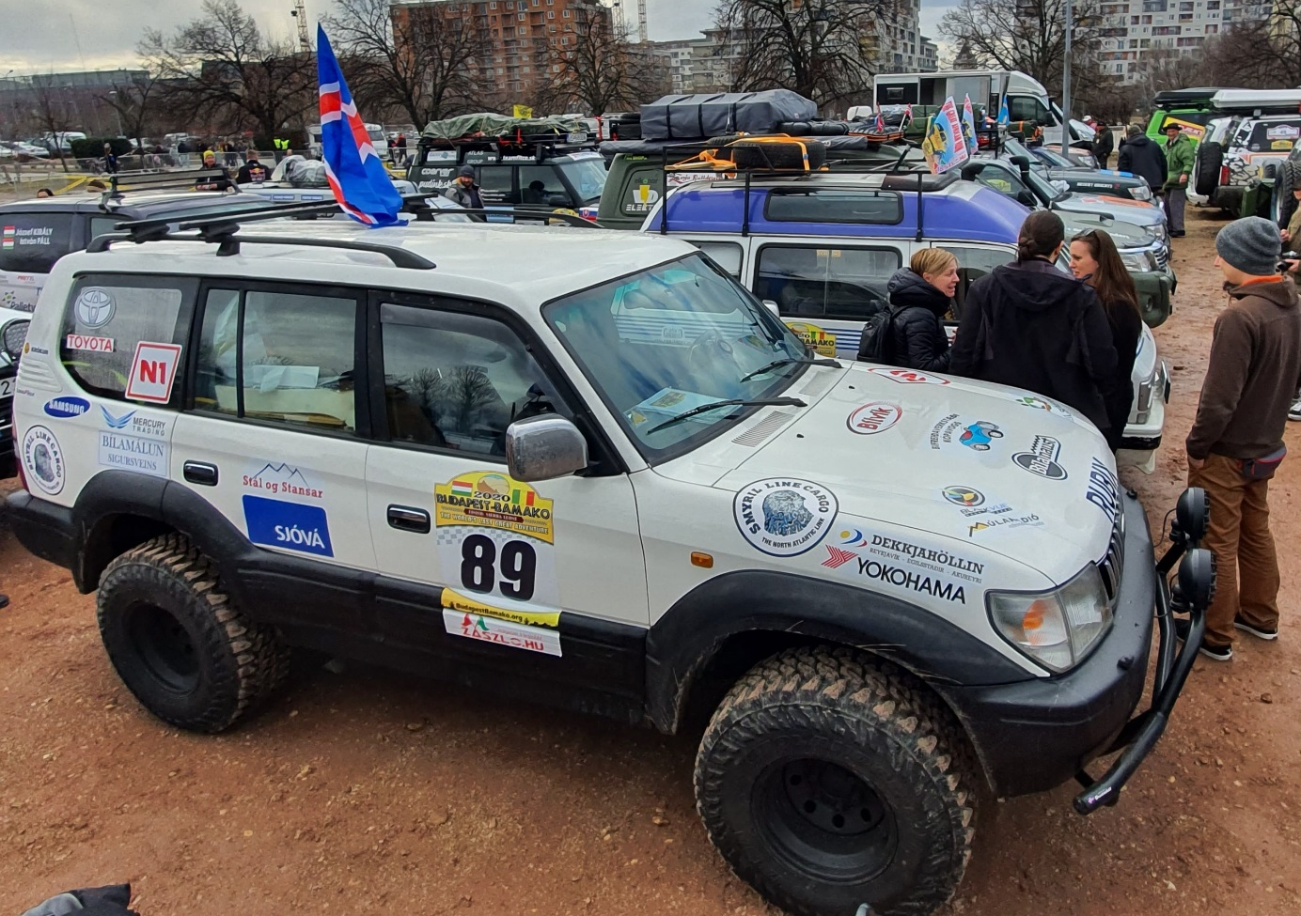
Yokohama supports Icelandic Charity effort

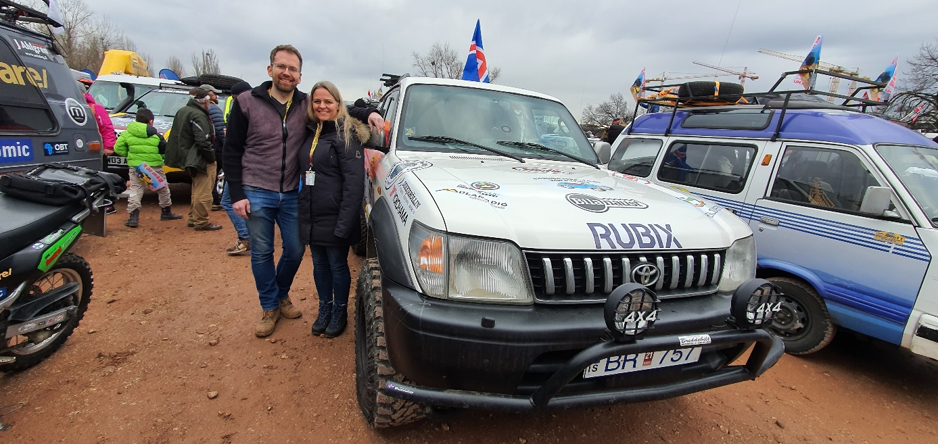
Thorolfur Gunnarsson and Margret Jonsdottir on Yokohama

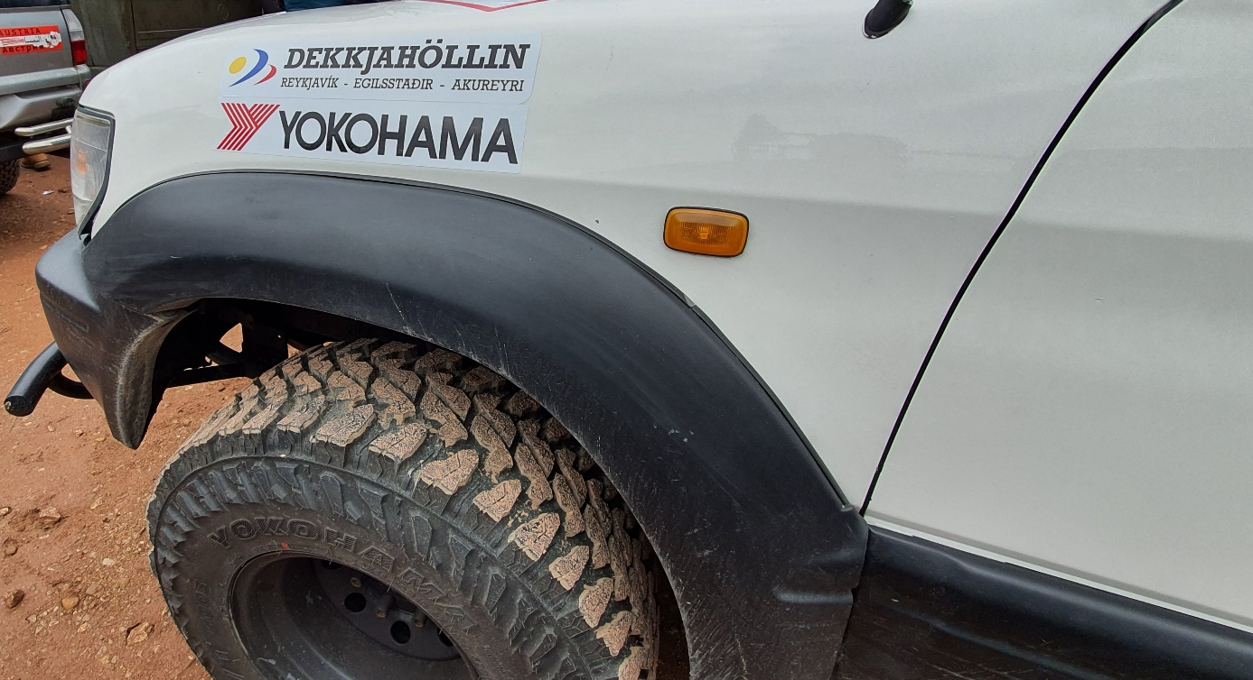
Geolandar MT G003 Tyres

