24th August 2023

Vehicles running on YOKOHAMA’s GEOLANDAR tyres take top three positions, including overall championship for two years in a row, in AXCR 2023

YOKOHAMA announced today that a vehicle equipped with its GEOLANDAR M/T G003 mud-terrain tyres for SUVs and pickup trucks won the overall championship in the Asia Cross Country Rally 2023 (hereafter, AXCR), Asia’s largest cross-country rally, which was held this year from 13th to 19th August. Vehicles running on GEOLANDAR M/T G003 tyres dominated the seven-day event, capturing the top three spots with 2nd and 3rd place finishes in addition to the championship. Last year, vehicles equipped with GEOLANDAR M/T G003 won the overall championship and finished in 3rd, 4th and 5th place. This year’s results once again demonstrated the superior performance and durability of the GEOLANDAR M/T G003 tyre in gruelling off-road races.

The overall championship was won by Vehicle #105 from TOYOTA GAZOO Racing Indonesia (driver Takuma Aoki, co-driver Ittipon Simaraks/Songwut Danphiphattrankoon) racing in a Toyota Fortuner SUV. Despite mechanical problems in leg 1, the team ran fast in legs 2 and 3 and made it to the top by the end of leg 3. The team held on to its lead in legs 5 and 6, and crossed the finish line in the top position. Another Vehicle #121 from TOYOTA GAZOO Racing Indonesia (driver Tubagus Moerinsyahdi, co-driver Jatuporn Burakitpachai) drove its Toyota Fortuner SUV equipped with GEOLANDAR M/T G003 tyres to a 2nd place finish.

The 3rd place finisher was Team MITSUBISHI RALLIART #101 (driver Chayapon Yotha, co-driver Peerapong Sombutwong) driving Mitsubishi Motors Corporation’s new Triton. This team achieved a good result two years in a row, along with the overall championship last year.

YOKOHAMA’s GEOLANDAR M/T G003 tyres deliver superior performance on the full range of off-road surfaces over an exceptionally long lifespan. In addition, the tyre features a sturdy and aggressive design that enhances the off-road driving sensation. YOKOHAMA’s GEOLANDAR brand tyres, including the M/T G003, are widely used in motorsports and have performed brilliantly in many of the most demanding off-road races in Asia, North America, and other regions.

First held in 1996, AXCR is an FIA (Federation Internationale de l’Automobile) officially sanctioned race, similar to the Dakar Rally. In recent years, the AXCR has been run over a different course each year, with the starting line in Thailand and then passing through many Southeast Asian countries as it winds through a diverse range of terrains, from mountains and jungles to beaches and plantations, and even race circuits. The rally started in Thailand and finished some 2,000kms away in Laos.

Under YOKOHAMA’s three-year (2021–2023) medium-term management plan, Yokohama Transformation 2023 (YX2023), the consumer tyre business aims to maximize the sales ratios of high-value-added YOKOHAMA tyres, namely the global flagship ADVAN brand, the GEOLANDAR brand of tyres for SUVs and pick-up trucks, and various winter tyres. As part of its 2023 “Mud Match” themed sales campaign, the consumer tyre business is introducing new tyres in its GEOLANDAR brand and accelerating the expansion of the size line-ups. YX2023 also positions participation in motorsports activities as crucial to the company’s effort to develop new tyre technologies that will further strengthen the ADVAN and GEOLANDAR brands. YOKOHAMA therefore is again participating in a wide variety of motorsports events in Japan and around the globe, from top-category to grassroots events.

Toshio Obara (Executive advisor’ TOYOTA GAZOO Racing Indonesia)

“We have tried AXCR four times since 2017. I was very happy that we finished in 1st and 2nd places. This result is attributable to not only the drivers’ effort but also in large part due to the mechanics from Japan, Indonesia and Thailand working together to support the team. I am really proud of this team. YOKOHAMA’s GEOLANDAR M/T G003 tyres supported our vehicles, and all the team drivers were very happy that they were able to drive with confidence on the tyres.”

Hiroshi Masuoka (Director’ Team MITSUBISHI RALLIART)
“The overall 3rd place finish is somewhat disappointing, but I am proud that all three vehicles crossed the finish line. I believe that this was also a good opportunity for everyone to know the reliability of new Triton. We will do our best to win the championship next year with a team further strengthened by taking advantage of know-how acquired in this race. In order to drive fast, safely and with certainty, the grip performance and reliability of tyres are very important. This race had muddy road surfaces and high-speed sections, and I saw that YOKOHAMA’s GEOLANDAR M/T G003 tyres are extremely reliable and grip all types of road surfaces with certainty.”

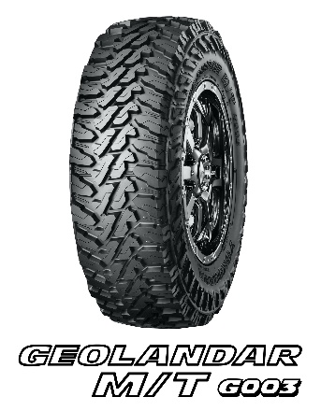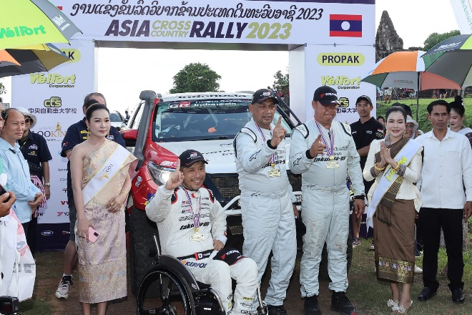
Driver Takuma Aoki (center left) and co-drivers Ittipon Simaraks (center) and Songwut Danphiphattrankoon (center right), raising their arms in front of Toyota Fortuner SUV (#105) after winning the overall championship
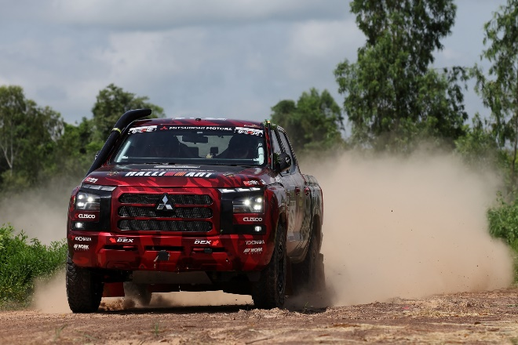
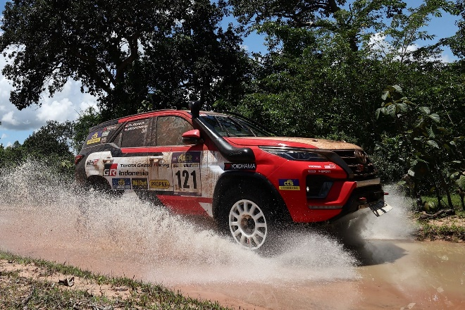
Mitsubishi Motors Corporation’s new Triton (#101), which finished in 3rd place
Toyota Fortuner SUV (#121), which finished in 2nd place
GEOLANDAR M/T G003

