08th August 2018

YOKOHAMA Develops Double-Tube Internal Heat Exchanger to Improve Cooling Efficiency of Automotive Air Conditioners

YOKOHAMA has developed a double-tube internal heat exchanger for use in automotive air-conditioners to improve the cooling efficiency.
At present, HFC-134a, which is widely used as a refrigerant for automotive air conditioners, has a high GWP (Global Warming Potential) of 1,430, and therefore, the switching to HFO-1234yf (GWP=4), which has a low GWP, is progressing to prevent global warming. On the other hand, the cooling efficiency of HFO-1234yf is lower than that of HFC-134a, but by using the double-tube internal heat exchanger developed this time, this reduction in the cooling efficiency can be covered. The double-tube internal heat exchanger is formed by integrating a portion of two refrigerant tubes, which are conventionally formed separately, into a double-tube, and the cooling efficiency of the entire air conditioner system is improved by exchanging internal heat by utilizing the temperature difference between the high-temperature refrigerant and the low-temperature refrigerant (Fig. 1).Since the automotive air conditioner system is arranged in a narrow space in the engine room, it is necessary to design the piping according to the layout in the engine room. In the double-tube internal heat exchanger developed this time, since the flow path of the refrigerant is not collapsed even if it is bent by arranging fins inside (Fig. 2), piping design can be freely carried out similarly to the piping of the conventional air conditioner system.
The double-tube internal heat exchanger developed this time has been adopted for the all-new 2018 “Jeep® Wrangler” and the all-new 2018 “Jeep® Compass”.
YOKOHAMA is promoting measures to regulate refrigerants for automotive air conditioners. The double-tube internal heat exchanger developed this time will be strengthened in sales mainly in North America, and development of high performance specifications will be carried out in order to expand adoption.

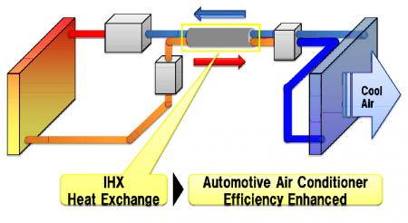
The image of Automotive air conditioner with double-tube internal heat exchanger

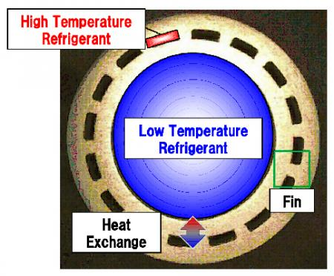
The cross-sectional view of a double-tube

