13th March 2018

YOKOHAMA Now Supplying OE Tyres for Volkswagen Tiguan

YOKOHAMA announced today that from this January it has begun supplying 17-inch (215/65R17 99V) “BluEarth-A AE-50” tyres as original equipment (OE) for the Tiguan to be sold in Russia. The Tiguan cars are being manufactured by Volkswagen AG’s local subsidiary Volkswagen Group Rus. The supply of 17-inch tyres follows on the supply of 18-inch (235/55R18 100V) “BluEarth-A AE-50” tyres that began in June 2017.
Developed under the “YOKOHAMA Pursuit of Driving Pleasure” concept, “BluEarth-A AE-50” tyres are fuel-efficient tyres featuring excellent wet grip and other functionalities that deliver superb driving performance and comfort in a wide range of road conditions. Volkswagen’s high evaluation of the performance of “BluEarth-A AE-50” tyres led to the brand becoming the first YOKOHAMA tyre selected by Volkswagen Group Rus., as OE back in November 2016 when two sizes—205/55R16 91V and 195/65R15 91H—were adopted for use on the Jetta in Russia.
The “BluEarth-A AE-50” tyres for the Tiguan and the Jetta are being manufactured at YOKOHMA’s Russian tyre manufacturing and sales subsidiary, LLC Yokohama R.P.Z., which was established in December 2008. The subsidiary began production near the end of 2011, making YOKOHAMA the first Japanese tyre maker to manufacture passenger car tyres locally in Russia. The Russian subsidiary has since increased its plant’s capacity to 1.6 million tyres a year, a 2.3-fold increase from the plant’s capacity upon the start of operations in 2012.

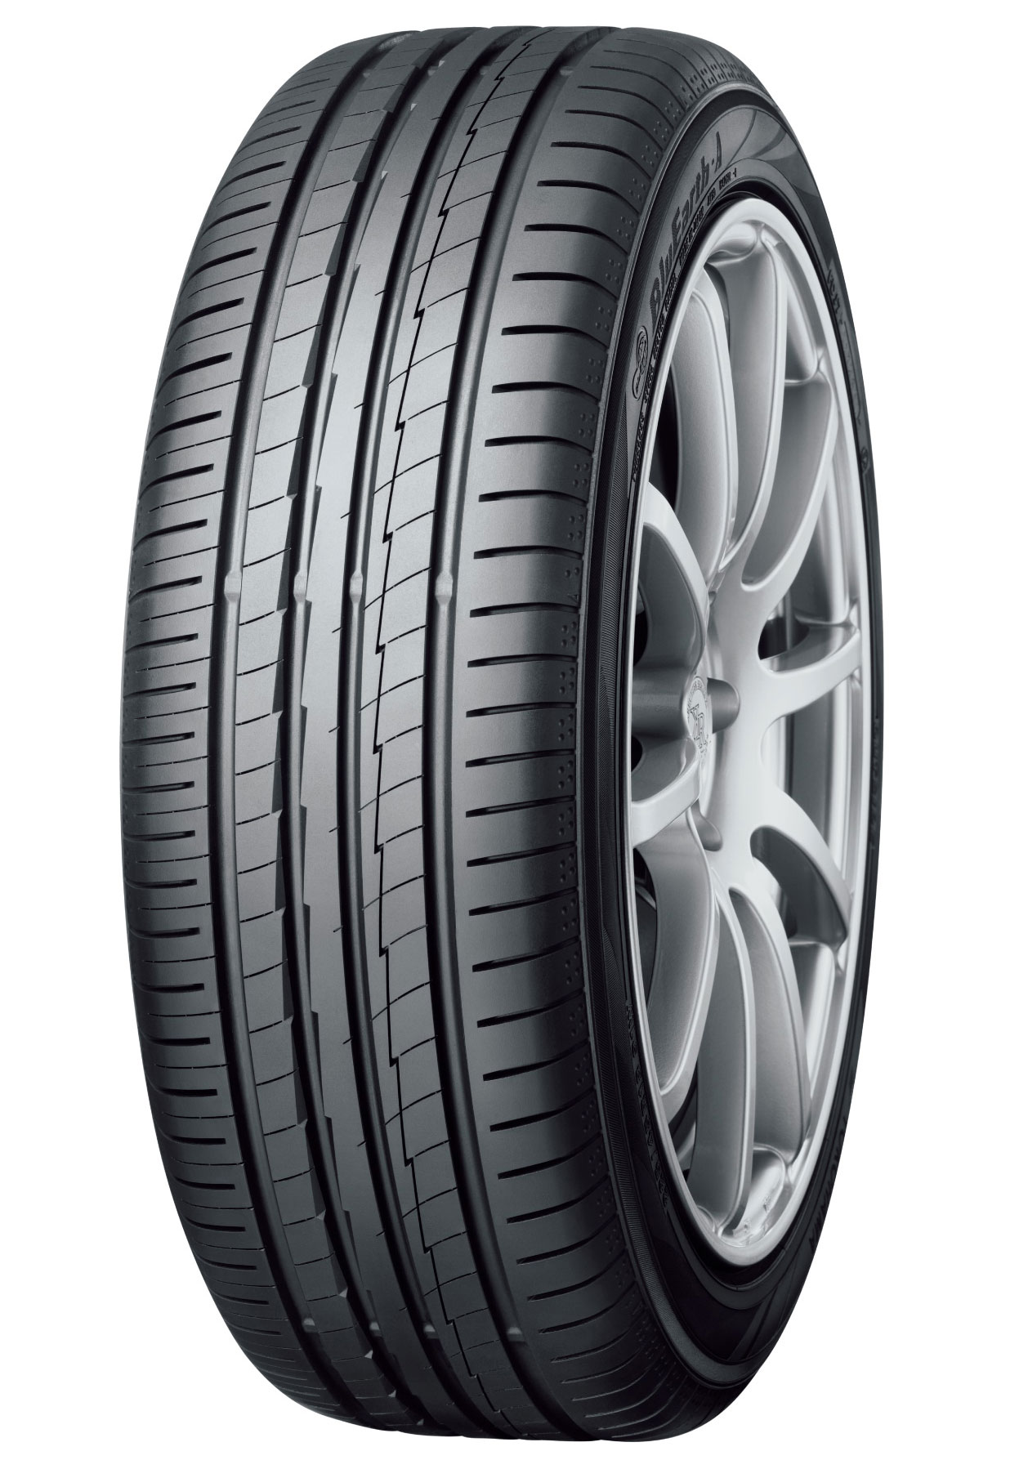
“BluEarth-A AE-50” Tyre shown in photo differs in size from those installed on the Tiguan (wheel shown in the photo is not standard equipment)

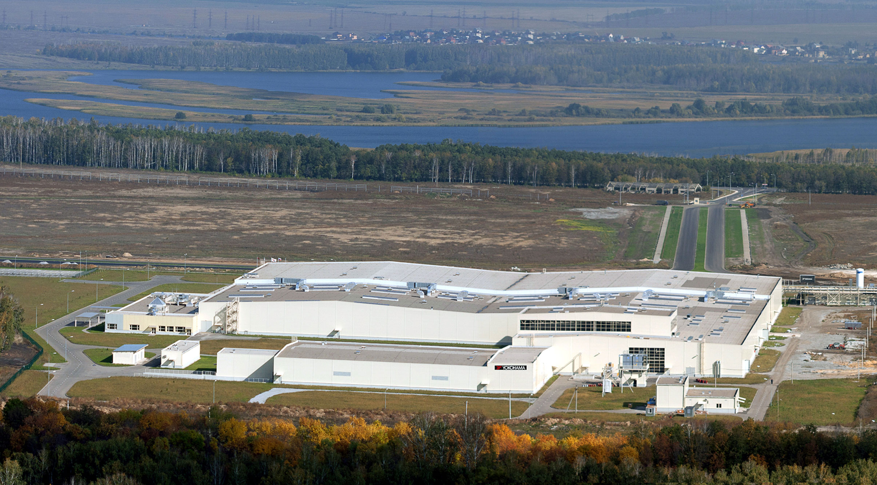
LLC Yokohama R.P.Z.’s passenger car tyre plant

