1st March 2018

YOKOHAMA to Exhibit at Geneva Motor Show 2018

YOKOHAMA will participate in the Geneva International Motor Show 2018. The 88th edition of the show will be held during 8th – 18th March, with press days on 6th and 7th March. In addition to showcasing three new premium tyres – one making its world premiere and two being launched in Europe for the first time – the YOKOHAMA booth will also include content that informs visitors about its new consumer tyre strategy, a core element in the Company’s new medium-term management plan, “Grand Design 2020 (GD2020)”. A press conference is scheduled to be held at the YOKOHAMA booth (Hall 4, Booth No. 4231) on 6th March from 4:15 p.m.
On 19th February, YOKOHAMA announced its new medium-term management plan, GD2020. The Company’s booth at the Geneva Motor Show will feature exhibits highlighting the new plan’s strategies for premium-car tyres, winter tyres, and hobby tyres, the first specific action taken to promote GD2020’s consumer tyre strategy’s focus on expanding YOKOHAMA’s presence in the market for premium-grade tyres.
As part of the new premium-car tyre strategy, the booth will introduce visitors to the company’s track record as a supplier of original equipment (OE) tyres to many of the world’s premium car models. “ADVAN Sport V105” will be on display as YOKOHAMA’s top-line tyre for high-performance premium cars. The YOKOHAMA booth will also celebrate the 40th anniversary of the ADVAN brand in 2018.
As part of the winter tyre strategy, the Geneva Motor Show will mark the world premiere of a brand new European all-season tyre for passenger cars as well as Europeans’ first opportunity to see YOKOHAMA’s studless tyre “iceGUARD iG60”. To promote the hobby tyre strategy, the YOKOHAMA booth will display tyres with a strong appeal to hobbyists, including the European premiere of “GEOLANDAR M/T G003” tyre, designed for SUVs and pickup trucks driving on muddy terrain, and the track-days street sport tyre “ADVAN A052”, for drivers seeking to enhance their hobby-driving pleasure.
In addition, it will include a special corner highlighting the Company’s partnership with the Chelsea Football Club. From 6th March to 11th March, the booth will display the 2016/17 season English Premier League Trophy won by the club.

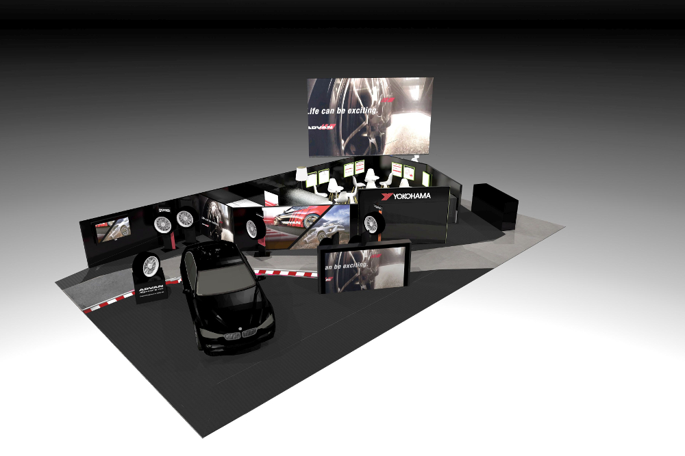
Image of YOKOHAMA booth at Geneva International Motor Show 2018

