6th March 2018

YOKOHAMA to Launch Spectacular Mud Terrain Tyre for SUVs and Pickup Trucks, the GEOLANDAR M/T G003 in Europe

YOKOHAMA will begin European sales of the “GEOLANDAR M/T G003”, mud terrain tyre in its GEOLANDAR brand of tyres for SUVs and pick-up trucks, from this spring. The tyres, to be introduced to specific country markets sequentially, will be available in 23 sizes, from 20-inches to 15-inches with POR (Professional Off-Road) stamped on the tyres’ sides. The same tyre has been sold in United states since July 2017.
The “GEOLANDAR M/T G003” seeks to provide off-road driving enthusiasts with tyres that deliver the ultimate performance on every off-road scene, from mud to rock, dirt and gravel. In addition, the Company constantly seeks to extend the tyres’ useful life by enhancing their durability and wear resistance. The “GEOLANDAR M/T G003” therefore is a total upgrade from its predecessor, featuring a new tread pattern, side design, profile, construction and rubber compound, all based on technological feedback received from participants in the most-demanding off-road races around the world. Tread pattern and the side block are particularly important parts of off-road tyres. The tread pattern of “GEOLANDAR M/T G003” includes large mesh lug grooves and sequential sipes that help the tyre achieve excellent traction on various off-road surfaces. In addition, the “GEOLANDAR M/T G003” has a thickened side with an aggressive side block in the upper part of the tyre’s side. This side block increases cut and wear resistance. The “GEOLANDAR M/T G003” development team’s dedication to creating a design that strengthens the vehicle’s off-road image has resulted in an aggressive-looking tyre that fulfils users’ needs to enjoy off-road driving in a dressed-up vehicle. On-road performance was not overlooked, and the “GEOLANDAR M/T G003” maintains the quiet, comfortable ride on the highway and city streets achieved by its predecessor.
“GEOLANDAR” is YOKOHAMA’s global brand for SUVs and pick-up trucks. Given the growing global popularity of SUVs and pick-up trucks in recent years, YOKOHAMA has accelerated its development and introduction of new additions to the “GEOLANDAR” series. The introduction of the “GEOLANDAR M/T G003” is aimed at expanding sales of higher-value-added tyres that are increasingly the choice of today’s drivers of SUVs and pick-up trucks. The “GEOLANDAR” brand also includes “GEOLANDAR A/T G015”, an all-terrain tyre; the “GEOLANDAR H/T G056”, a highway tyre for midsize and large SUVs; and the “GEOLANDAR SUV”, for urban crossovers and small/midsize SUVs. The “GEOLANDAR M/T G003” further expands the brand’s line-up to meet the needs of a wider and more diverse group of users.

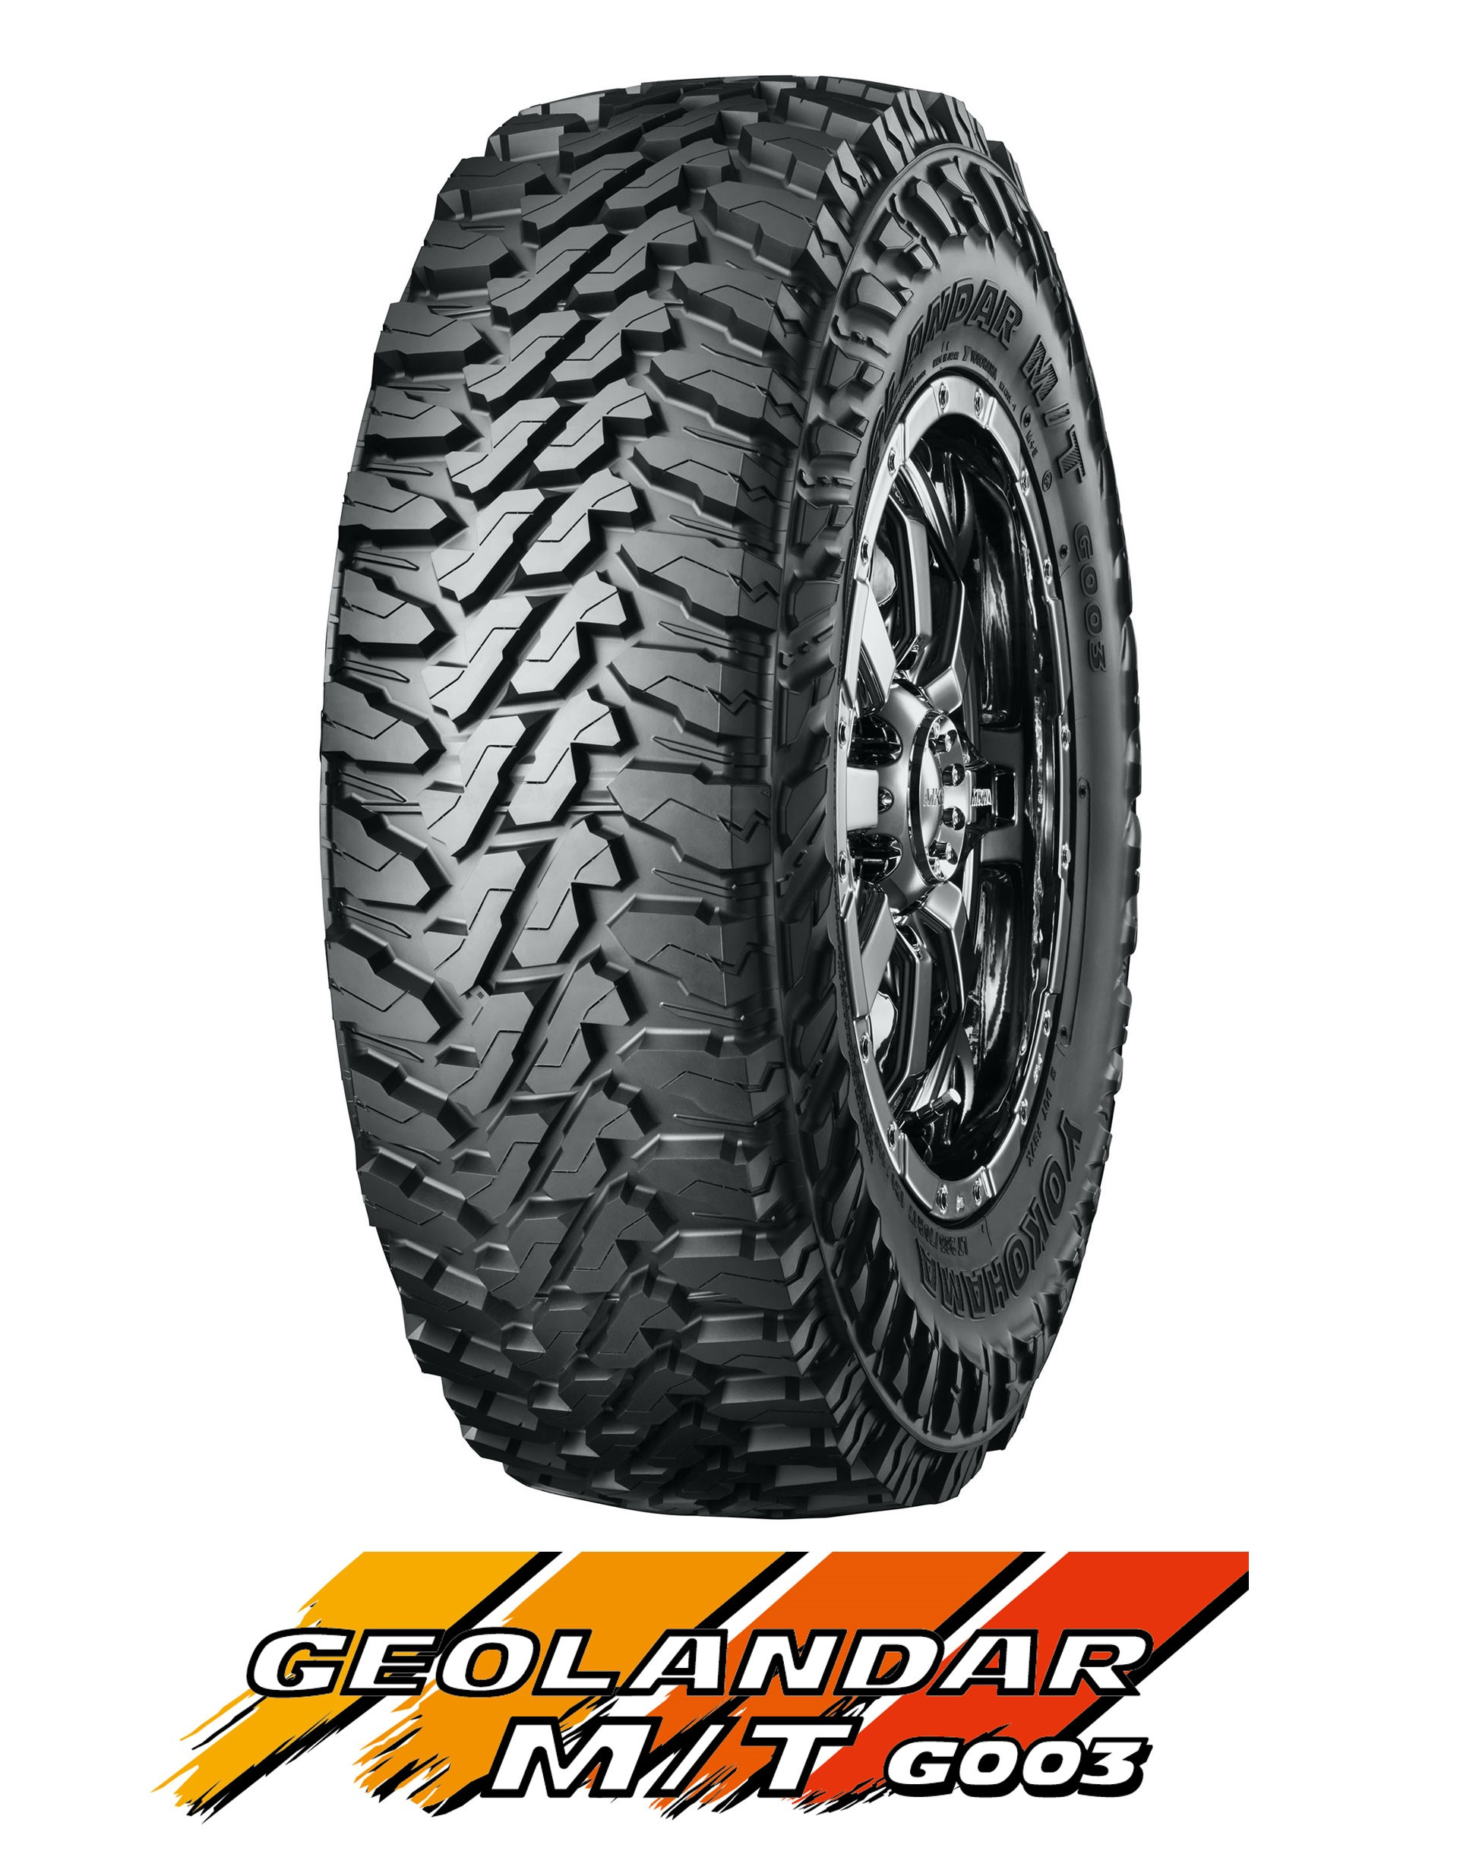
Geolandar M/T G003

Tread Pattern Delivers Superior Off-Road Performance

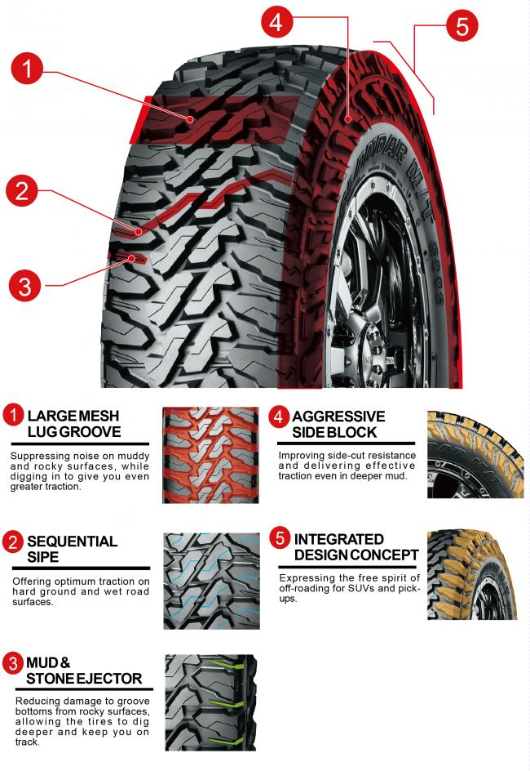

Special Construction Increases Durability

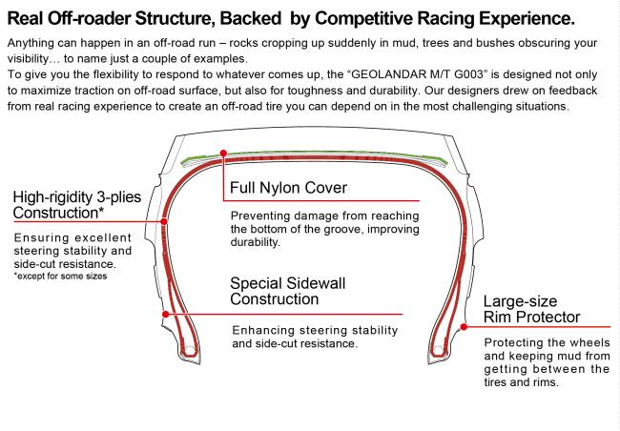

New Compound and Profile Enhance Traction and Wear Resistance

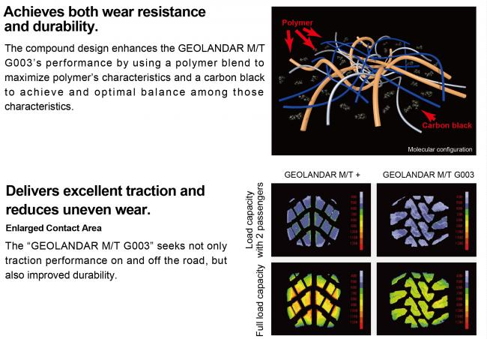

Available Sizes
