4th March 2020

YOKOHAMA to Launch the BluEarth*Winter V906, a New Winter Tyre for Passenger Cars in Europe

YOKOHAMA announced today that it will begin sales of the BluEarth*Winter V906, a new winter tyre for passenger cars in Europe, from this autumn. The tyre will be available in 30 sizes, ranging from 225/40R18 92W XL to 185/65R15 88T.

The BluEarth*Winter V906, based on the concept of “Powerful Traction", improves upon the performance of its predecessor tyre, the BluEarth*Winter V905, in two key areas considered important for winter tyres by European drivers - performance on snow and ice and wet-grip performance - while also maintaining a high level of wear resistance.

The tyre’s tread pattern is based on Harmony Tread Design concept that positions grooves, blocks, and sipes in a harmonious layout that delivers a more powerful performance. Smooth V-shaped grooves efficiently displace snow and water, while the Uniform Pressure Blocks evenly distributed over the entire pattern increase the tyre’s rigidity to deliver outstanding grip performance on all winter road surfaces. Optimally placed widespread 3D sipes enhance the tyre’s edge effect to further improve its performance on snow and ice. The tyre’s tread compound is a newly developed super-rich silica compound that uses a large amount of silica to dramatically enhance the tyre’s wet-grip performance. YOKOHAMA’s proprietary A.R.T. Mixing Technology, an advanced reaction mixing technology, greatly improves the dispersibility of materials, which heightens the efficiency of the silica. Meanwhile, the tyre’s unique construction includes a low-heat generating under-tread rubber that maintains a low rolling resistance.

The consumer tyre strategy in YOKOHAMA’s current medium-term management plan, the Grand Design 2020 (GD2020), includes a winter tyre strategy that aims to assert performance leadership in winter tyres supplied in Japan and overseas markets. In addition to a line-up of winter tyres, studless tyres and stud tyres, in 2018 YOKOHAMA introduced its first all-season tyre for the European market, the BluEarth-4S AW21. The company is accelerating the development of new products and expanding the size line-up of existing products.
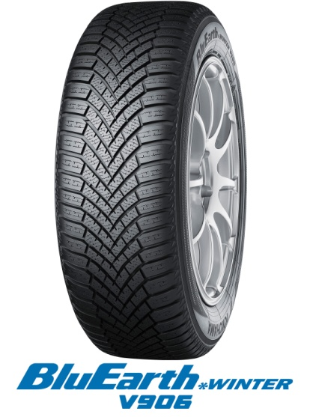

Harmony Tread Design
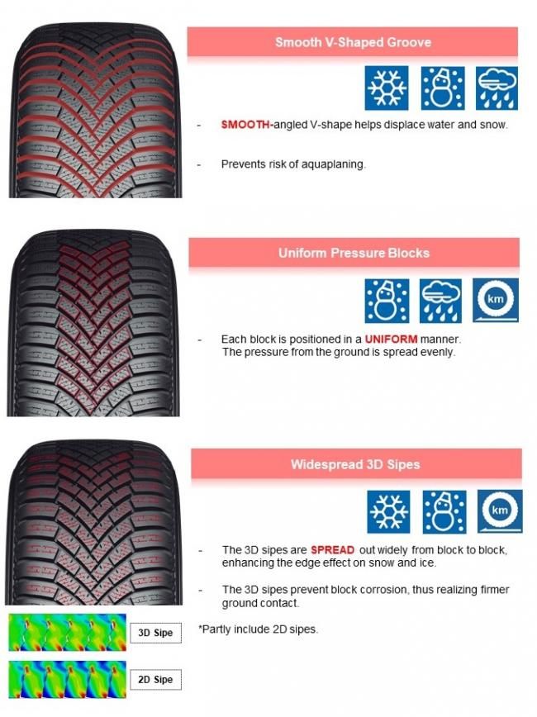

Newly Developed Super-Rich Silica Compound
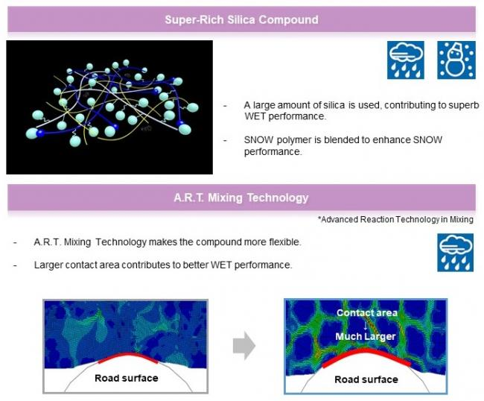

Robust Construction and Optimized Profile
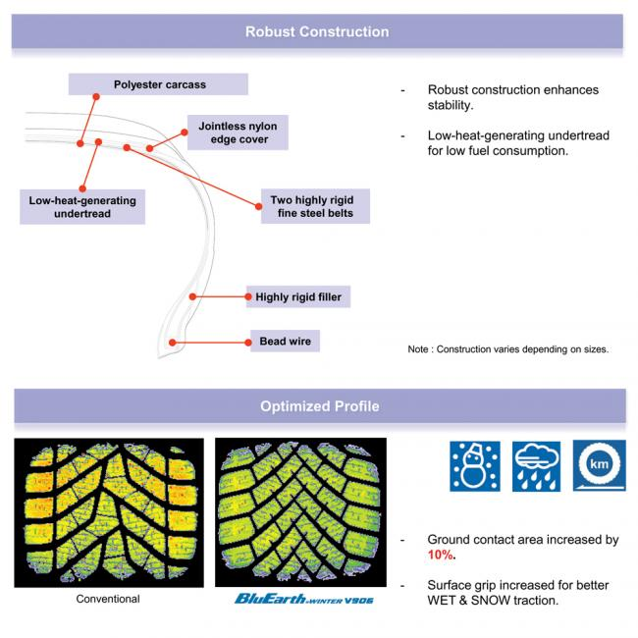

Available Sizes
