20th February 2018

YOKOHAMA’s “GEOLANDAR” to Come Factory-Equipped on Ram 1500

YOKOHAMA announced today that its “GEOLANDAR A/T G015” tyre has been adopted as original equipment on FCA US LLC’s 2018 Ram 1500 full-size pickup trucks. Ram 1500 will come equipped with LT265/70R17 121/118S size “GEOLANDAR A/T G015” tyres. Ram 1500 is available in the United States, Canada, and Mexico.
The “GEOLANDAR A/T G015” is an all-terrain tyre designed especially for use in SUVs and pickup trucks. In addition to superior driving performance and greater durability in off-road conditions, the “GEOLANDAR A/T G015” delivers a more comfortable and quieter ride on paved roads. The tyre also features a stylish yet strong design befitting a tyre mounted on SUVs and pickup trucks.
“GEOLANDAR” is YOKOHAMA’s global tyre brand for SUVs and pickup trucks. Amid the rising popularity of these vehicles in recent years, YOKOHAMA has been steadily expanding the offerings in its “GEOLANDAR” series, which now features a line-up capable of meeting the diverse needs of SUV drivers for tyres delivering superior performance in on- and off-road conditions. In addition to the Ram 1500, “GEOLANDAR” tyres have also won high marks from automakers, as evidenced by their adoption as original equipment on a number of 4x4 vehicles and premium SUVs, including the Jeep® Compass and the Jeep® Cherokee.

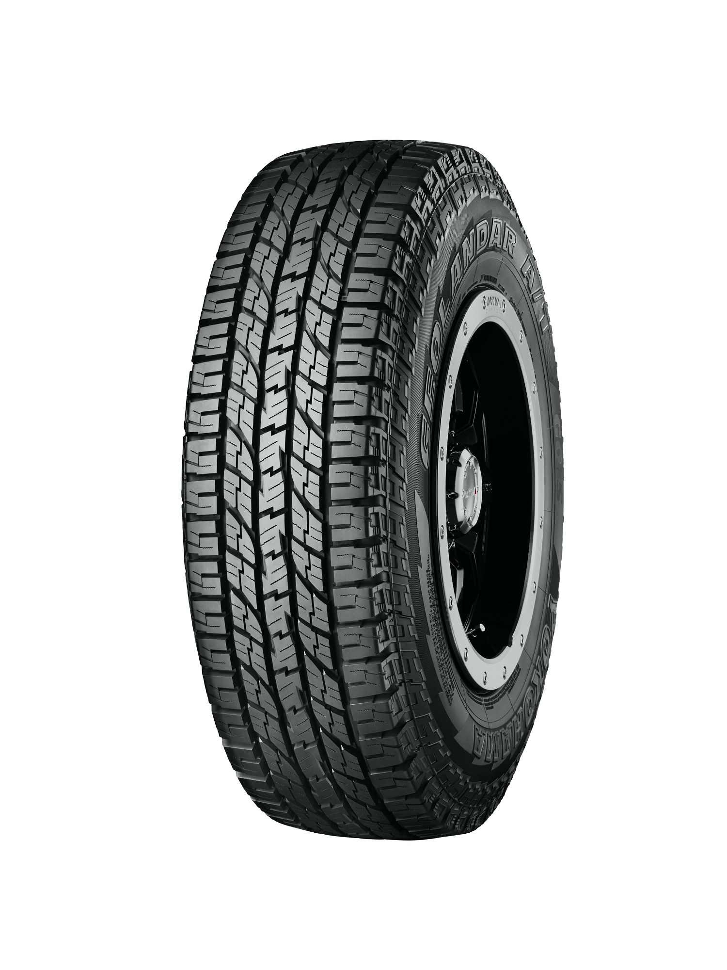
“GEOLANDAR AT G015” Tyre shown in photo differs in size from those installed on the Ram 1500 (wheels shown are not standard equipment)

