25th May 2023

YOKOHAMA–supported Kalle Rovanperä wins FORMULA DRIFT JAPAN Round 2

YOKOHAMA is pleased to announce that 2022 WRC champion Kalle Rovanperä, driving a car fitted with YOKOHAMA’s global flagship ADVAN brand tyres and wheels, was the victor in Round 2 of FORMULA DRIFT® JAPAN (hereafter, FDJ), held on 20th – 21st May on the Ebisu Circuit Nishi (West) Course in Fukushima Prefecture. Rovanperä’s victory in his FDJ debut is the second in a row for YOKOHAMA–supported drivers at this year’s FDJ, following the Round 1 win by 13-year old Hiroya Minowa, who also was drifting on ADVAN tyres.

YOKOHAMA supplied Rovanperä with its ADVAN NEOVA AD09, YOKOHAMA’s strongest street sports tyres and ADVAN Racing RS-DF Progressive aluminum sports wheels. The ADVAN NEOVA AD09 tyres have a well-balanced combination of enhanced levels of dry grip, controllability, and wear resistance. Driving KR69 CUSCO Racing’s Red Bull GR COROLLA, Rovanperä finished first in the solo-run qualifying round with a score of 97 points. In the final one-on-one tournament round, Rovanperä displayed aggressive but smooth drifting with precise control to win each of his matches and capture the championship. YOKOHAMA’s support for Rovanperä, a highly talented young driver attracting attention from drifting fans around the world, is reinforcing its ADVAN brand’s reputation as high-performance tyres.

Kalle Rovanperä is a rally driver from Finland. He began full participation in the World Rally Championship (WRC) in 2020. After finishing the 2021 season with two victories and an overall fourth place driver’s ranking, in 2022 he became the youngest WRC champion at the age of 22. Before coming to Japan for FDJ Round 2, Rovanperä was the victor in Round 5 of the 2023 WRC held in Portugal on May 11-14. Having mastered drifting techniques at the age of eight, Rovanperä has deep knowledge of drift competition and is also participating in the Drift Masters European Championship series. FDJ is an international version of the FORMULA DRIFT® series held in the United States. Inaugurated in 2014, FDJ essentially is a reverse import from the US FORMULA DRIFT®, which has elevated the popularity of drift driving, a motorsport that originated in Japan.

Under YOKOHAMA’s three-year (2021–2023) medium-term management plan, Yokohama Transformation 2023 (YX2023), the consumer tyre business aims to maximize the sales ratios of high-value-added YOKOHAMA tyres, namely the global flagship ADVAN brand, the GEOLANDAR brand of tyres for SUVs and pick-up trucks, and various winter tyres. YX2023 also positions participation in motorsports activities as crucial to the company’s effort to develop new tyre technologies that will further strengthen the ADVAN and GEOLANDAR brands. YOKOHAMA therefore is again participating in a wide variety of motorsports events in Japan and around the globe, from top-category to grassroots events.

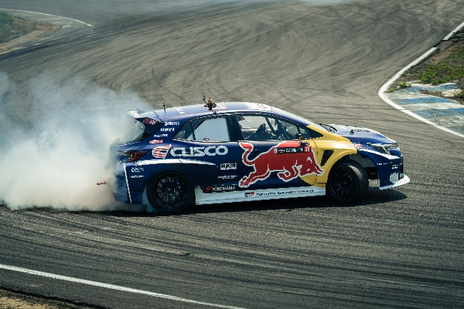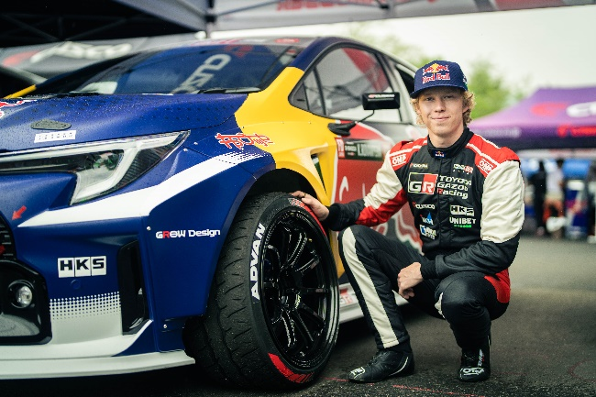
Kalle Rovanperä posing with a hand on an ADVAN NEOVA AD09 tyre
Red Bull GR COROLLA displaying superb drifting

