16th October 2023

YOKOHAMA ADVAN-equipped car wins the Nürburgring Endurance Series’ NLS Speed Trophy

YOKOHAMA is delighted to announce that the Walkenhorst Motorsport BMW customer racing team’s #34 BMW M4 GT3 captured the NLS Speed Trophy awarded to the car that accumulates the most points over the entire Nürburgring Endurance Series (NLS). The #34 BMW M4 GT3 was one of two Walkenhorst Motorsport ADVAN-coloured cars* that competed in this year’s NLS on YOKOHAMA’s global flagship ADVAN brand racing tyres. The #34 car also took home the NIMEX Team Trophy in the NLS highest SP9 Pro class.
* The two cars featured ADVAN colours from the second race of the series.

As part of this year’s ADVAN CHALLENGE that seeks to maximize sales of ADVAN tyres during the brand’s 45th year, YOKOHAMA is supplying its ADVAN racing tyres to teams aiming for victories in top-category motorsports events around the world, such as the NLS. The NLS is an endurance race series run on the Nürburgring race track, widely considered the world’s most demanding course. Some 170 cars competed in this year’s nine NLS races held from March to October.

YOKOHAMA supplied its ADVAN racing tyres to two Walkenhorst Motorsport cars competing in the NLS SP9 Pro class. Demonstrating its overwhelming power, Walkenhorst Motorsport’s #34 BMW M4 GT3 came in first in five of the nine NLS races to capture the overall championship. The team ran every race on ADVAN tyres - ADVAN A005 for dry conditions and ADVAN A006 for wet conditions - leaving race fans with a strong impression of ADVAN brand tyres and their excellent performance. The same team also captured the Speed Trophy and SP9 Pro class championship in the 2020 NLS, with tyres and support from YOKOHAMA.

Under YOKOHAMA’s three-year (2021–2023) medium-term management plan, Yokohama Transformation 2023 (YX2023), the consumer tyre business aims to maximize the sales ratios of high-value-added YOKOHAMA tyres, namely the global flagship ADVAN brand, the GEOLANDAR brand of tyres for SUVs and pick-up trucks, and various winter tyres. YX2023 also positions participation in motorsports activities as crucial to the company’s effort to develop new tyre technologies that will further strengthen the ADVAN and GEOLANDAR brands. YOKOHAMA therefore is again participating in a wide variety of motorsports events in Japan and around the globe, from top-category to grassroots events.

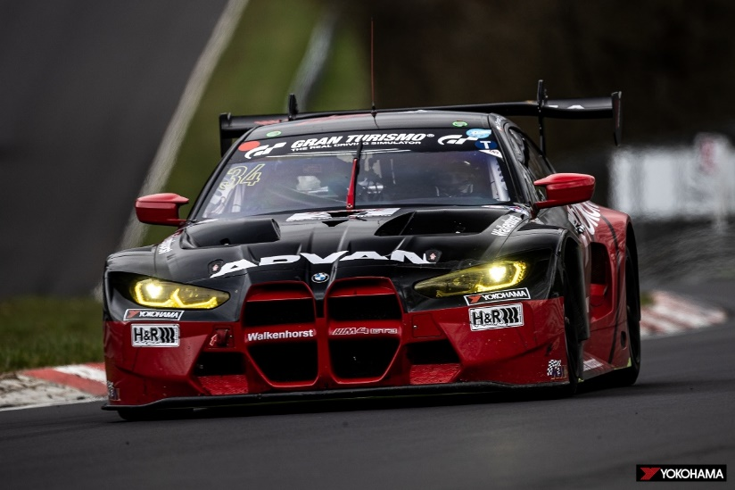

Walkenhorst Motorsport’s #34 BMW M4 GT3, winner of the NLS Speed Trophy

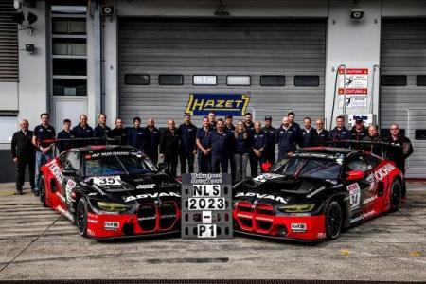
Walkenhorst Motorsport’s two ADVAN-coloured BMWs

