29th June 2023

YOKOHAMA ADVAN-equipped cars finish first in 5 divisions, including a second straight overall championship in US’s most challenging hill climb

This year’s overall championship was won by a car using sustainable ADVAN tyres

YOKOHAMA is pleased to announce the excellent results achieved by cars running on its ADVAN racing tyres at the 101st Pikes Peak International Hill Climb held in Colorado, USA, on June 25. The event’s overall champion, Robin Shute, climbed Pikes Peak in a car equipped with dry-use ADVAN A005 partially made from sustainable materials. The overall championship was the second straight for Shute and YOKOHAMA, achieving one of the goals of this year’s ADVAN CHALLENGE, which seeks to maximize sales of ADVAN tyres during the global flagship brand’s 45th year.

Competing in the Unlimited division, Robin Shute drove his 2018 Wolf TSC-FS to the summit in a sizzling 08:40:080, for a first-place division finish as well as the overall championship. Shute’s 2022 overall championship also was achieved on ADVAN racing tyres. This year, his car was equipped with ADVAN A005 tyres with the same 33% sustainable materials ratio* as the tyres being supplied by YOKOHAMA as the control tyre for this year’s Japanese SUPER FORMULA Championship series, where the tyres have demonstrated the same excellent grip performance as standard racing tyres. Another car running on ADVAN A005 tyres using sustainable materials, Randy Pobst’s 2021 Tesla Model S Plaid, finished second in the Exhibition division. The ADVAN A005 tyres on Randy’s car had an even higher renewable material content realized by using biomass rubber in the tyres’ sidewalls. These excellent results demonstrated YOKOHAMA’s advanced technologies’ ability to create tyres using sustainable materials that deliver excellent driving performance while also being environmentally friendly.

Many other drivers competing in cars equipped with standard ADVAN tyres also achieved excellent results at Pikes Peak. Tanner Foust drove his 2023 Radford Type 62-2 to a first place finish in the Exhibition division. Codie Vahsholtz was first in the Open Wheel division in his 2013 Ford Open Vahsholtz Custom, and David Donohue and his 2019 Porsche GT2 RS Clubsport finished first in the Time Attack 1 division. Meanwhile, Hayden Bradley captured the trophy in the Porsche Pikes Peak Trophy by Yokohama division, in which all entrants race in Porsches equipped with YOKOHAMA’s A052 tyres. In addition to the five division champions, one of whom also claimed the overall championship, YOKOHAMA is proud to have supported several other drivers competing in this year’s Pikes Peak hill climb by supplying them with ADVAN racing tyres (see Table below).

The Pikes Peak International Hill Climb is a hill climb race with a long and illustrious history dating back to 1916. It is also known as the “Race to the Clouds”, as the course starts at 2,862 meters above sea level and covers about 20 kilometers before reaching the finish line at an altitude of 4,300 meters. Cars equipped with YOKOHAMA tyres captured the overall championship in 2020 and 2022.

Under YOKOHAMA’s three-year (2021–2023) medium-term management plan, Yokohama Transformation 2023 (YX2023), the consumer tyre business aims to maximize the sales ratios of high-value-added YOKOHAMA tyres, namely the global flagship ADVAN brand, the GEOLANDAR brand of tyres for SUVs and pickup trucks, and various winter tyres. The plan also positions participation in motorsports activities as crucial to YOKOHAMA’s development of advanced tyre technologies and strengthening of its ADVAN and GEOLANDAR brands. The company’s development of high-performance and top-quality tyres for new cars and the replacement market benefits from the technologies accumulated through its participation in a wide variety of motorsports events in Japan and around the globe, from top-category races to grassroots races.

YOKOHAMA also is promoting sustainability initiatives based on the concept of “Caring for the Future.” The company believes that conducting its business activities aligned with these sustainability initiatives will help resolve social issues and lead to the continued increase of its corporate value. One goal of YOKOHAMA’s sustainability initiatives is to contribute to the realization of a circular economy. Toward that end, YOKOHAMA aims to increase the ratio of renewable and recyclable materials used by the Company to more than 30% of total materials used by 2030 and then raise that ratio to 100% in 2050.

*The 33% sustainable materials ratio has been achieved by using natural rubber, various naturally derived compounding agents, such as oil from oil palm fruit nuts and orange peels, recycled iron, rubber recycled from waste tyres, and synthetic rubber made using the mass-balance method.

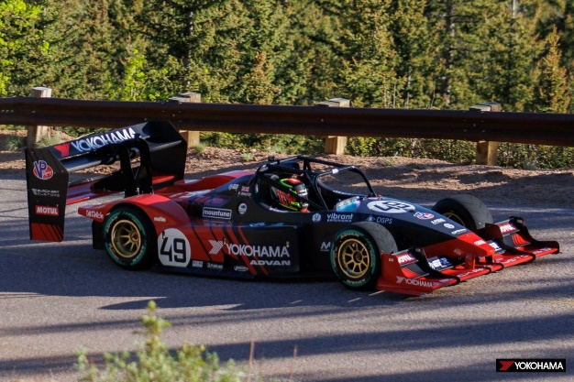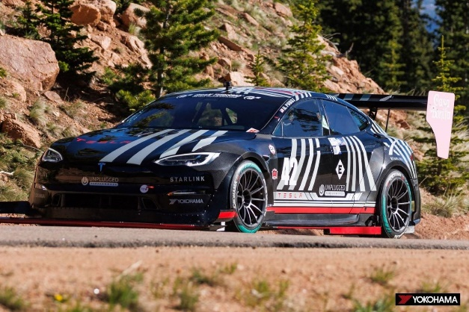
2018 Wolf TSC-FS climbing to the overall championship
2021 Tesla Model S Plaid took 2nd place in Exhibition division

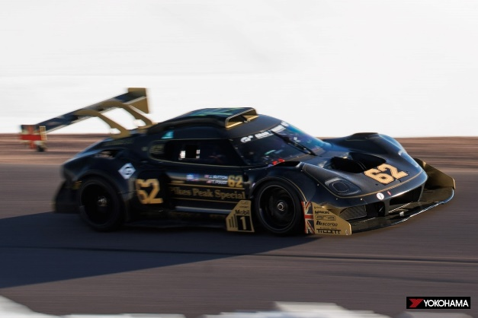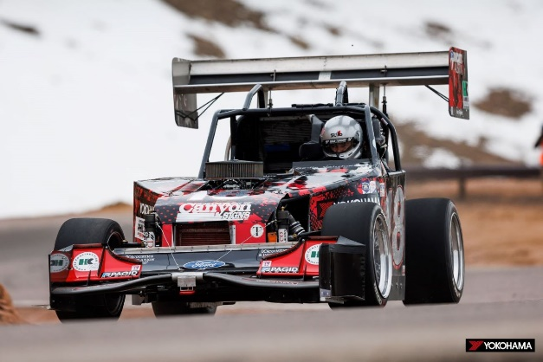
2013 Ford Open Vahsholtz Custom won in the Open Wheel division
2023 Radford Type 62-2 finished 1st in Exhibition division

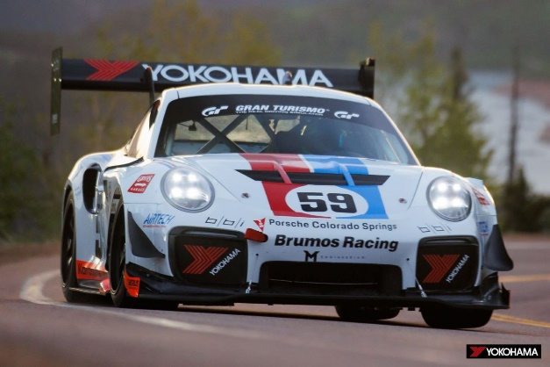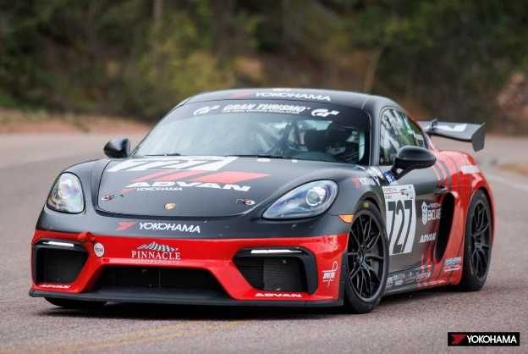
2020 Porsche Cayman GT4 Clubsport won the Porsche Pikes Peak Trophy by Yokohama
2019 Porsche GT2 RS Clubsport Time Attack 1 division winner

Results for YOKOHAMA-supported teams

Division | Drivers | Entry-Year( Make/Model | Result | Supplied Tyres
Unlimited | Robin Shute | 2018 Wolf TSC-FS | Overal Campion | Sustainable A005
Exhibition | Tanner Foust  Randy Pobst | 2023 Radford Type 62-2  2021 Tesla Model S Plaid | 1st in division  2nd in division | A005  Biomass A005
Open Wheel | Codie Vahsholtz | 2013 Ford Open Vahsholtz Custom | 1st in division | A005
Porsche Pikes Peak Trophy by Yokohama | Hayden Bradley  Nuno Caetano  Hutton McKenna | 2020 Porsche Cayman GT4 Clubsport  2020 Porsche Cayman Clubsport  2023 Porsche GT4 | 1st in division  2nd in division  3rd in division | A052  A052  A052
Time Attack 1 | David Donohue  James  Robinson | 2019 Porsche GT2 RS Clubsport  2022 Acura NSK | 1st in division  3rd in division | A005´  A005

