25th August 2021

YOKOHAMA ADVAN equipped cars dominate GT300 class in Round 3 of SUPER GT Series as the top 6 finishers all raced on ADVAN tyres

ADVAN-equipped car also finished third in the GT500 class

YOKOHAMA is pleased to announce that cars outfitted with its global flagship ADVAN brand tyres dominated the GT300 class in Round 3 of the 2021 AUTOBACS SUPER GT Series, Japan’s top-level touring car racing series. Round 3 was held on 21st – 22nd August at the Suzuka Circuit in Mie Prefecture. In addition to the winner in the GT300 class, the next five GT300 class cars to cross the finish line were all running on ADVAN tyres. An ADVAN-equipped car also finished third in the GT500 class.

The GT300 class winner was Max Racing’s Takanoko-no-yu GR Supra GT (Atsushi Miyake/Yuui Tsutsumi). JLOC’s JLOC Lamborghini GT3 (Takashi Kogure/Yuya Motojima) finished second, followed by GOODSMILE RACING & TeamUKYO’s GOODSMILE Hatsune Miku AMG (Nobuteru Taniguchi/Tatsuya Kataoka), filling the podium with teams supported by YOKOHAMA. The Takanoko-no-yu GR Supra GT started 3rd on the grid based on the previous day’s qualifying session and was in the lead after 24 laps, when it made a pit stop to change drivers. After returning to the track, it battled with the JLOC Lamborghini GT3 for the lead, ultimately surging ahead on lap 38 and held on to the lead for the rest of the 52-lap race. The GOODSMILE Hatsune Miku AMG moved up toward the end of the race to finish in 3rd place.

The Takanoko-no-yu GR Supra GT’s win was the first GT300 victory for Max Racing and its two drivers, and it vaulted the drivers and the team to the top of the 2021 season standings. Meanwhile, the JLOC Lamborghini GT3 and GOODSMILE Hatsune Miku AMG teams got to the podium for the first time this season. The first-place finish was the second this year for a YOKOHAMA tyre-supported team in the GT300 class, following a win in the seasons’ opening race.

In the GT500 class, KONDO RACING’s Realize corporation ADVAN GT-R (Mitsunori Takaboshi/Daiki Sasaki) started in the No. 4 position and was in 6th place after completing their last pit stop and driver change on the GT500 class 25th lap. It then overtook three cars over the rest of the race to capture 3rd place, this season’s second podium finish in the GT500 class for a YOKOHAMA tyre–supported team.

Under YOKOHAMA’s three-year (2021–2023) medium-term management plan, Yokohama Transformation 2023 (YX2023), the consumer tyre business aims to maximize the sales ratios of high-value-added YOKOHAMA tyres, namely the global flagship ADVAN brand, the GEOLANDAR brand of tyres for SUVs and pick-up trucks, and various winter tyres. YX2023 also positions participation in motorsports activities as crucial to the company’s effort to develop new tyre technologies that will further strengthen the ADVAN and GEOLANDAR brands. YOKOHAMA therefore is again participating in a wide variety of motorsports events in Japan and around the globe, from top-category to grassroots events.

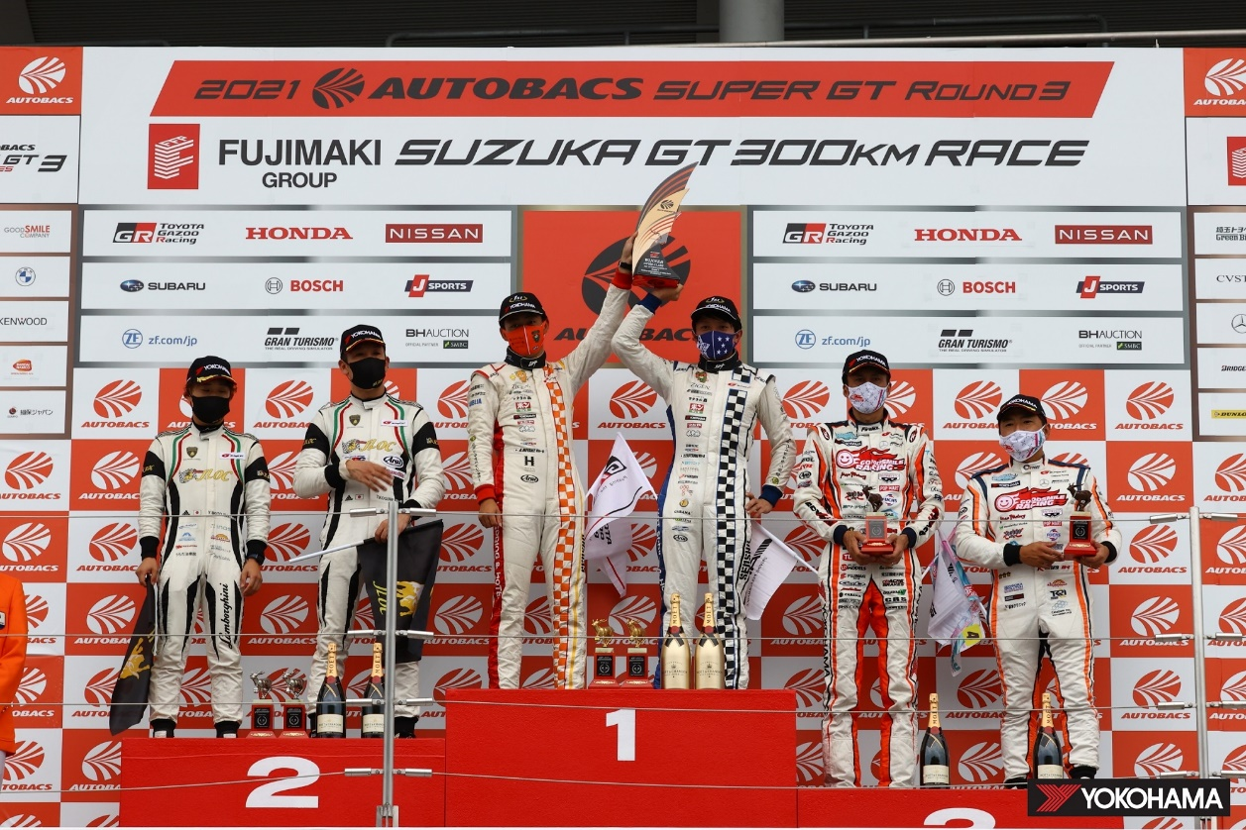
YOKOHAMA-supported teams dominate the podium for the GT300 class–from left Yuya Motojima & Takashi Kogure (2nd), Atsushi Miyake & Yuui Tsutsumi (1st), Nobuteru Taniguchi & Tatsuya Kataoka (3rd)

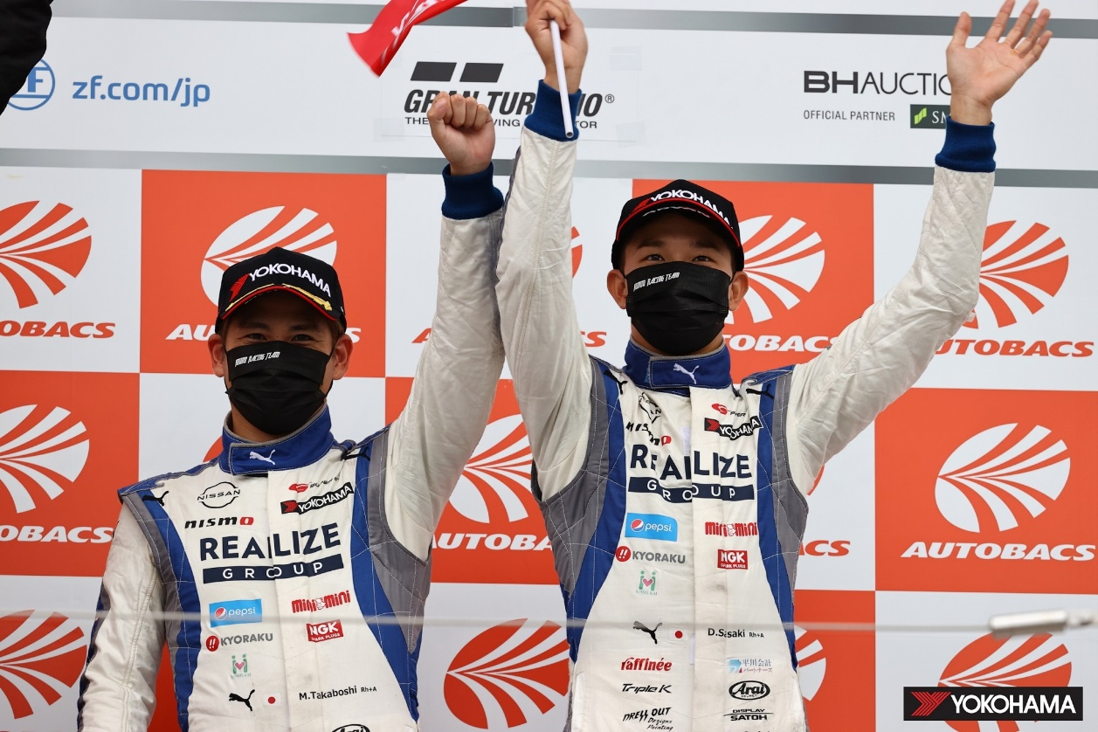
GT500 class 3rd place finishers Mitsunori Takaboshi (left) & Daiki Sasaki

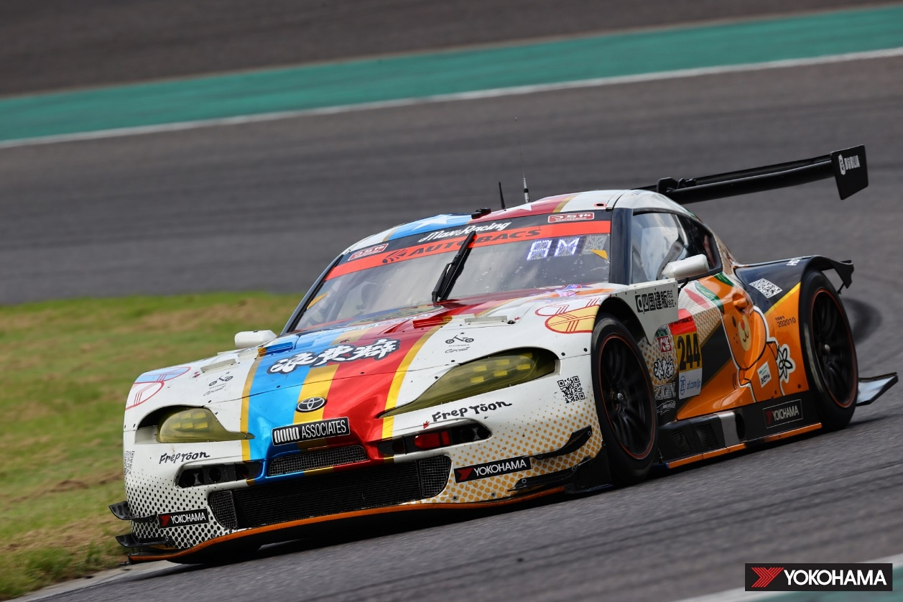
Takanoko-no-yu GR Supra GT GT300 class winner

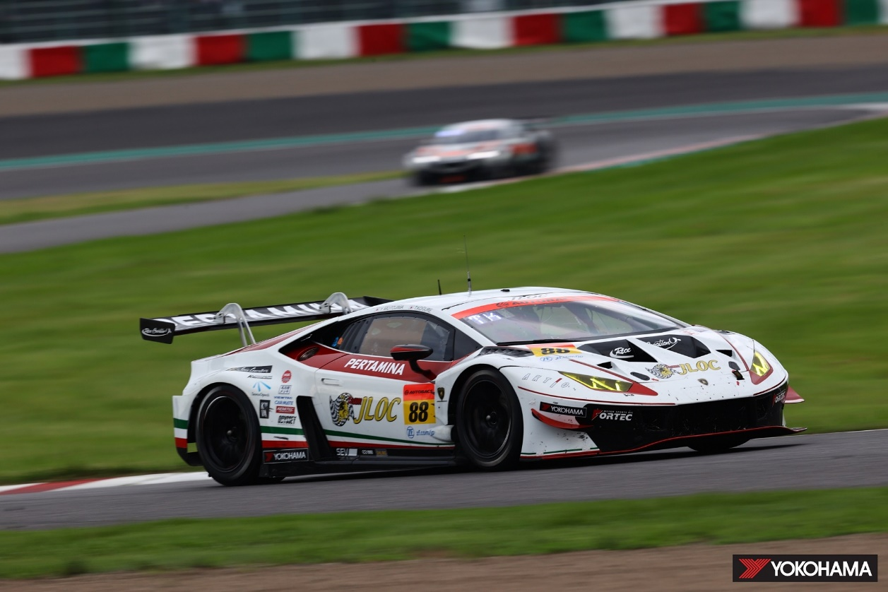
JLOC Lamborghini GT3 2nd place in the GT300 class

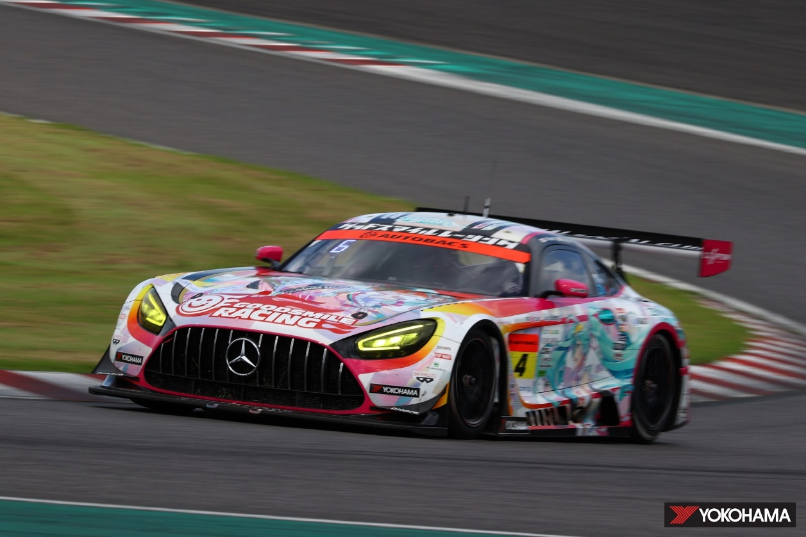
GOODSMILE Hatsune Miku AMG 3rd place in the GT300 class

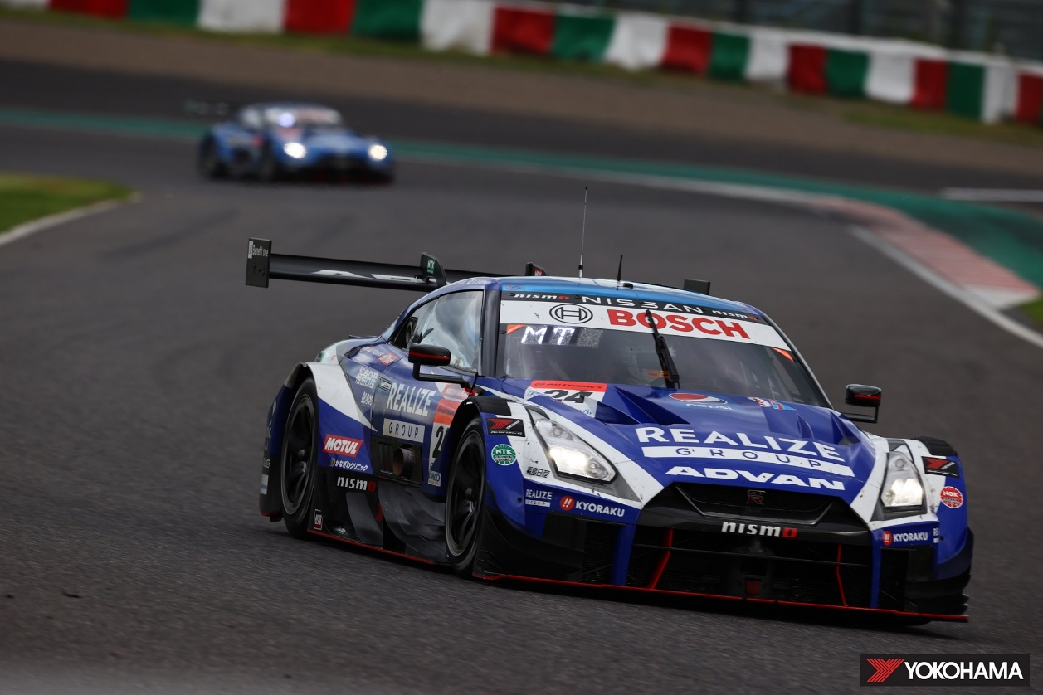
Realize corporation ADVAN GT-R 3rd place in the GT500 class

