4th October 2021

YOKOHAMA Europe announces new President and new Chairman

Düsseldorf - YOKOHAMA is pleased to announce the appointment of Gregorio Borgo as President and CEO of YOKOHAMA´s European headquarters, Yokohama Europe GmbH. He succeeds the current President, Hiroyuki Shioiri, who will become Chairman of Yokohama Europe GmbH effective from 10th October 2021.

Prior to his new assignment, Gregorio Borgo has been Chief Operating Officer of Prometeon Tyre Group since 2018. During his 26 years of experience in the tyre industry, he has held various positions and gained deep insights into numerous markets through his different roles at Pirelli Italy, China and Japan among others.

Commenting, current President Hiroyuki Shioiri stated: “With the appointment of Gregorio to the role of YOKOHAMA´s European President, we are convinced to have the right leader to achieve our goals in the European market. Throughout this year, YOKOHAMA has merged already diverse markets into Yokohama Europe GmbH, like Austria, Belgium, Czech Republic, Germany, Poland, Slovakia. Gregorio has the multicultural experience and knowledge to team up the countries and to strive into a bright future for our brand. We are confident that he will guide Europe into the Yokohama Transformation 2023 and beyond.”

Yokohama Transformation (YX2023) is YOKOHAMA’s three-year (2021–2023) medium-term management plan, which serves as the platform for growth over the next years. YX2023’s HR strategy includes reforming the personnel system to strengthen staffing at the company’s management and administrative levels, building a stronger organization that can quickly respond to changes in the environment, and implementing work-style reforms that will benefit all employees. In line with the company’s CSR slogan "Caring for the Future," ESG initiatives will continue to focus on providing environmentally friendly products, achieving carbon neutrality, and supporting activities in communities that are home to YOKOHAMA operations. Management also will strengthen corporate governance and continue the company’s efforts to create safe, secure, and comfortable workplaces.

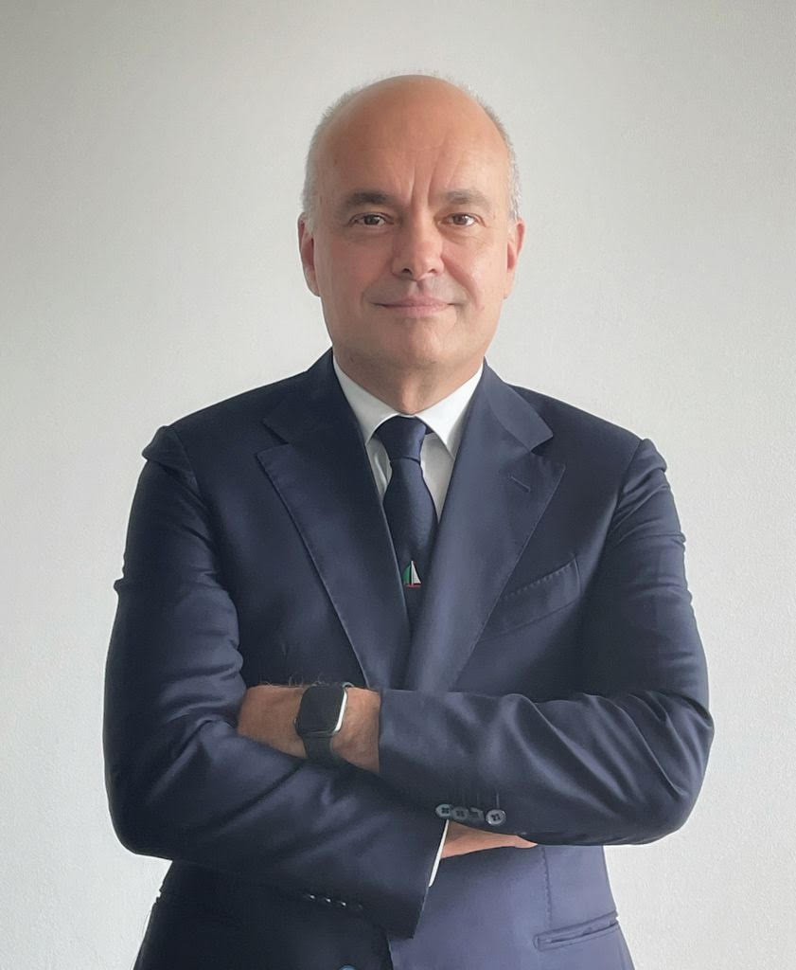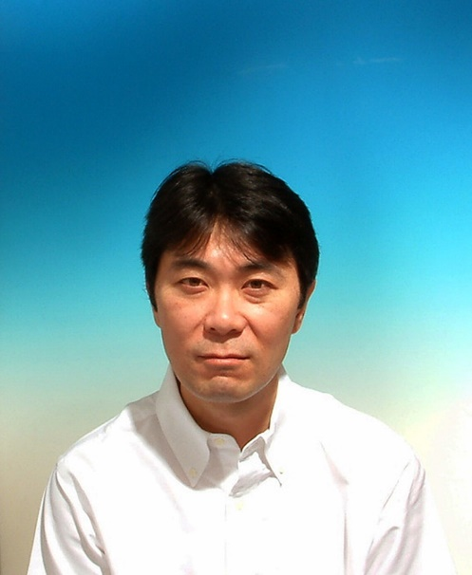
Gregorio Borgo Hiroyuki Shioiri

