8th October 2021

YOKOHAMA GEOLANDAR-equipped machine wins its class in the latest round of North America’s ultimate off-road racing series

YOKOHAMA is pleased to announce that a vehicle running on its GEOLANDAR M/T G003 mud-terrain tyres for SUVs and pick-up trucks finished first in the Trick Truck class of the 2021 King Shocks Laughlin Desert Classic, the next-to-last event of the “Best In The Desert” Series 2021, North America’s ultimate off-road racing series. The event was held from 23rd September to 26th September 2021 in Laughlin, Nevada, USA.

The Trick Truck class was won by Justin Lofton driving his 2WD Jimco trophy truck outfitted with specially tuned versions of the commercially available GEOLANDAR M/T G003 tyres. Justin praised the GEOLANDAR tyres for providing the superb traction and non-flat performance needed to secure victory. The 2021 King Shocks Laughlin Desert Classic races were run over a 17-mile (≒27km) semi-short course over two days, 25th – 26th September, with each day’s race a four-lap competition for a two-day total of 136 miles (≒219km). The winner was the driver with the lowest combined time over the two days of racing. Trick Truck class winner Justin Lofton also drove his GEOLANDAR M/T G003-equipped Jimco to the overall championship in the series 2020 finale, the BlueWater Desert Challenge.

GEOLANDAR M/T G003 tyres deliver superior performance on the full range of off-road surfaces over an exceptionally long lifespan. In addition, the tyre features a sturdy and aggressive design that enhances the off-road driving sensation. YOKOHAMA’s GEOLANDAR tyres have demonstrated their superior off-road performance in many races over the years, including a one-two finish in the 4800 class at the 2021 King Shocks Area BFE Beatdown this past April.

Under YOKOHAMA’s three-year (2021–2023) medium-term management plan, Yokohama Transformation 2023 (YX2023), the consumer tyre business aims to maximize the sales ratios of high-value-added YOKOHAMA tyres, namely the global flagship ADVAN brand, the GEOLANDAR brand of tyres for SUVs and pick-up trucks, and various winter tyres. YX2023 also positions participation in motorsports activities as crucial to the company’s effort to develop new tyre technologies that will further strengthen the ADVAN and GEOLANDAR brands. YOKOHAMA therefore is again participating in a wide variety of motorsports events in Japan and around the globe, from top-category to grassroots events.
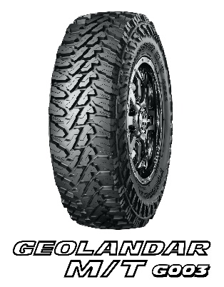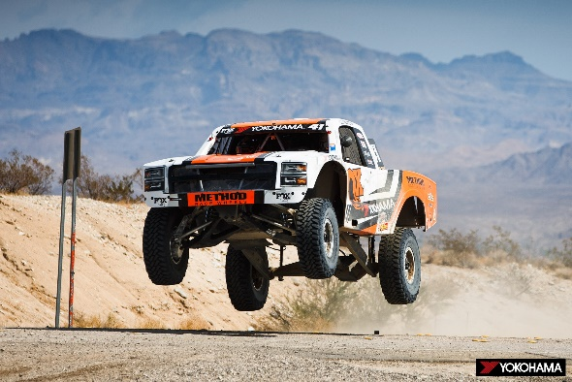
Justin Lofton racing to victory in his Jimco trophy truck

