30th August 2022

YOKOHAMA GEOLANDAR-equipped machine wins its class in the latest round of North America’s ultimate off-road racing series

YOKOHAMA is pleased to announce that a vehicle equipped with its GEOLANDAR SD offroad tyres sold in overseas markets finished first in the UTV N/A Pro class at the 2022 Method Race Wheels “Casey Folks” Vegas to Reno. The race, held in the U.S. state of Nevada during10th – 13th August 2022, was the latest round of the 2022 Best In The Desert series.

After finishing the long, demanding desert terrain course without a puncture, team’s driver Max Eddy praised his vehicle’s GEOLANDAR SD tyres, saying "My Yokohama GEOLANDAR SD tyres worked flawlessly, providing confidence, predictability and its drive ability is just what I needed to get me through the brutal Nevada desert in first place." Max Eddy also drove his GEOLANDAR SD-equipped UTV to a class victory in the previous Best In The Desert 2022 event in April.

Drivers have praised the GEOLANDAR SD for its superb durability and performance in rugged offroad races. A vehicle equipped with the tyres also finished first in the Pro UTV Open class at this year’s SCORE SAN FELIPE 250, held from 30th March to 3rd April in Mexico.

The 2022 Method Race Wheels “Casey Folks” Vegas to Reno is a 495 mile (about 800km) offroad race across a challenging desert landscape that includes muddy, sandy and rocky areas from Las Vegas in southern Nevada to Reno in northwest Nevada. Vehicles fitted with GEOLANDAR tyres have achieved excellent results in past Best In The Desert events, including the overall championship in the October 2020 race and a class championship in the September 2021 race.

Under YOKOHAMA’s three-year (2021–2023) medium-term management plan, Yokohama Transformation 2023 (YX2023), the consumer tyre business aims to maximize the sales ratios of high-value-added YOKOHAMA tyres, namely the global flagship ADVAN brand, the GEOLANDAR brand of tyres for SUVs and pick-up trucks, and various winter tyres. YX2023 also positions participation in motorsports activities as crucial to the company’s effort to develop new tyre technologies that will further strengthen the ADVAN and GEOLANDAR brands. YOKOHAMA therefore is again participating in a wide variety of motorsports events in Japan and around the globe, from top-category to grassroots events.

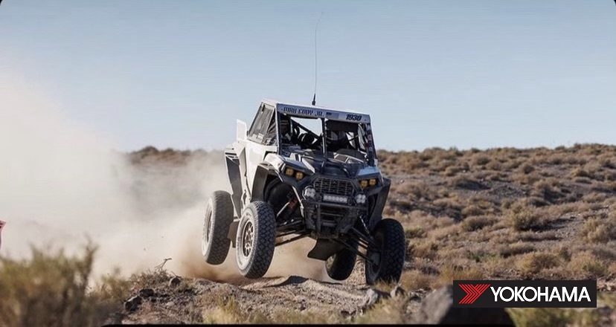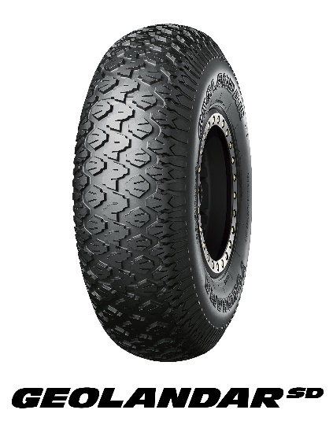
Max Eddy’s UTV racing to victory in the UTV N/A Pro class

