22nd February 2023

YOKOHAMA GEOLANDAR-equipped vehicle wins King of the Hammers, a U.S. offroad race

YOKOHAMA is pleased to announce that a vehicle equipped with its GEOLANDAR off-road tyres for SUVs and pickup trucks finished first in the King of the Hammers off-road race held in California during February 4th–11th.

The winning vehicle in the event’s 4900 Can-Am UTV race was driven by Kyle Chaney. In addition to the 4900 Can-Am Pro Stock Turbo UTV class in which Chaney was entered, the King of the Hammers’ 4900 Can-Am UTV race has multiple classes combined and features vehicles from several 4900 Can-Am classes. In addition to winning his class, Chaney finished first among all classes competing in the 4900 Can-Am UTV race. In his post-race interview, Chaney commented that “While other competitors suffered punctures and sidewall tears, we had no flats the entire race. We are confident in the performance and durability of the GEOLANDAR in any conditions.” In another event race, the 4WP Every Man Challenge, Duane Garretson finished third in his 4500 Yukon Gear and Axle Modified class vehicle running on GEOLANDAR tyres.

The King of the Hammers, which is the season opener for the year-long Ultra4 National Series racing tour, combines desert racing and rock crawling, and is considered the one of the toughest off-road races in the world. At this year’s King of the Hammers, YOKOHAMA supplied its GEOLANDAR tyres to more than 30 vehicles. The tyres supplied included the GEOLANDAR M/T G003 mud terrain tyres including race-versions, and its GEOLANDAR SD off-road racing tyre sold in overseas markets.

YOKOHAMA’s GEOLANDAR tyres have delivered their superior off-road performance in many races over the years, including capturing the overall championship in the Asia Cross Country Rally 2022, Asia’s largest cross-country rally, as well as class championships at the 35th SCORE SAN FELIPE 250 held in Mexico and the 2022 Method Race Wheels “Casey Folks” Vegas to Reno, part of the 2022 Best In The Desert series, the ultimate off-road racing series in North America.

Under YOKOHAMA’s three-year (2021–2023) medium-term management plan, Yokohama Transformation 2023 (YX2023), the consumer tyre business aims to maximize the sales ratios of high-value-added YOKOHAMA tyres, namely the global flagship ADVAN brand, the GEOLANDAR brand of tyres for SUVs and pick-up trucks, and various winter tyres. YX2023 also positions participation in motorsports activities as crucial to the company’s effort to develop new tyre technologies that will further strengthen the ADVAN and GEOLANDAR brands. YOKOHAMA therefore is again participating in a wide variety of motorsports events in Japan and around the globe, from top-category to grassroots events.

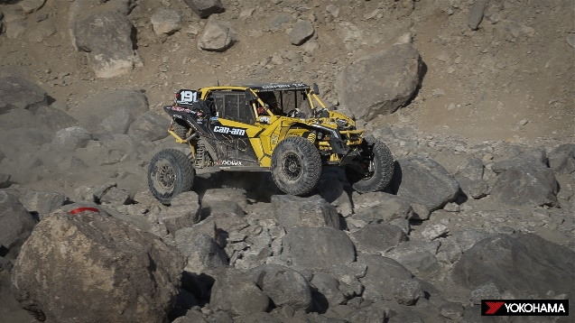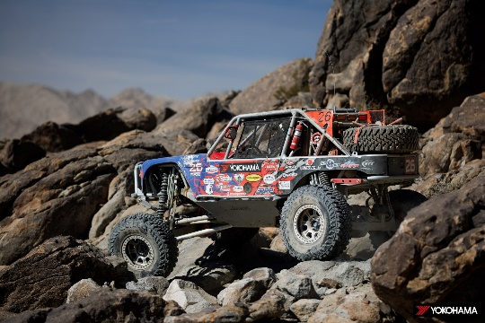
GEOLANDAR SD equipped UTV driven by Kyle Chaney GEOLANDAR M/T G003 equipped vehicle
driven by Duane Garretson

