7th March 2024
YOKOHAMA GEOLANDAR-equipped vehicles to participate in The Mint 400 off-road race in US
YOKOHAMA announced today that vehicles fitted with its GEOLANDAR tyres for SUVs and pick-up trucks will be participating in The Mint 400, an off-road race to be held in Nevada, USA, from 6th to 10th March 2024. YOKOHAMA is supplying its GEOLANDAR M/T G003 mud-terrain tyres and a special off-road race version of the GEOLANDAR M/T G003 that features a sustainable material content and still provides the performance needed to win gruelling off-road races.
The Mint 400 is the oldest off-road race in America. Annually some 400 teams from around the world come to Nevada to race over a treacherous 400-mile (about 644km) hilly desert course outside Las Vegas. This year, YOKOHAMA is supplying its GEOLANDAR tyres to more than 25 vehicles competing in 10 classes, with supported drivers including Jonathan Brenthel, the his class series champion in the 2023 Best in the Desert, the largest off-road racing series in North America, his brother Jordan Brenthel, and Ikuo Hanawa, who finished second in his class at the 2022 Mint 400.
GEOLANDAR M/T G003 tyres deliver superior performance on the full range of off-road surfaces over an exceptionally long lifespan. In addition, the special off-road race version based on the GEOLANDAR M/T G003 delivers dramatically increased driving performance and durability while having a 42% sustainable raw material content that includes the use of renewable materials in the tread compound, zinc oxide, inner liners. This special tyre is being supplied to three veteran off-road race drivers, including Jonathan Brenthel, who will be competing in the Unlimited Truck (4WD) class, and brother Jordan Brenthel, competing in the Unlimited Truck SPEC class. YOKOHAMA’s GEOLANDAR tyres have demonstrated superior off-road performance in many races in recent years, including first-place finishes in three classes at the King of the Hammers race held in California from 28th January to 3rd February. King of the Hammers is widely considered to be one of the toughest off-road races in the world.
The consumer tyre strategy in YOKOHAMA’s new three-year (2024–2026) medium-term management plan, Yokohama Transformation 2026 (YX2026), aims to maximize the sales ratios of high-value-added tyres by expanding sales of YOKOHAMA’s global flagship ADVAN brand, the GEOLANDAR brand of tyres for SUVs and pick-up trucks, winter tyres, and 18-inch and larger tyres. YOKOHAMA positions participation in motorsports activities as crucial to its effort to further strengthen the ADVAN and GEOLANDAR brands. YOKOHAMA therefore is again participating in a wide variety of motorsports events around the globe, from top-category to grassroots events.

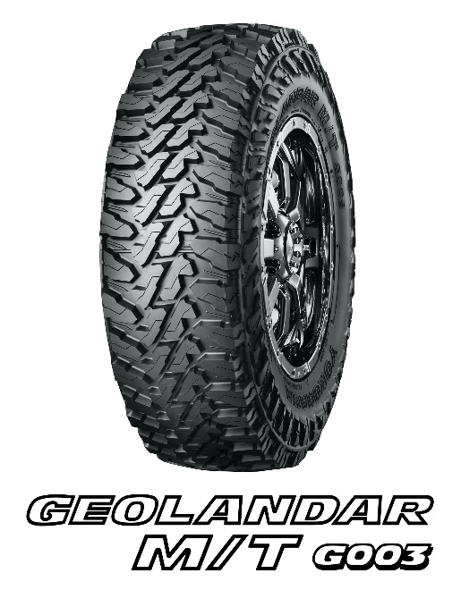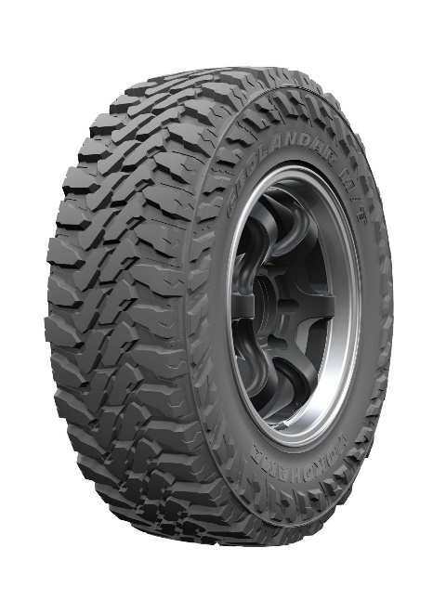
Off-road racing tyre based on GEOLANDAR M/T G003

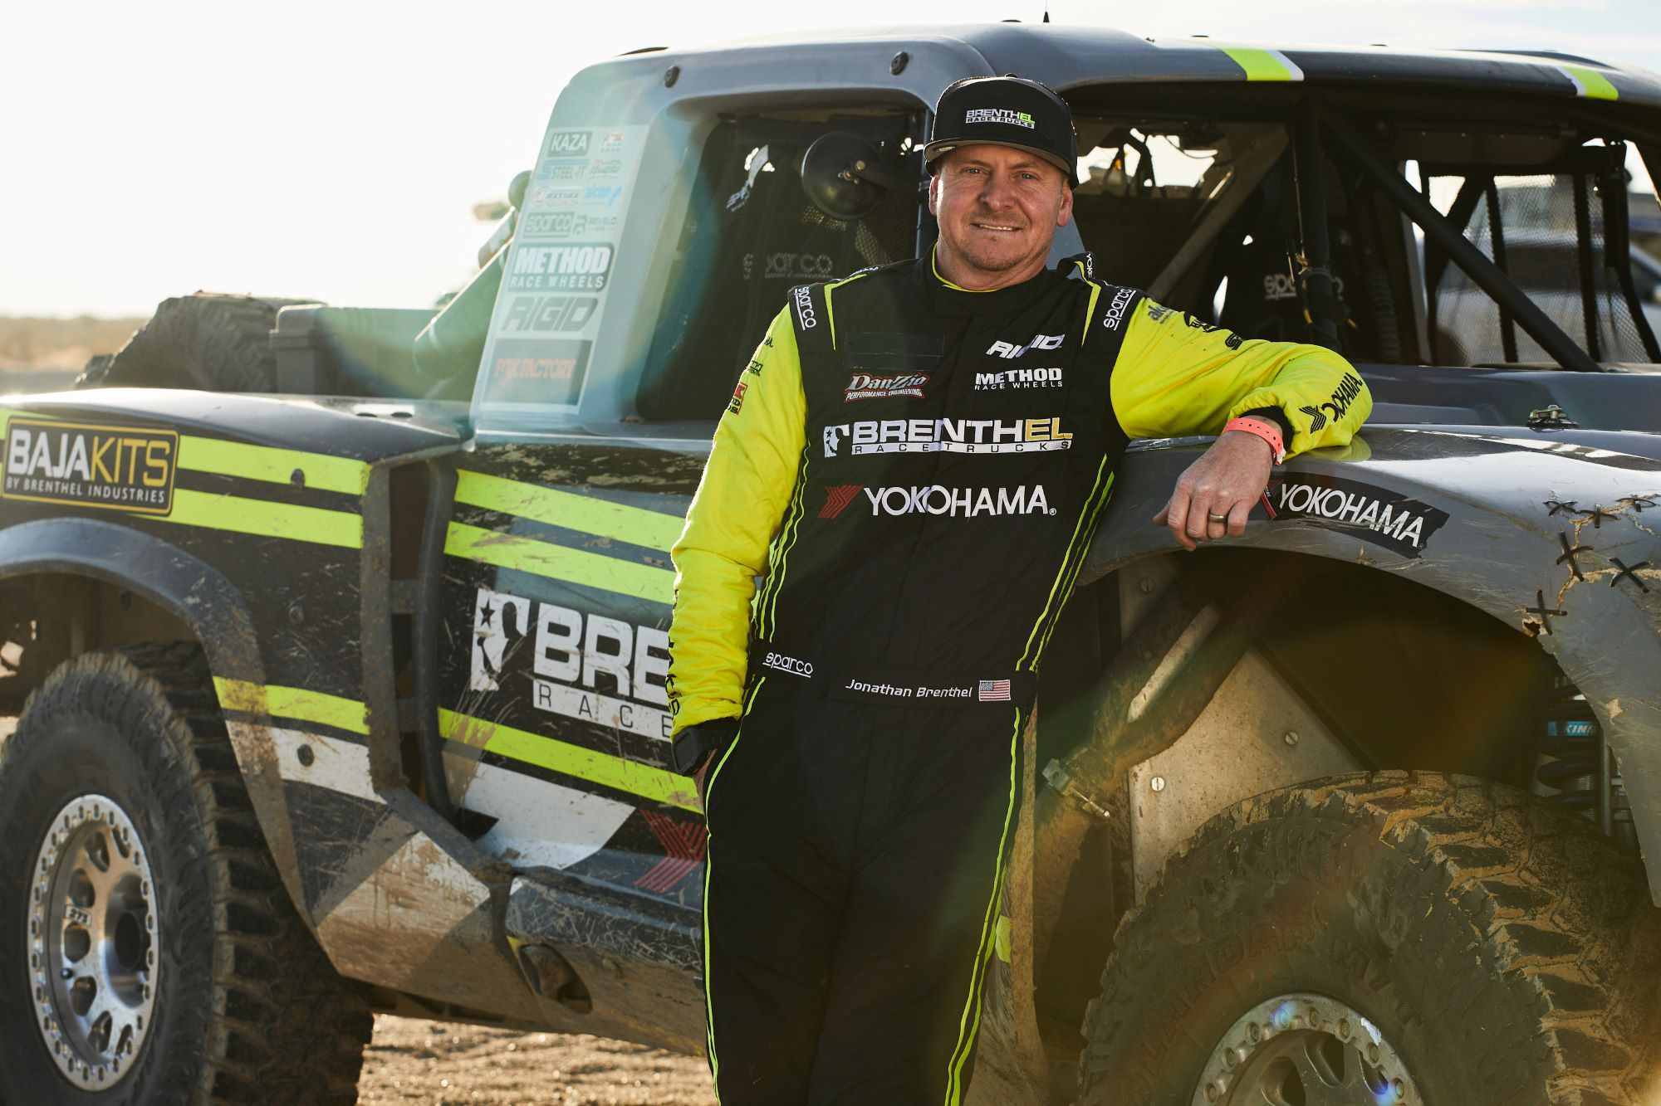
Jonathan Brenthel will be competing in the Unlimited Truck (4WD) class

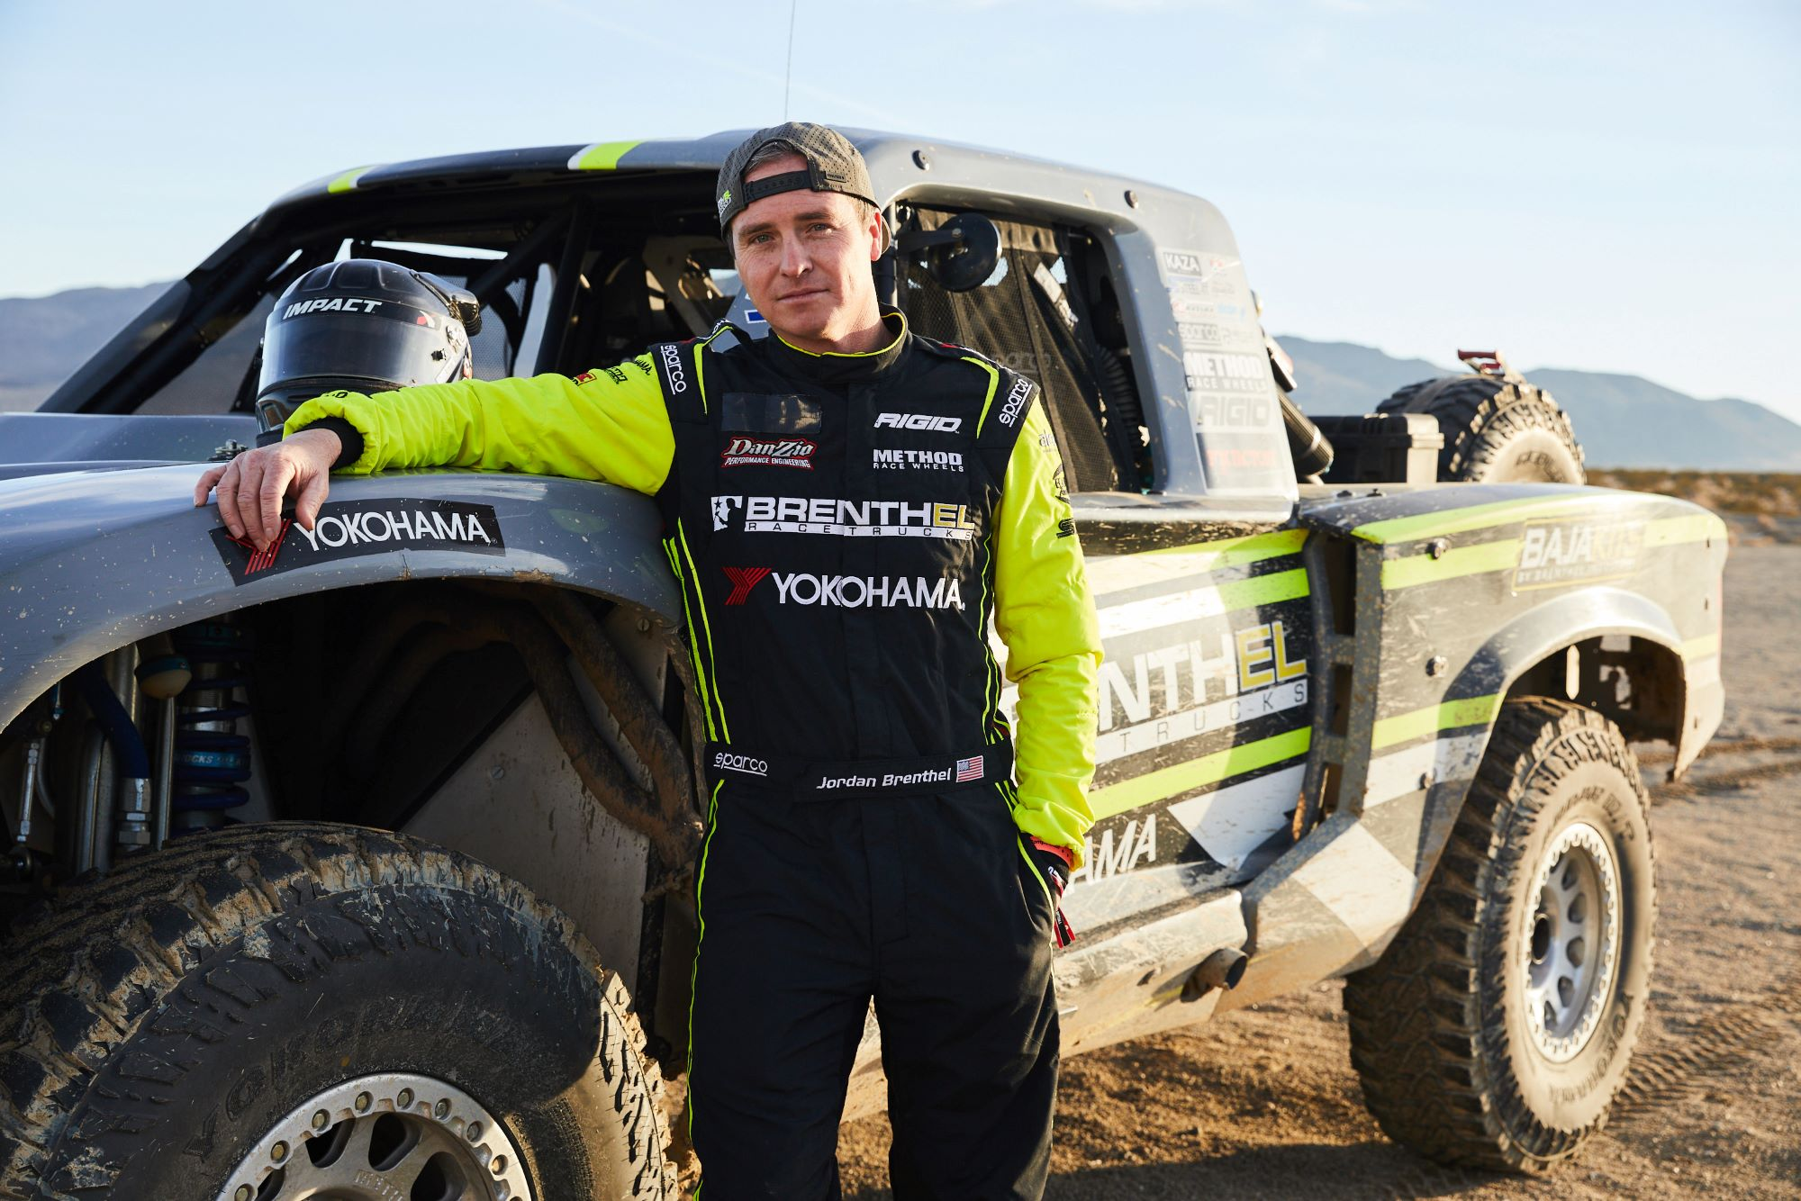Jordan Brenthel will be competing in the Unlimited Truck SPEC class
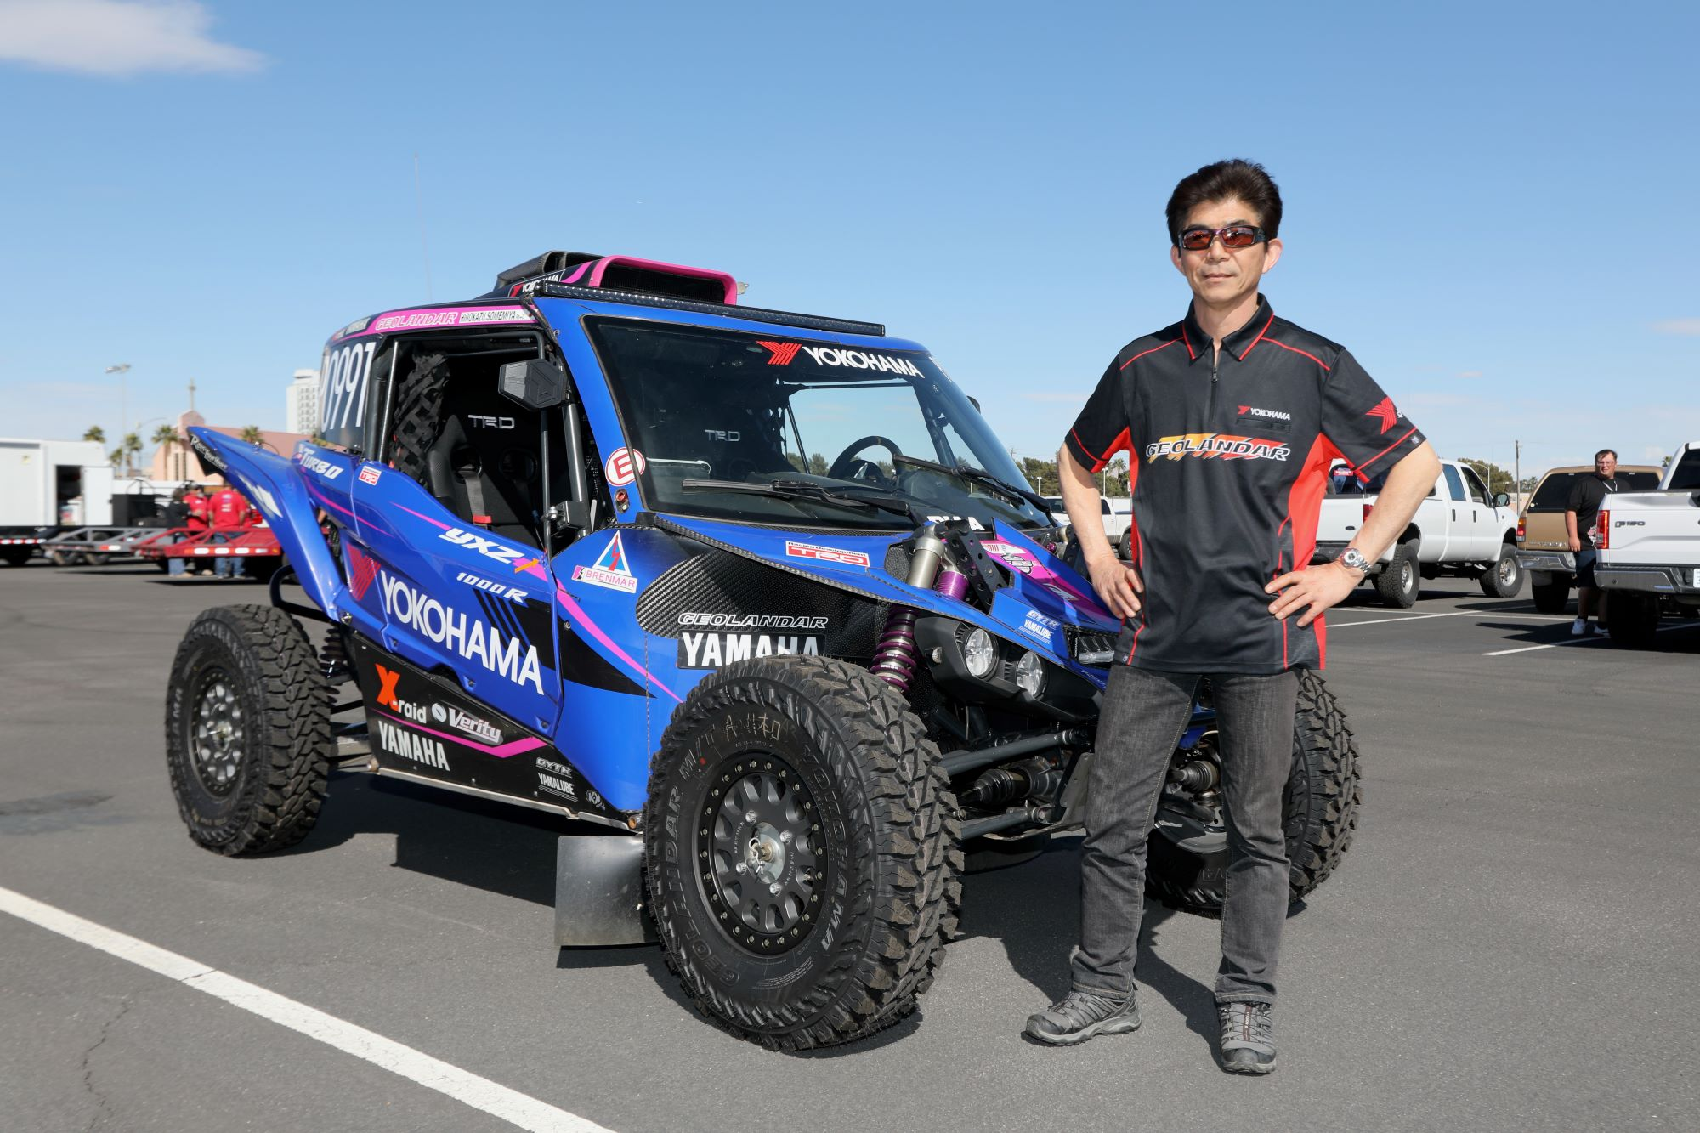Ikuo Hanawa will be competing in the UTV Pro Open class

