31st October 2023

YOKOHAMA US subsidiary to supply control tyre for Porsche Carrera Cup North America

YOKOHAMA announced today that its US subsidiary Yokohama Tire Corporation (YTC) has been named the new Premier Partner of the Porsche Carrera Cup North America in 2024 and will supply ADVAN racing tyres as the control tyre for all series races to be held in the United States and Canada. YTC will supply ADVAN A005 tyres for dry conditions and ADVAN A006 tyres for wet conditions.

The Porsche Carrera Cup North America is the top tier Porsche one-make racing series in North America and part of the global Porsche Carrera Cup that is widely considered the world’s fastest one-make racing series. In 2024, the Porsche Carrera Cup North America will feature 16 races at eight different circuits in the United States and Canada, with professional and amateur drivers competing in Porsche 911 GT3 Cup (Type 992) race cars with specs based on Porsche’s 911 Carrera (Type 992). YTC also will be supplying control tyres for the 2024 Porsche Sprint Challenge North America by Yokohama and Porsche Sprint Challenge USA West by Yokohama.

Under YOKOHAMA’s three-year (2021–2023) medium-term management plan, Yokohama Transformation 2023 (YX2023), the consumer tyre business aims to maximize the sales ratios of high-value-added YOKOHAMA tyres, namely the global flagship ADVAN brand, the GEOLANDAR brand of tyres for SUVs and pick-up trucks, and various winter tyres. YX2023 also positions participation in motorsports activities as crucial to the company’s effort to develop new tyre technologies that will further strengthen the ADVAN and GEOLANDAR brands. YOKOHAMA therefore is again participating in a wide variety of motorsports events in Japan and around the globe, from top-category to grassroots events.

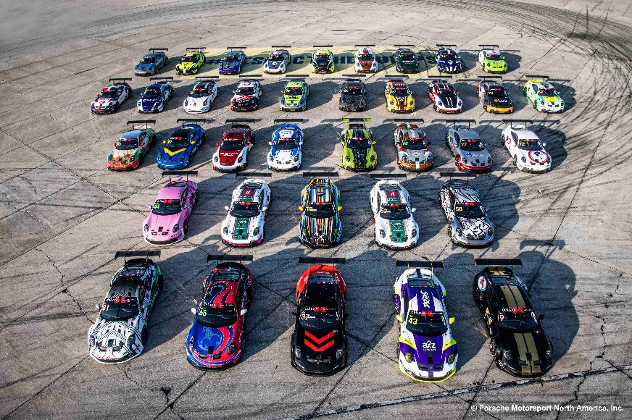
911 GT3 Cup (Type 992) race cars competing in the Porsche Carrera Cup North America

