21st February 2024

**YOKOHAMA and Interpneu renew strategic partnership**

***The strategic collaboration between Yokohama Commercial Vehicle Tyres and the Pneuhage Group, which began in 2019, will continue in 2024.***

Both parties see a new cooperation agreement as the best opportunity to further expand product sales and market penetration. The continuation of the cooperation that has now been agreed builds on the consistently positive experiences of the past five years.

Dirk Eschenburg, Head of TBR Sales Yokohama Europe, commented on the signing of the contract: "Our intention is to continue to invest in strengthening and expanding our brand in Germany in addition to our proven product quality. It fills us with enthusiasm that we can do this together with an experienced and strong strategic sales partner in order to further consolidate the positioning we have achieved in the future." Christoph Freudenthaler, Sales Director at Yokohama Europe, added: "Our customers will also continue to benefit from this collaboration. Increasing demand will enable us to open up new sales channels together and thus meet the needs of our customers even better."

Dirk Gleinser, Product Sales Manager Truck Tyres of the Pneuhage Group, emphasises: "The continuation of our sales cooperation for Yokohama truck tyres as a strategic partnership not only underlines our shared vision of the brand. We see the co-operation to date as a pioneering innovation for both sides. For example, we and our customers have developed great confidence in the product quality. I personally and our team are delighted to be able to further expand our success together in this way."

The strategic cooperation is intended to promote the brand, which has been successfully positioned with Pneuhage/Interpneu customers in particular, in the future. Among other things, a support point dealer concept for Yokohama commercial vehicle tyres was successfully established via the sales partner systems of the Reifen1+ and First Stop group of companies. This also includes high-profile marketing campaigns such as the show truck of Reifen1+ partner Stegmaier, which attracted a great deal of interest at NUFAM. In principle, other Interpneu customers should also be able to become authorised dealers in the future.

According to Dirk Gleinser, the wide range of products for the transport and fleet sector will continue to be available within 24/48 hours from Interpneu's central warehouse in Hainichen. Orders can be placed via the toll-free online store or Interpneu's Commercial Tires Service Centre.

Ein Bild, das Kleidung, Gebäude, Mann, draußen enthält.

*On 20 February 2024, the new contract for the strategic partnership was signed in Interpneu's truck tyre warehouse in Hainichen. Christoph Freudenthaler (Sales Director Yokohama Europe), Dirk Eschenburg (Head of TBR Sales Yokohama Europe), Robin Brucke (Head of Product Group Management Commercial Pneuhage Group) and Dirk Gleinser (Product Sales Manager Truck Tyres Pneuhage Group)*

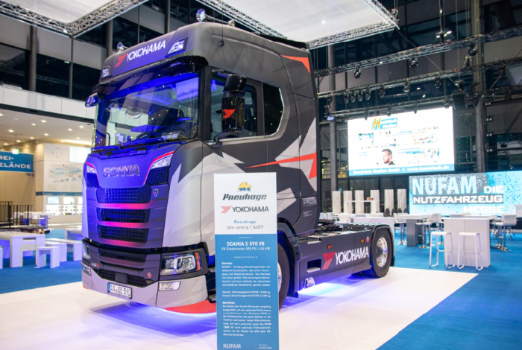

*NUFAM trade fair photo: The trade fair appearance of the Yokohama truck of the supporting dealer Stegmaier at NUFAM 2023, organised by Pneuhage as an exhibitor, attracted a great deal of attention*