9th December 2021

YOKOHAMA announces launch of new high-performance street sports tyre ADVAN NEOVA AD09

Today YOKOHAMA announced the launch of a new street sports tyre, the ADVAN NEOVA AD09, with sales beginning in Japan in February 2022 and gradually being expanded to Asia and North America. The tyre will initially be available in 20 sizes, ranging from 275/30R20 97W XL to 165/55R15 75V, suitable for use on sports cars and the world’s most prestigious premium cars. Another 60 sizes, including 21-inch tyres, will be added to the size line-up by the end of 2022.

ADVAN is the YOKOHAMA tyre global flagship brand. Its line-up of outstanding, high-performance tyres and their use as OE on many of the world’s leading premium cars as well as in motorsports events around the world have raised global recognition of the YOKOHAMA tyre brand. The ADVAN NEOVA series has its roots in motorsports and circuit racing. Designed to be the strongest ADVAN street tyre, ADVAN NEOVA tyres incorporate the latest racing technologies cultivated in YOKOHAMA’s various motorsports activities and have become immensely popular with many users who love driving, including those who like to customize their cars.

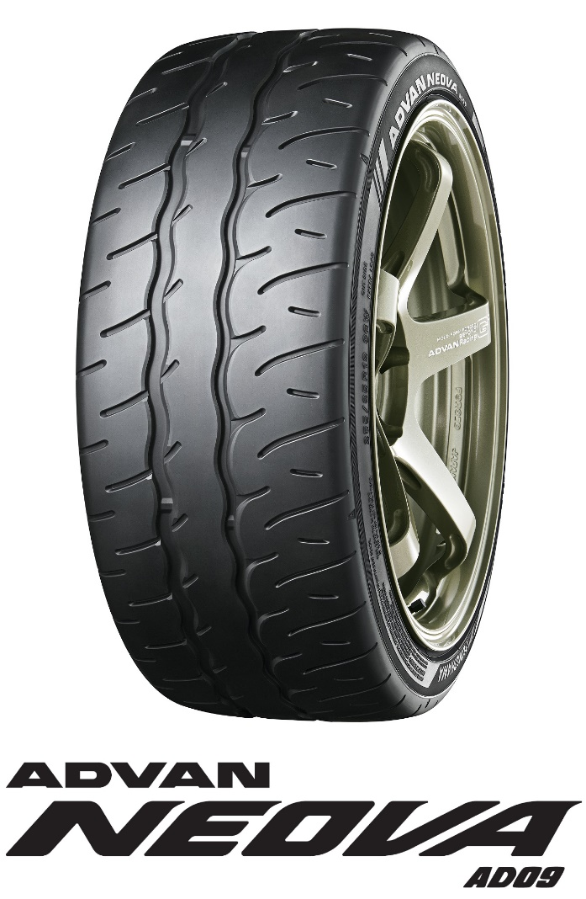

The ADVAN NEOVA AD09 is the first all-new NEOVA tyre since the introduction of ADVAN NEOVA AD08R nine years earlier in 2013. Maintaining the special performance characteristics that make ADVAN NEOVA series’ tyres the “fastest and most enjoyable” street sports tyres, the new ADVAN NEOVA AD09 features enhanced dry grip performance, control performance, and wear resistance appropriate for YOKOHAMA’s strongest street sports tyre. Featuring a new structure with a meticulous design that starts from the materials used and a new profile that delivers greater strength and agility, the ADVAN NEOVA AD09 achieves the highest level of casing rigidity* in YOKOHAMA history. In addition to a finely optimized asymmetric tread pattern, the ADVAN NEOVA AD09 is made from a newly developed compound that achieves an ideally balanced viscoelasticity. As a result, in addition to a dry grip performance that contributes to faster lap times, the tyre provides the controllability that enables amateur drivers to drive as fast as they can while also realizing a wear resistance that enables long-lasting performance on circuit racing conditions. In addition to a unique and highly refined pattern design that reflects YOKOHAMA’s uncompromising pursuit of a custom-tuned outer appearance combined with a high-contrast brand logo give the ADVAN NEOVA AD09 a modernized-look suitable for use on custom-tuned cars.
*Compared with the Company’s other summer replacement tyres.

Under YOKOHAMA’s three-year (2021–2023) medium-term management plan, Yokohama Transformation 2023 (YX2023), the consumer tyre business aims to maximize the sales ratios of high-value-added YOKOHAMA tyres, namely the global flagship ADVAN brand, the GEOLANDAR brand of tyres for SUVs and pick-up trucks, and various winter tyres. In 2022, the Company plans to strengthen sales of ADVAN brand summer tyres by launching the ADVAN NEOVA AD09, as well as its new global
flagship tyre, the ADVAN Sport V107.

Available Sizes
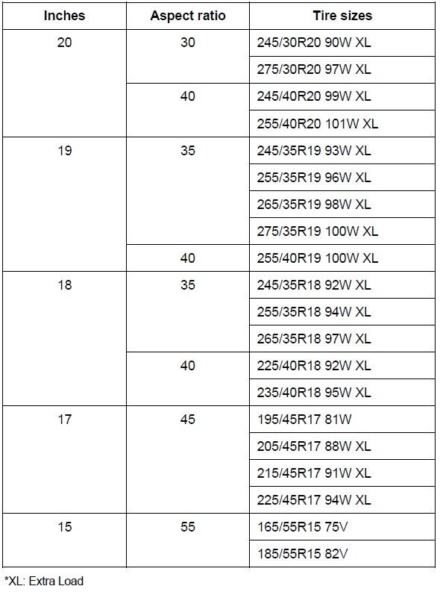

Meticulously designed new tread pattern & new profile
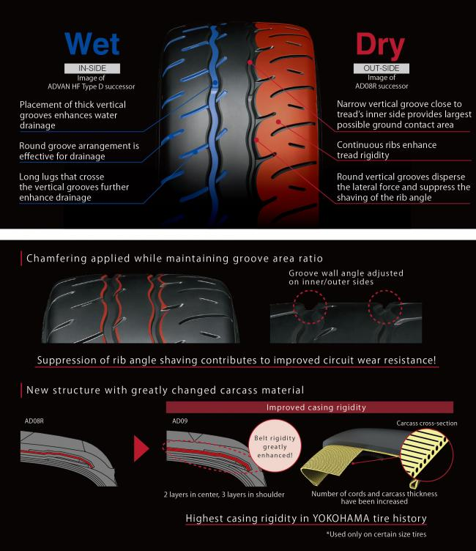

Modernized-looking side design
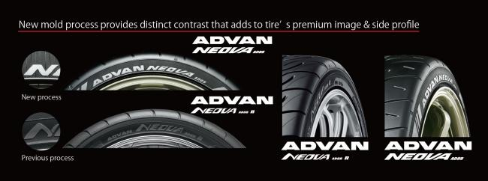

Performance data
