16th February 2024

YOKOHAMA announces new medium-term management plan, Yokohama Transformation 2026

YOKOHAMA today announces its new medium-term management plan, Yokohama Transformation 2026 (YX2026). The new plan will be implemented over the next three years, 2024-2026, as the successor to Yokohama Transformation 2023 (YX2023), which guided the Company over the past three years, 2021–2023.
Under YX2026, YOKOHAMA will further advance the “exploitation” of the strengths of its existing businesses and the “exploration” of new value and complete the transformation begun under YX2023 while being mindful to not leave any negative legacies for the next generation. Under this guiding philosophy, management will resolutely implement the growth strategies established in each business as it aims to achieve “Hockey Stick Growth” during YX2026 to fiscal 2027. Management’s targets for fiscal 2026, the final year of YX2026, are sales revenue of ¥1,150 billion, business profit of ¥130 billion, a business profit margin of 11%, and ROE of more than 10%.

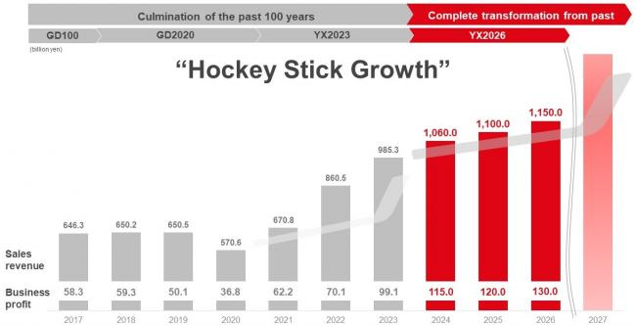

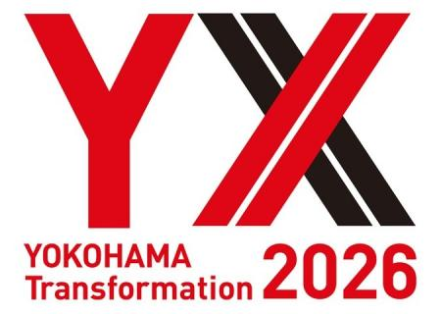

Review of YX2023

Under YX2023, YOKOHAMA strongly promoted its basic strategy of “exploitation” of the strengths of its existing businesses and the “exploration” of new value that will meet the needs of customers and society in an era of great change for the automotive industry across all the Company’s business domains. In addition to strengthening product development, production, and sales, the YOKOHAMA promoted acquisitions, business restructuring, and other measures to strengthen its competitive strengths in each of its markets. Most notably, the tyre business achieved a major transformation of its business structure by strengthening its highly-profitable off-highway tyre (OHT) business to bring its consumer tyre/ commercial tyre sales composition in line with the global tyre market ratio of 1:1, instead of the previous 3:2 ratio weighted toward consumer tyres. In addition, YOKOHAMA steadily implemented measures to enhance asset efficiency, including the sale of certain businesses and subsidiaries as well as cross-shareholdings and idle assets. The cash proceeds from these sales were channelled into strategic investments targeted at fuelling growth that would increase YOKOHAMA’s corporate value. As a result, during the three years of YX2023, YOKOHAMA achieved record high sales revenue and business profit every year, establishing a solid foundation for continued strong growth during the new medium-term management plan YX2026. In fiscal 2023, sales revenue totalled ¥985.3 billion, below the November 2023 upwardly revised target of ¥1 trillion but well above YX2023’s initial target of ¥700 billion. Business profit of ¥99.1 billion and a profit margin slightly above 10% are both all-time highs. In addition, cumulative cash flow from operations over the three years of YX2023 totalled ¥267.2 billion, well above the plan’s target.

Overview of YX2026

Financial targets for FY2026
Sales revenue: ¥1,150 billion
Business profit: ¥130 billion
Business profit margin: 11%
Equity ratio: 50% target
ROE: Above 10%
Operating cash flow: ¥385 billion (3 years cumulative）
Capital investment: Within scope of depreciation (excluding strategic investments)

Growth Strategies in Each Business
● Consumer Tyres
In the consumer tyre market, recent years have seen low-cost, low-price emerging tyre makers expand their production capacity and increase their market share. In response, during YX2026 YOKOHAMA will accelerate its efforts to maximize the sales ratio of its high-value-added tyres as it aims to increase the profitability of its consumer tyre business. In addition, the consumer tyre business has initiated the “1-year plant” challenge, which aims to bring new plants on line within one year and achieve the low cost and high efficiency needed to compete with the cost-competitiveness of emerging tyre makers and achieve “Hockey Stick Growth”. As part of its effort to maximize the sales ratio of high-value-added tyres and enhance brand value, the consumer tyre business will promote its tyres as original equipment (OE) for premium cars and continue its participation in motorsports events around the world. It also will continue its “Product and Regional Strategies” focused on strengthening the development, supply, and sales of tyres that respond to specific trends in each regional market.

● Commercial Tyres
[OHT business]
Current OHT global market size is about ¥4 trillion and is expected to grow 6% a year, considerably higher than the projected 2% annual growth for the consumer tyre market. Agriculture and forestry machinery is estimated to account for about 40% of the global OHT market. The Yokohama Rubber Group has the top share in this market segment and plans to strengthen its market position by implementing a multi-brand strategy that will leverage its production, sales, and technology strengths in all three tiers of this market segment. The Yokohama Rubber Group currently has the second largest share of the global market for industrial and port-use machinery, which is estimated to account for about 25% of the OHT market. During YX2026, the Group will further expand the global operation of its Interfit tyre maintenance service provided by highly specialized staff into new countries. As part of its effort to realize “Hockey Stick Growth,” YOKOHAMA will consider programmatic M&A as a measure to boost its as yet rather small shares in the global markets for construction and mining machinery and further strengthen its OHT business. In addition to further increasing OHT production capacity, the entire Yokohama Rubber Group will strengthen efforts to generate synergies made possible by the May 2023 acquisition of Trelleborg Wheel Systems (currently Yokohama-TWS=Y-TWS).

[TBR business]
Truck and bus tyres are another area where emerging tyre manufacturers are expanding production capacity and seek to increase their supply in markets around the world. However, this effort is being met by antidumping and countervailing duties in Europe and the United States. YOKOHAMA will aim for profitable growth by strengthening sales in countries and regions where these measures are supporting the maintenance of appropriate pricing .

● MB Business
During YX2023, the MB Business implemented business restructuring and profit-improvement measures that have established a new business platform that will generate strong revenues during YX2026. The hose & couplings business is positioned as a growth driver during YX2026 and will restructure its value chain and North American production network in order to fulfil that role. The industrial products business will solidify its leading share in Japan’s conveyor belt market and undertake internal reforms to establish a more stable high-profit structure in its marine hose operations. The MB Business as a whole aims to achieve a 10% business profit margin in fiscal 2026 and elevate its presence within the Yokohama Rubber Group.

● Technology & Production
During YX2026, YOKOHAMA will implement technology and production strategies based on a moto of “Low cost, speedy development of quality products” that will strengthen the entire Yokohama Rubber Group. “Quality products” refers to strengthening development of OE tyres suitable for the next-generation of premium cars. “Low cost” refers to efforts to drastically reduced costs that can’t be beat by other companies, and “Speedy” refers to the “1-year plant” challenge that is the centrepiece of the consumer tyre strategy aimed at achieving “Hockey Stick Growth” and its efforts to speed up tyre development.

● Sustainability
YOKOHAMA considers sustainability activities an important corporate activity that should contribute to the company’s growth. For that reason, management will give serious consideration to environment-related investments that also contribute to corporate earnings. One example is the new plan under YX2026 to reduce the Group’s 2019-level Scope 1 & 2 emissions of greenhouse gases by 30% by 2026 and 40% by 2030 while also reducing costs. Also, to reduce Scope 3 emissions, YOKOHAMA will promote greater use of sustainable materials and has targeted increasing its sustainable materials ratio to 28% in 2026 and 30% in 2030. However, during YX2026 it will consider raising the 2030 target to 40% without incurring any cost increases.

●Financial Strategy
During YX2026, YOKOHAMA will continue to aggressively pursue strategic investments aimed at realizing “Hockey Stick Growth” and enhancing corporate value. The Company also will continue unwinding cross-shareholdings as a measure to improve asset efficiency and will implement measures to create a capital structure with an optimal balance of debt and equity that fits its business structure (aiming for an equity ratio of 50%). To raise PER, management will conduct more IR events and endeavour to reduce the cost of capital and raise expected growth rate by increasing information disclosures and deepening dialogue with investors. Regarding capital allocation during YX2026, the plan is to allocate about ¥320 billion of the estimated three-year ¥450 billion increase in cash to strategic investments and investments in ongoing operations. Lastly, regarding shareholder returns, YOKOHAMA aims to stably and steadily raise its dividend in accordance with its basic policy of maintaining stable dividends while securing sufficient internal reserves to support its business development and fortify its financial position while continuing to actively invest in sustainable profit growth.

