20th March 2023

YOKOHAMA begins production and sales of HLC tyre

YOKOHAMA announced today that it has begun production and sales of HLC (high load capacity) tyres to meet the needs of heavy duty passenger cars such as EVs and hybrid cars with high capacity batteries, as well as large SUVs. Having been developed as the original equipment (OE) on new cars and for their repairs, YOKOHAMA will also develop products for the replacement market in line with market needs.

In response to the increase in the number of heavy duty passenger cars, for which conventional XL (extra load) standard^{*1} tyres have difficulty maintaining high load capacity and performance characteristics, HLC tyres were established as a new tyre size in the passenger car tyre category of ETRTO standards^{*2} with a higher load capacity than conventional XL tyres.

Comparing the load capacities of 275/35R23 size tyres, conventional XL tyres weigh 900 kg (load index 104), while HLC tyres weigh 1,000 kg (load index 108)*3. HLC tyres are indicated with "HL" at the beginning of their tyre size descriptions.

*1 higher air pressure and load capacity than standard specifications
*2 Tyre and rim standards established by the European Tyre and Rim Technical Organization
*3 Load capacity of each single wheel. Air pressure of each tyre is 290 kPa.

HLC tyre requires advanced technology to ensure quietness and handling stability while maintaining high load durability. Through repeated simulations of failures caused by high loads, YOKOHAMA has developed the dedicated profile for HLC tyres that achieves a balance between load durability and other performance characteristics, with less heat generation and strain under high loads than standard tyres.

YOKOHAMA is actively promoting the response to the electric vehicles and large SUVs, which have been increasing in recent years, and is developing tyres tailored to high load capacity and various other vehicle characteristics.

Under YOKOHAMA’s three-year (2021–2023) medium-term management plan, Yokohama Transformation 2023 (YX2023), the consumer tyre business aims to maximize the sales ratios of high-value-added YOKOHAMA tyres, namely the global flagship ADVAN brand, the GEOLANDAR brand of tyres for SUVs and pick-up trucks, and various winter tyres. One of the key initiatives under this strategy is expanding sales of ADVAN and GEOLANDAR tyres as original equipment on new cars.

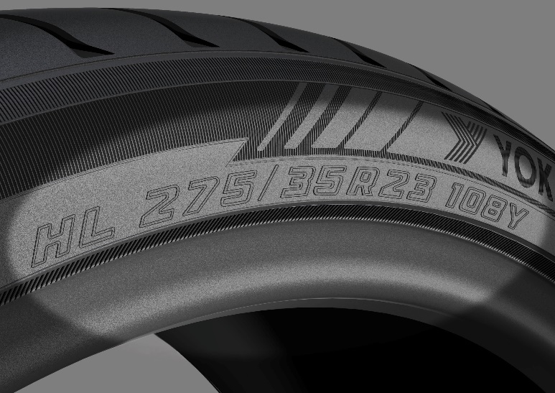
Size description of HLC tyres
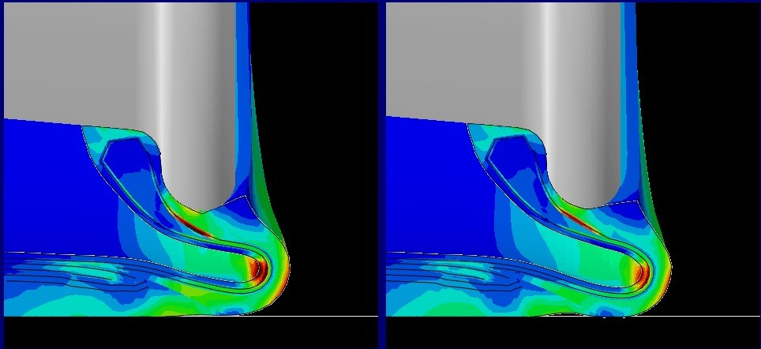
Comparison of heat generation and strain under load (left: standard tyre; right: HLC tyre)
HLC tyres generate less heat and strain and have higher load durability.
*To confirm the effects of dedicated profiles, simulations are done with larger loads than expected in actual use.

