22nd April 2022

YOKOHAMA developed technology that monitors tyre wear using sensing waveforms sent from a sensor inside the tyre

YOKOHAMA announced today that it has developed a technology that detects the wear condition of passenger car tyres by analysing sensing waveforms transmitted by a proprietary signal processing technology from a sensor attached to the tyre’s inner surface that is being jointly developed with Alps Alpine Co., Ltd.

This innovative technology uses these sensors to capture sensing waveforms of a rotating tyre’s changing shape and then applies a proprietary analysis method to distinguish between new and worn-out tyres. The technology enables timely notification to the car owner or a vehicle fleet manager of the need to rotate or replace worn tyres, enabling more optimal tyre maintenance that will promote safety while extending tyres’ useful lifespan and reducing their economic and environmental impact. As mobility services shift to self-driving vehicles, the opportunities for drivers and fleet managers to visually check tyre wear will become less frequent. The ability to remotely visualization a tyre’s condition via the cloud will contribute to safer and more sustainable mobility services.

The CASE*1 and MaaS*2 initiatives included in Yokohama Transformation 2023 (YX2023), YOKOHAMA’s medium-term management plan for fiscal years 2021–2023, include the promotion of a new tyre solutions service based on the development of a SensorTire (Internet of Things [IoT] tyre) with sensing functionality and stronger, more flexible service capabilities. In February 2021, YOKOHAMA announced its SensorTire Technology Vision, a medium- and long-term technological development vision for passenger car tyre sensors. The aim of this new vision is to provide continued support for the safe and sound movement of people while also addressing changes in mobility demand by seamlessly providing data obtained from IoT tyres fitted with sensing functionality to customers using the service, including drivers and passengers as well as operators of a diverse range of automobile-related services. To achieve the goals of this vision, YOKOHAMA is conducting practical testing with partners from various industries.

*1: An acronym for Connected, Autonomous, Shared & Services (short for car-sharing and related services, or in some cases sharing only), and Electric (for e-cars).
*2: Mobility as a Service. The provision through packaged search, reservation, payment, and other related functions of optimal combinations of public transport and other mobility services for addressing the mobility needs of residents and of travellers.

Image of a sensor attached inside a tyre (being developed with Alps Alpine)
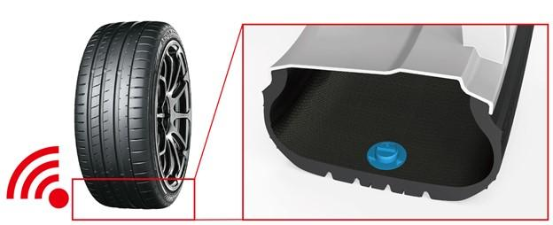

Sensing image generated by tyre sensor

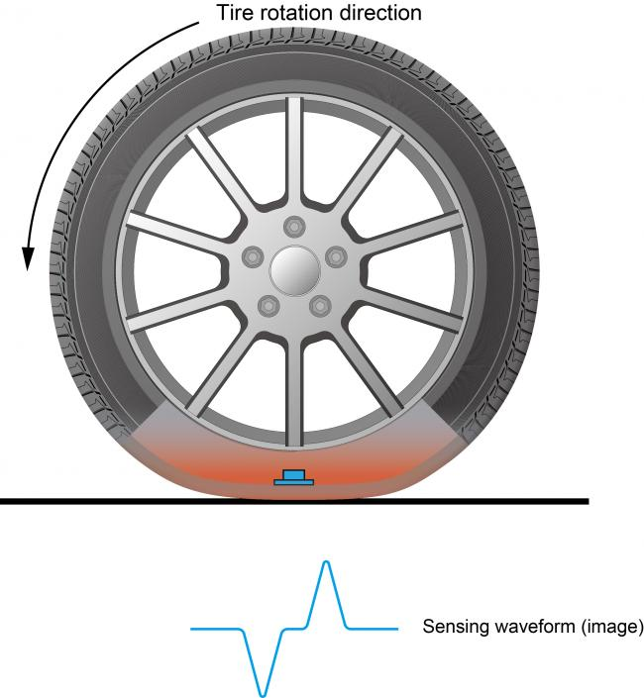

Image of service using Sensor Tyre Technology

