27th July 2023

YOKOHAMA expands fender portfolio

YOKOHAMA has added V-type solid fenders for harbour moorings to its product range, in addition to pneumatic fenders, which it has sold for many years. The company will continue to expand its line-up of solid fenders in phases, with the objective of becoming a comprehensive manufacturer of fenders.

Fenders are cushioning materials used to prevent damage to a vessel’s hull and to the quay by protecting it from the impact of berthing. They are mainly used when berthing between quays and vessels onshore, such as at harbour moorings, and offshore during ship-to-ship operations. The pneumatic fender absorbs shock through the elasticity of the encapsulated air, while the solid type absorbs shock through rubber elasticity. The solid fenders for onshore use, which will be added to the product line-up, account for approximately 80% of the demand for fenders. Since 1958, when YOKOHAMA developed the world’s first pneumatic fenders for offshore use, which were used for the offshore berthing of two vessels, the company has focused on pneumatic fenders, which are used in harsh offshore environments and require the highest performance requirements and specifications. In the future, YOKOHAMA will use the brands and technologies they have developed to enter the solid fender market, a key market for fenders, to further strengthen their revenue base.

The new model to be marketed is a basic model widely used in ports and harbours. The new model has been certified by the Specialists Center of Port and Airport Engineering (SCOPE). In the future, YOKOHAMA plans to develop a high-performance version of the solid fender with a buffer plate for use in cargo handling facilities at ports. The company will create a comprehensive product portfolio together with the ABF-P pneumatic fender, which is the top-end model currently on sale.

YOKOHAMA is currently implementing its Yokohama Transformation 2023 (YX2023) medium-term management plan for fiscal years 2021-2023. The plan calls for the MB Segment to concentrate its resources in its two strongest business domains—hose & couplings and industrial products - as it aims to become a growth driver capable of generating stable profits. As part of this effort, YOKOHAMA aims to maintain its high market share for fenders and other marine products, which are included among its industrial products, and is strengthening its product line-up.

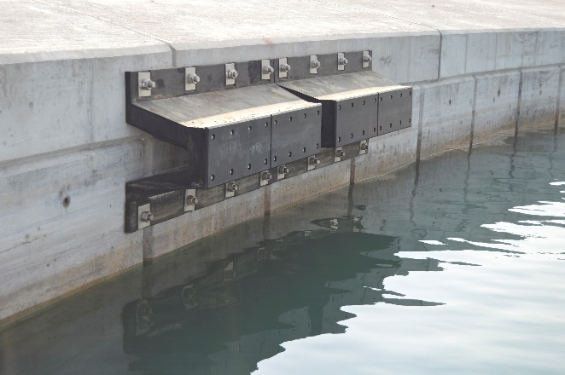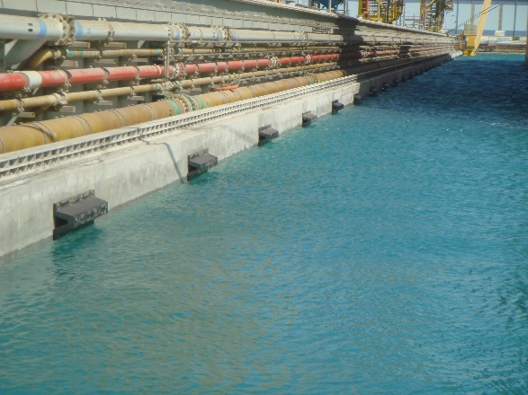
V-shaped solid fender installed on the quay wall

