21st July 2022

YOKOHAMA holds information exchange event with natural rubber supplier

YOKOHAMA and its Singapore subsidiary Yokohama Rubber Singapore Pte. Ltd., held a “Suppliers’ Day” for suppliers of natural rubber in this past May. The event was part of YOKOHAMA’s efforts to promote procurement of sustainable natural rubber, facilitating the exchange of information and establishing a common awareness of supply chain issues. The May 2022 event is the third “Suppliers’ Day” held by the company, following events in 2016 and 2018.

Owing to the continued risk of COVID-19 infections, this year’s event was held online and attended by 180 participants, including natural rubber producers and trading companies from seven countries including the two major natural rubber producing countries of Thailand and Indonesia. The participants came from 35 companies and representing 76 rubber processing factories. During the event, YOKOHAMA explained the environmental aspects of its ESG medium-to long-term goals as well as its new human rights policy implemented since this April. The company also asked participants for their cooperation in realizing specific initiatives based on YOKOHAMA’s “Procurement Policy for Sustainable Natural Rubber.” This event also featured a presentation by Yokohama Rubber President and Chairman Masataka Yamaishi in
which he expressed his deep appreciation of the participants’ attendance and awards presentation to suppliers that have made strong contributions supporting the procurement of natural rubber. In addition to deepening common understanding with suppliers, this event strengthened YOKOHAMA’s partnerships with them. A video message was received from Stefano Savi (Director) of Global Platform for Sustainable Natural Rubber (GPSNR) to congratulate YOKOHAMA and its subsidiary for holding the event.

As a founding member of GPSNR, YOKOHAMA revised its “Procurement Policy for Sustainable Natural Rubber” in September 2021 and strengthened its collaboration with GPSNR activities. The event is a concrete action that reflected YOKOHAMA’s principle of "Communication with Suppliers,” as set forth in the updated Procurement Policy. YOKOHAMA will continue implementing its initiatives in line with the action guidelines stipulated in this policy. YOKOHAMA also endeavours to achieve the Sustainable Development Goals (SDGs) adopted by the United Nations. As part of these efforts, the Yokohama Rubber Group is also promoting the procurement of sustainable raw materials.

The ESG initiatives included in Yokohama Transformation 2023 (YX2023), YOKOHAMA’s medium-term management plan for fiscal years 2021–2023, are based on the concept of “Caring for the Future.” By implementing ESG initiatives under this concept, YOKOHAMA strives to resolve social issues through its business activities.

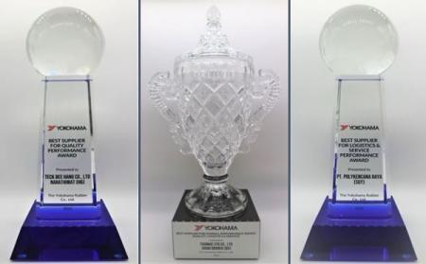
Awards given to Outstanding Suppliers

