7th August 2024

**YOKOHAMA holds information exchange event with natural rubber suppliers**

YOKOHAMA and its Singapore subsidiary Yokohama Rubber Singapore Pte. Ltd., held a “Suppliers’ Day” for suppliers of natural rubber in Singapore in this past July. The event was part of YOKOHAMA’s efforts to promote procurement of sustainable natural rubber, facilitating the exchange of information and establishing a common awareness of supply chain issues. The July 2024 event was the fourth “Suppliers’ Day” held by the company, following events in 2016, 2018, and 2022.

This was the first time for YOKOHAMA to resume a “Suppliers’ Day” in person since the last event took place six years ago in 2018. This year’s event was attended by 61 participants representing a total of 30 companies, including natural rubber producers and trading companies from eight countries - China, Guatemala, Indonesia, Côte d'Ivoire, the Philippines, Singapore, Thailand, and Vietnam. During the event, YOKOHAMA shared information with the suppliers and explained the details of the revision of its “Procurement Policy for Sustainable Natural Rubber” that it is conducting in accordance with a “materiality” (important issues) review as well as the impact of the Yokohama Rubber Group's sustainable procurement initiatives on natural rubber. Stefano Savi (Director) of Global Platform for Sustainable Natural Rubber (GPSNR) delivered a speech at the event in which he congratulated YOKOHAMA and its subsidiary for holding the event and described GPSNR’s activities. By featuring a video message from Yokohama Rubber Chairman & CEO, Chairman of the Board Masataka Yamaishi and President & COO Shinji Seimiya in which they expressed their appreciation of the participants’ attendance and an awards presentation to suppliers that have made strong contributions supporting the procurement of natural rubber, the event enabled YOKOHAMA to strengthen its partnerships with suppliers.

As a founding member of GPSNR, Yokohama Rubber formulated its “Procurement Policy for Sustainable Natural Rubber” in October 2018 and has reviewed it on a continuous basis to strengthen its collaboration with GPSNR activities. The event is a concrete action that reflects YOKOHAMA’s principle of "Communication with Suppliers” as set forth in the Procurement Policy. YOKOHAMA will continue implementing its initiatives in line with the action guidelines stipulated in this policy. YOKOHAMA also endeavours to achieve the Sustainable Development Goals (SDGs) adopted by the United Nations. As part of these efforts, the Yokohama Rubber Group is also promoting the procurement of sustainable raw materials.

Under the sustainability slogan “Caring for the Future”, YOKOHAMA is creating shared value by addressing social issues through its business activities.

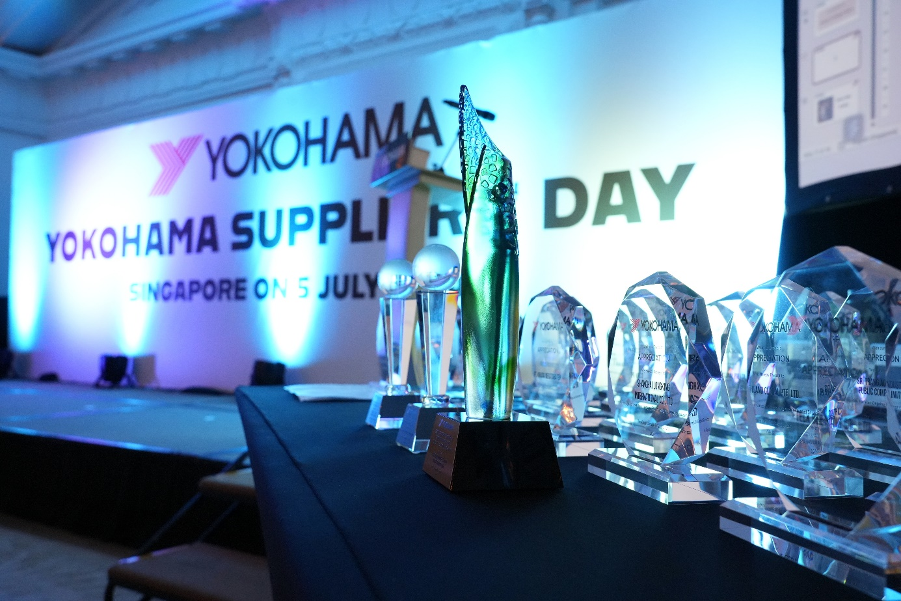*Awards given to Outstanding Suppliers*

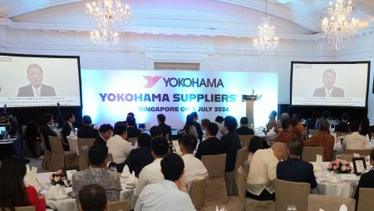

*Scene from the „Suppliers´ Day”*