19th February 2024

YOKOHAMA in CDP’s 2023 Climate Change A List
YOKOHAMA is proud to announced that it has once again been recognized for leadership in corporate sustainability by the global environmental non-profit CDP, which named YOKOHAMA to its prestigious A List for tackling climate change on 6th February. YOKOHAMA’s selection recognizes its efforts to cut emissions, mitigate climate risks, and develop the low-carbon economy, based on its responses to the CDP’s 2023 climate change questionnaire, which scored more than 21,000 companies worldwide. This is YOKOHAMA’s two-straight and fifth time on the A list.
CDP runs the world’s environmental disclosure system for companies, cities, states and regions. Founded in 2000, it has motivated companies to disclose their environmental impacts, and to reduce greenhouse gas emissions, safeguard water resources and protect forests. CDP scores are widely used to drive investment and procurement decisions towards a zero carbon, sustainable and resilient economy. In 2023, over 740 financial institutions with over US$136 trillion in assets requested companies to disclose data on environmental impacts, risks and opportunities through CDP’s platform. A record-breaking 23,000 companies responded.
Under the slogan for sustainability management “Caring for the Future”, YOKOHAMA is creating shared value by addressing social issues through its business activities.

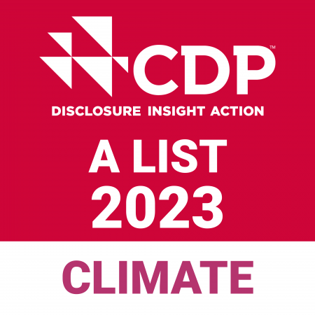
Logo mark indicating selection to the CDP A List

