17th February 2022

YOKOHAMA now supplying its ADVAN Sport V107 for leading German automotive manufacturer’s premium cars

YOKOHAMA announced today that it has begun delivering ADVAN Sport V107 tyres to BMW AG for use as original equipment (OE) on the German automaker’s BMW X5 M performance Sports Activity Vehicle (SAV) and its BMW X6 M performance Sports Activity Coupe (SAC), both of which are sold around the world. YOKOHAMA had been supplying its ADVAN Sport V105 as OE for the two models, but from now on it will supply the new ADVAN Sport V107. Both models are being fitted with 275/40R21 107Y size front tyres and 315/35R21 111Y size rear tyres.

The “ADVAN Sport V107” is a high-performance tyre in YOKOHAMA’s global flagship ADVAN brand. The tyres being supplied were co-developed by YOKOHAMA and BMW group. In addition to maintaining the ADVAN Sport V105’s optimal balance of high driving performance combined with superior comfort and safety characteristics, the newly developed ADVAN Sport V107 tyres also have received the EU labelling system’s highest "A" grade for wet performance. The tyre’s sidewall bears the German car manufacturer’s star mark indicating its recognition of the tyre manufacturer’s technology, quality and reliability, a recognition granted to the select few of the world’s tyre makers that supply OE tyres for BMW models.

Under YOKOHAMA's current medium-term management plan, Yokohama Transformation 2023 (YX2023), the consumer tyre business aims to maximize the sales ratios of high-value-added YOKOHAMA tyres, namely the global flagship ADVAN brand, the GEOLANDAR brand of tyres for SUVs and pick-up trucks, and various winter tyres. One of the key initiatives being implemented under this strategy is the expansion of ADVAN and GEOLANDAR tyres as original equipment on new cars.

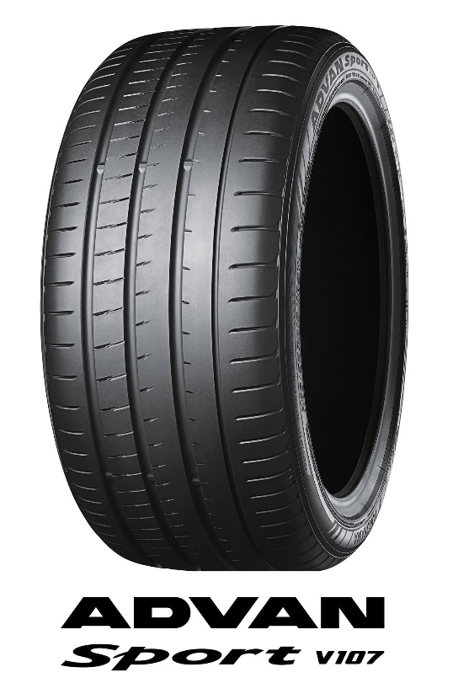
Tyre shown in photo differs in size from those installed on the BMW X5/X6 M performance

