3rd February 2023

YOKOHAMA participating in the King of the Hammers, a U.S. offroad race

YOKOHAMA announces that cars equipped with its GEOLANDAR off-road tyres for SUVs and pick-up trucks will be racing in the annual King of the Hammers off-road race being held in California during February 4-11. YOKOHAMA is supplying its mud-terrain GEOLANDAR M/T G003 tyre or a special race version based on that tyre to more than 30 teams.

The King of the Hammers, which is the season opener for the year-long Ultra4 National Series racing tour, combines desert racing and rock crawling, and is considered the one of the toughest off-road races in the world. YOKOHAMA is participating in all four-wheel class races held during the week-long event. Race-version GEOLANDAR M/T G003 tyres are being supplied to veteran Levi Shirley and father and son team Brian and Chayse Caprara competing in the Unlimited 4400 class. All other drivers are being supplied with production spec GEOLANDAR M/T G003 tyres for the replacement tyre market.

GEOLANDAR M/T G003 tyres deliver superior performance on the full range of off-road surfaces over an exceptionally long lifespan. In addition, the tyre features a sturdy and aggressive design that enhances the off-road driving sensation. YOKOHAMA’s GEOLANDAR tyres have delivered their superior off-road performance in many races over the years, including capturing the overall championship in the Asia Cross Country Rally 2022, Asia’s largest cross-country rally, as well as class championships at the 35th SCORE SAN FELIPE 250 held in Mexico and the 2022 Method Race Wheels “Casey Folks” Vegas to Reno, part of the 2022 Best In The Desert series, the ultimate off-road racing series in North America.

Under YOKOHAMA’s three-year (2021–2023) medium-term management plan, Yokohama Transformation 2023 (YX2023), the consumer tyre business aims to maximize the sales ratios of high-value-added YOKOHAMA tyres, namely the global flagship ADVAN brand, the GEOLANDAR brand of tyres for SUVs and pick-up trucks, and various winter tyres. YX2023 also positions participation in motorsports activities as crucial to the company’s effort to develop new tyre technologies that will further strengthen the ADVAN and GEOLANDAR brands. YOKOHAMA therefore is again participating in a wide variety of motorsports events in Japan and around the globe, from top-category to grassroots events.

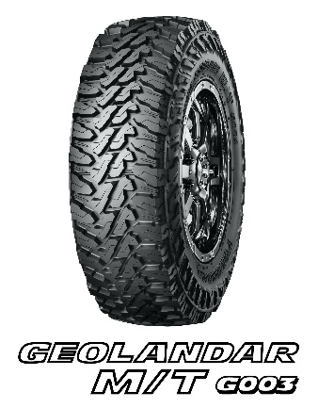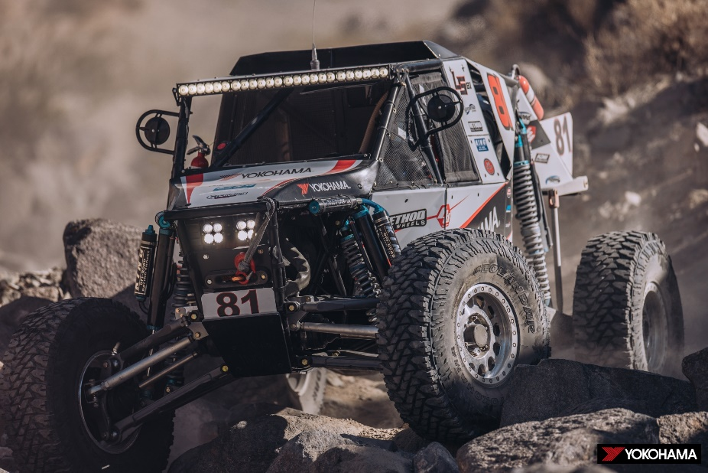
Levi Shirley’s four-wheeler competing in the Unlimited 4400 class

