13th March 2024
YOKOHAMA’s 2024 Motorsports Activity Plan
YOKOHAMA today announced its motorsports activity plan for 2024. The Company’s consumer tyre strategy aims to maximize the sales ratios of high-value-added YOKOHAMA tyre brands, namely the global flagship ADVAN brand, the GEOLANDAR brand of tyres for SUVs and pick-up trucks, and various winter tyres. YOKOHAMA positions participation in motorsports activities as crucial to its efforts to further strengthen the ADVAN and GEOLANDAR brands. The Company therefore is again participating in a wide variety of motorsports events around the globe, from top-category to grassroots events.
Continuing the ADVAN CHALLENGE launched in 2023 to maximize sales of ADVAN tyres, YOKOHAMA will again supply its ADVAN tyres to many teams participating in the world’s top-category motorsports events, such as Japan’s SUPER GT, the Nürburgring 24-Hour Race, and the Pikes Peak International Hill Climb, which feature lineups filled with the world’s strongest racing teams. YOKOHAMA aims to stand out amid this strong competition by winning even more races than in 2023. YOKOHAMA’s motorsports activities in 2024 also will continue its efforts to realize sustainable motorsports by developing tyres with a high sustainable materials content ratio and providing motorsports tyres made on a dedicated production line at its Mishima Plant, which is powered by 100% renewable energy. YOKOHAMA’s GEOLANDAR tyres will be supplied to teams participating in leading off-road races in North America and Asia, including the Baja 1000, King of the Hammers, the Mint 400, and the Asia Cross Country Rally. YOKOHAMA expects its GEOLANDAR tyres contribution to winning these challenging off-road races will raise recognition and enhance the reputation of the GEOLANDAR brand around the world.
Following is a list of the main events YOKOHAMA will be participating in this year. We will post event updates and results on YOKOHAMA’s dedicated motorsports website and on our official motorsports SNS sites.

GT/Touring Car Races
SUPER GT
Super GT races are contested in two classes, GT500 and GT300. GT500 is dominated by works teams from major automakers while GT300 teams tend to be more varied and individualistic. While all GT500 machines must meet certain specifications, GT300 races are open to a variety of cars made in Japan and overseas. GT300 machines can broadly be divided into three types: (1) car manufacturer´s production cars that meet the international FIA GT3 specifications, (2) Japan’s unique GTA-GT300 machines, and (3) the so-called “Mother Chassis" group of machines. In 2023, a YOKOHAMA-supported team was victorious in the GT500 class SUPER GT third round race, and YOKOHAMA-supported teams dominated the GT300 class, finishing first in four of the series’ eight races. This year, we look forward to more victories, with ADVAN racing tyres being supplied to two cars in the GT500 class and 15 cars in the GT300 class.
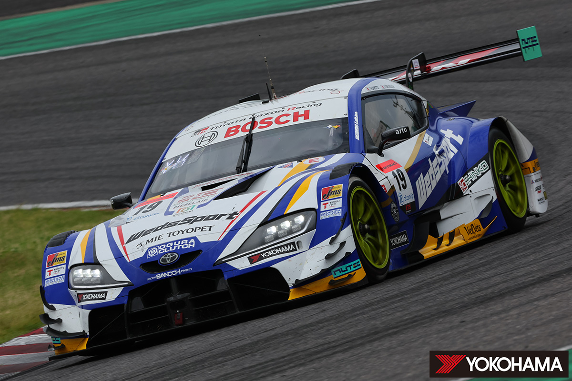<SUPER GT GT500 class> TGR TEAM WedsSport BANDOH WedsSport ADVAN GR Supra (2023)
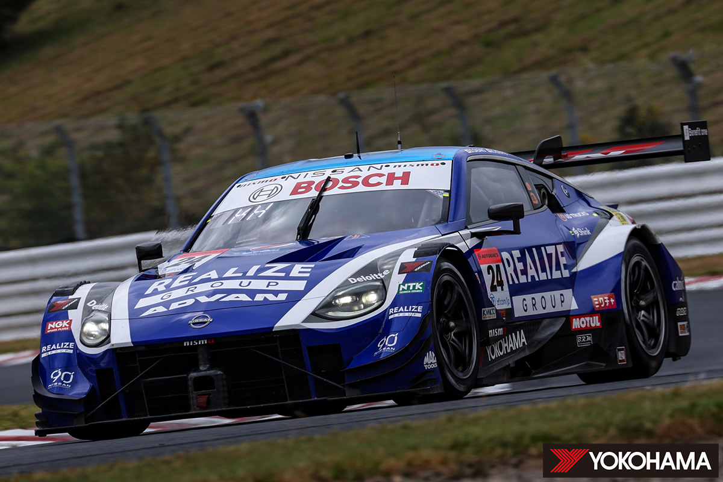<SUPER GT GT500 class> KONDO RACING REALIZE CORPORATION ADVAN Z (2023)

GT500 class teams being supported by YOKOHAMA in 2024
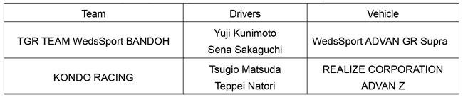

GT300 class teams being supported by YOKOHAMA in 2024
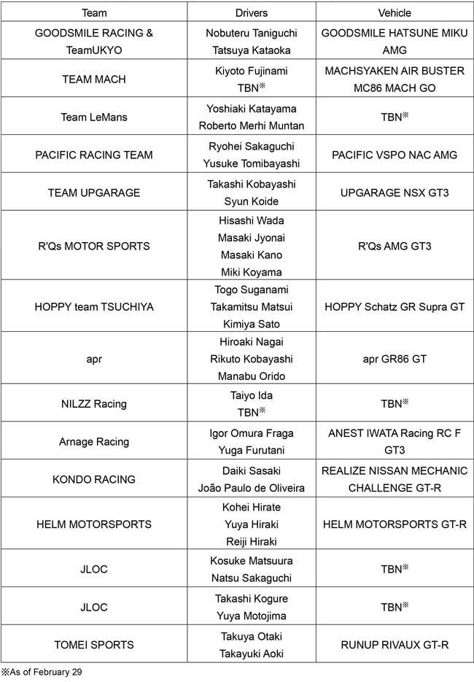

Nürburgring 24-Hour Race / Nürburgring Langstrecken Serie / Nürburgring Endurance Series
YOKOHAMA will be participating in this year’s Nürburgring 24-Hour Race (ADAC RAVENOL 24h Nürburgring) and aiming for victory by supplying ADVAN racing tyres to a prominent team competing in the top-level SP9 class. We also will supply tyres to leading teams competing in the SP9 class in the Nürburgring’s two endurance series, Nürburgring Langstrecken Serie（NLS）and the Nürburgring Endurance Series (NES). In last year’s NLS, an ADVAN equipped car captured the NLS Speed Trophy and the overall championship in the series’ ultimate SP9 Pro class.
Porsche Carrera Cup North America
Starting this year, YOKOHAMA will be supplying ADVAN racing tyres as the control tyre for the Porsche Carrera Cup North America, the top tier Porsche one-make racing series in North America and part of the global Porsche Carrera Cup series. YOKOHAMA will supply ADVAN A005 tyres for dry conditions and ADVAN A006 tyres for wet conditions. Porsche Carrera Cup North America races feature professional and amateur drivers competing in Porsche 911 GT3 Cup (Type 992) race cars with specs based on Porsche’s 911 Carrera (Type 992). YOKOHAMA will also supply control tyres for the Porsche Sprint Challenge North America by Yokohama and Porsche Sprint Challenge USA West by Yokohama. These two series are step-up category races for semi-pro drivers aiming to compete in the Porsche Carrera Cup.
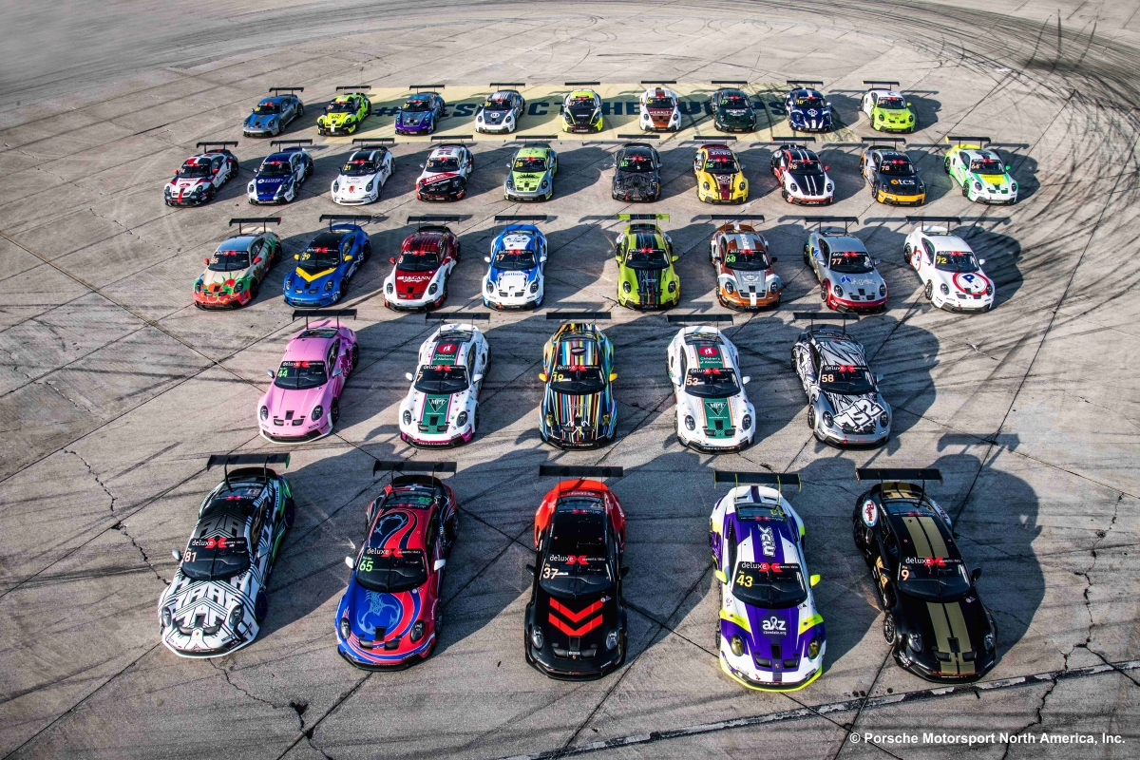911 GT3 Cup (Type 992) race cars participating in the Porsche Carrera Cup North America

Other GT and Touring Car Races

YOKOHAMA will again supply its ADVAN racing tyres to a number of other GT and touring car races held around the world, including the Toyota Gazoo Racing Motorsport races and Honda One Make Races in Thailand and the Inter Proto Series in Japan.
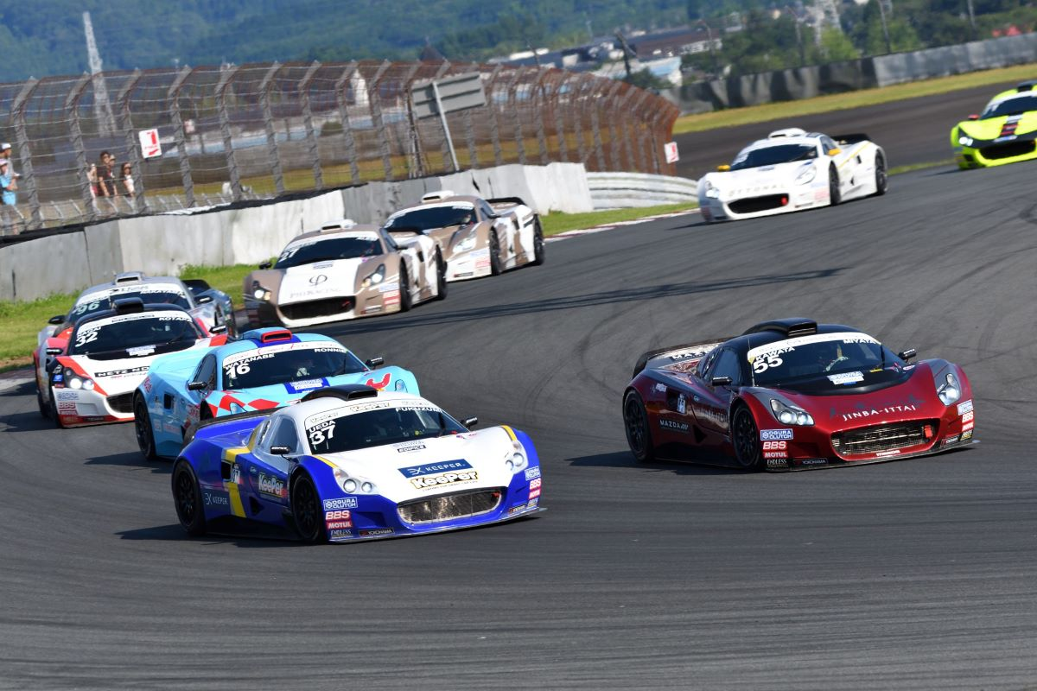Inter Proto Series (2023)
Formula Races
YOKOHAMA tyres have been the control tyres for the Japanese SUPER FORMULA Championship series since 2016. Last year, YOKOHAMA began supplying ADVAN A005 racing tyres for use in dry conditions that have a 33% sustainable material content ratio as the series’ control tyre. This season, we are increasing the use of sustainable materials by supplying a new version of our ADVAN A006 tyre for wet conditions that has a higher sustainable material content ratio. This activity is part of an effort to create a sustainable motorsports industry, and YOKOHAMA is continuing to advance its development of racing tyres that sustainable materials without compromising driving performance as part of a broader perspective to develop tyres suitable for a circular economy.
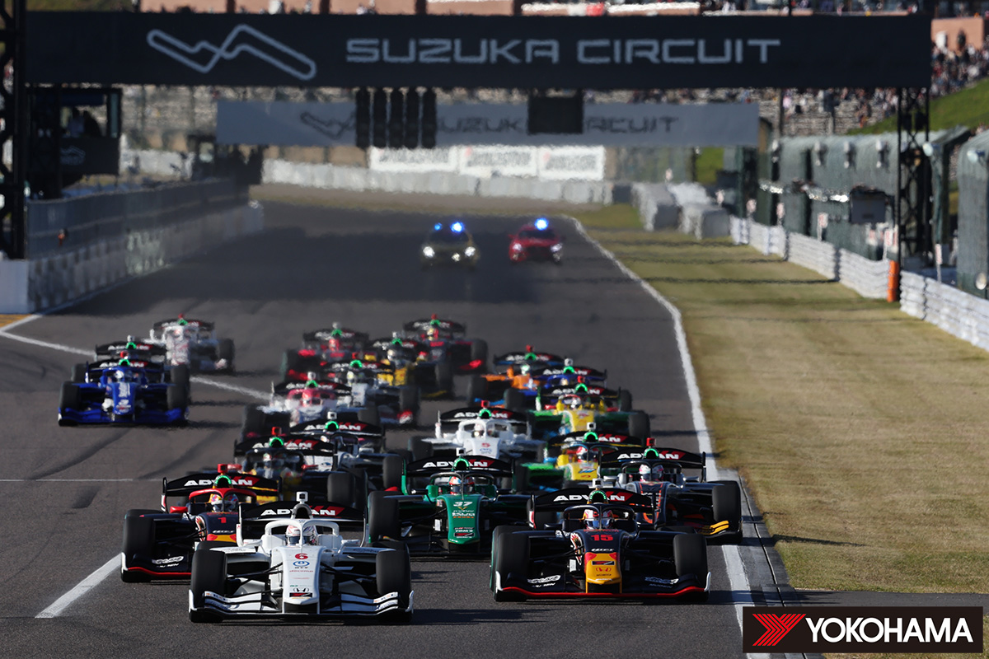Cars racing in a 2023 Japanese SUPER FORMULA Championship race
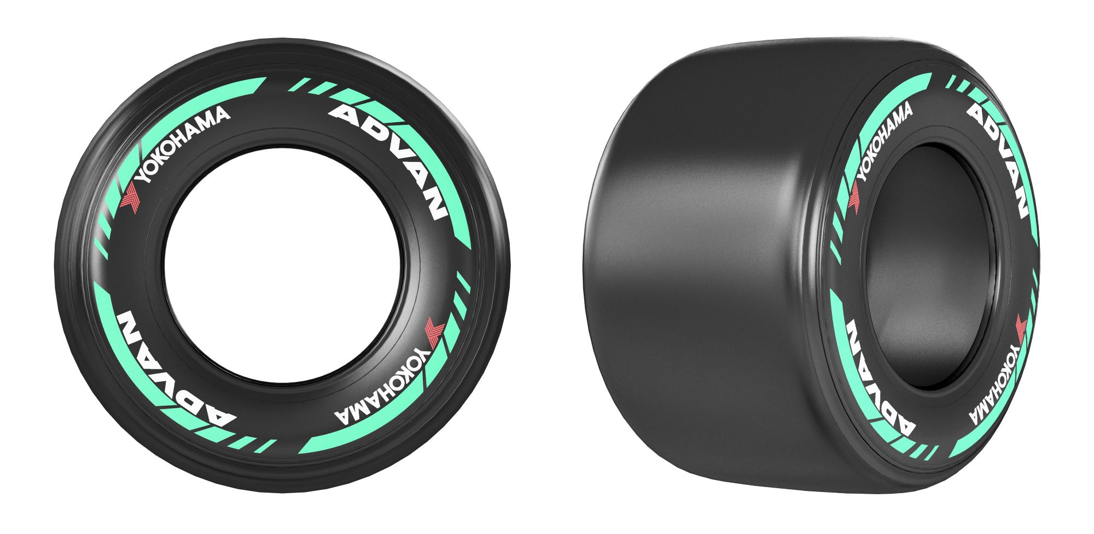ADVAN racing tyres made from sustainable materials

Hill Climbs

Pikes Peak International Hill Climb

YOKOHAMA will again participate in the Pikes Peak International Hill Climb in the United States. In 2023, a car equipped with ADVAN racing tyres won the overall championship for the second straight year, while other ADVAN equipped cars finished first in five classes. We will again supply ADVAN racing tyres to drivers competing in many classes and hope to achieve a third consecutive overall championship. In addition, we will again provide the control tyre for the Porsche Pikes Peak Trophy by Yokohama, a hill climb competition for Porsche Cayman GT4 Clubsport vehicles.

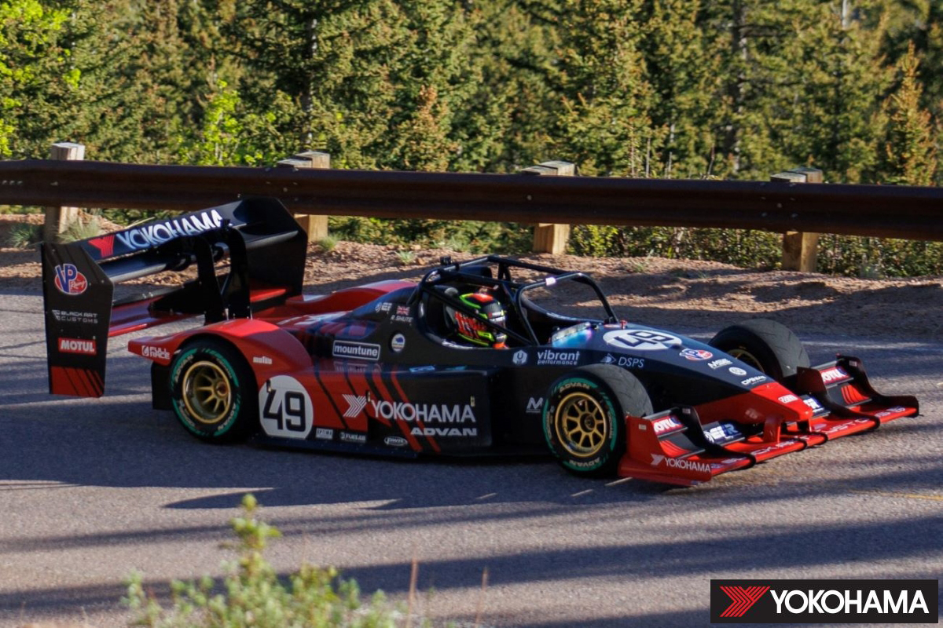
ADVAN equipped vehicle that won the overall championship at the 2023 Pikes Peak International Hill Climb

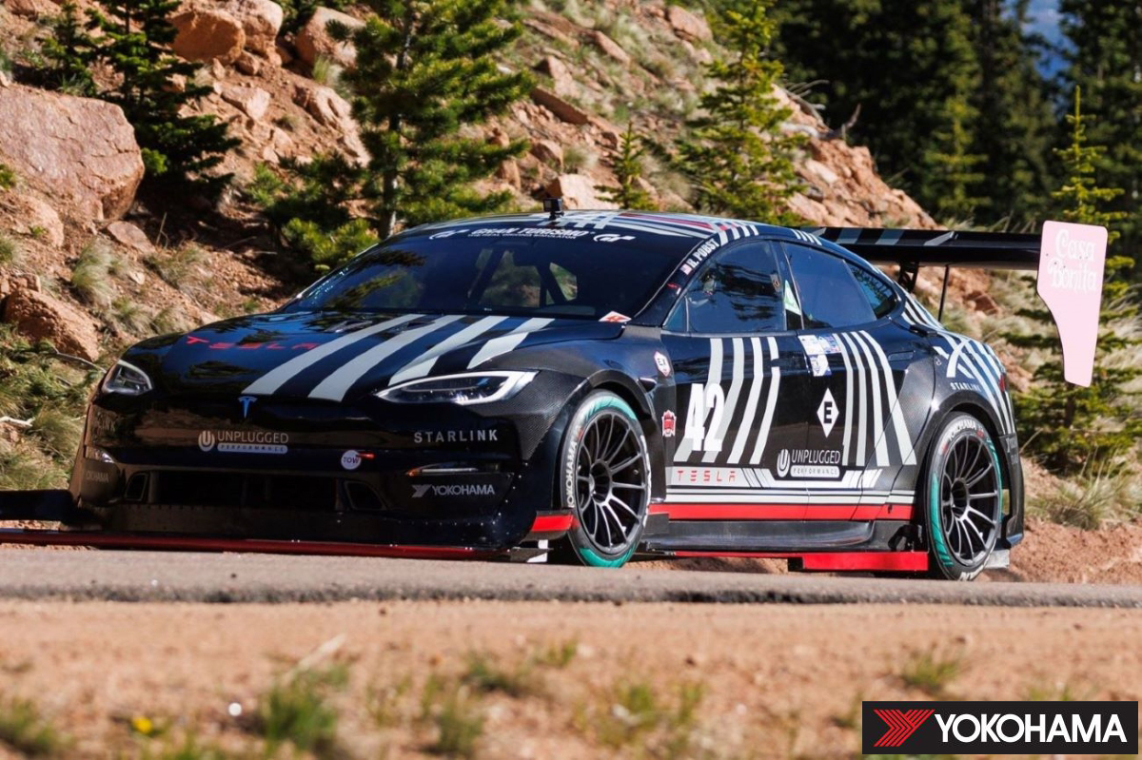
Car competing in the 2023 Pikes Peak International Hill Climb on ADVAN A005 tyres using biomass materials

Rally and Rallycross

Japanese Rally Championship

Last year, YOKOHAMA provided teams competing in the Japanese Rally Championship with ADVAN A051T, ADVAN A08B and ADVAN A052 tyres for use on tarmac and the ADVAN A053 for use on gravel. These high-performance tyres contributed to overall championships in three of six classes. We again will be aiming for championships in multiple classes, including the series highest JN1 class.

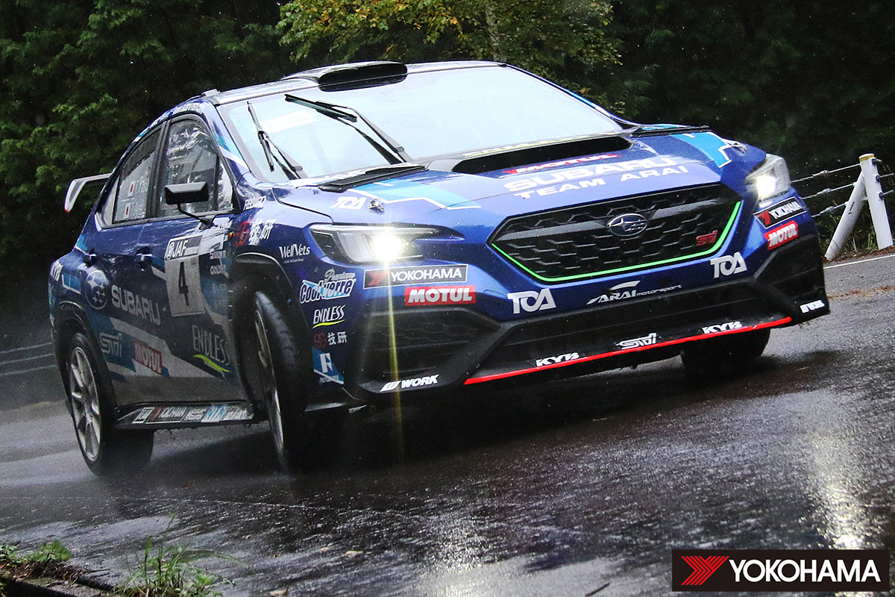
Fuji Subaru AMS WRX STI (2023)
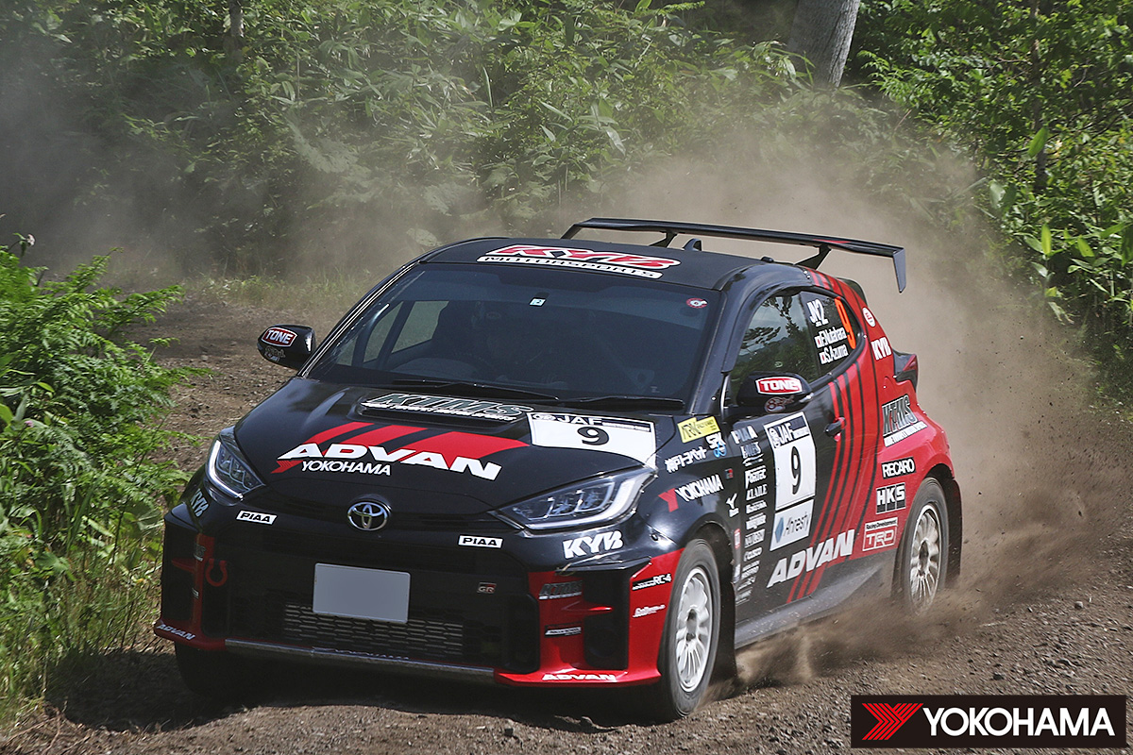ADVAN KYB KTMS GR YARIS (2023)

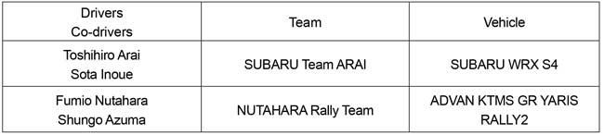
Nitrocross
YOKOHAMA will again supply the control tyre for Nitrocross, a highly popular rallycross racing series in North America that began in 2021. The control tyre for EV category cars as well as internal combustion engine cars will be the ADVAN A054 rallycross tyre, which was developed specifically for rallycross.
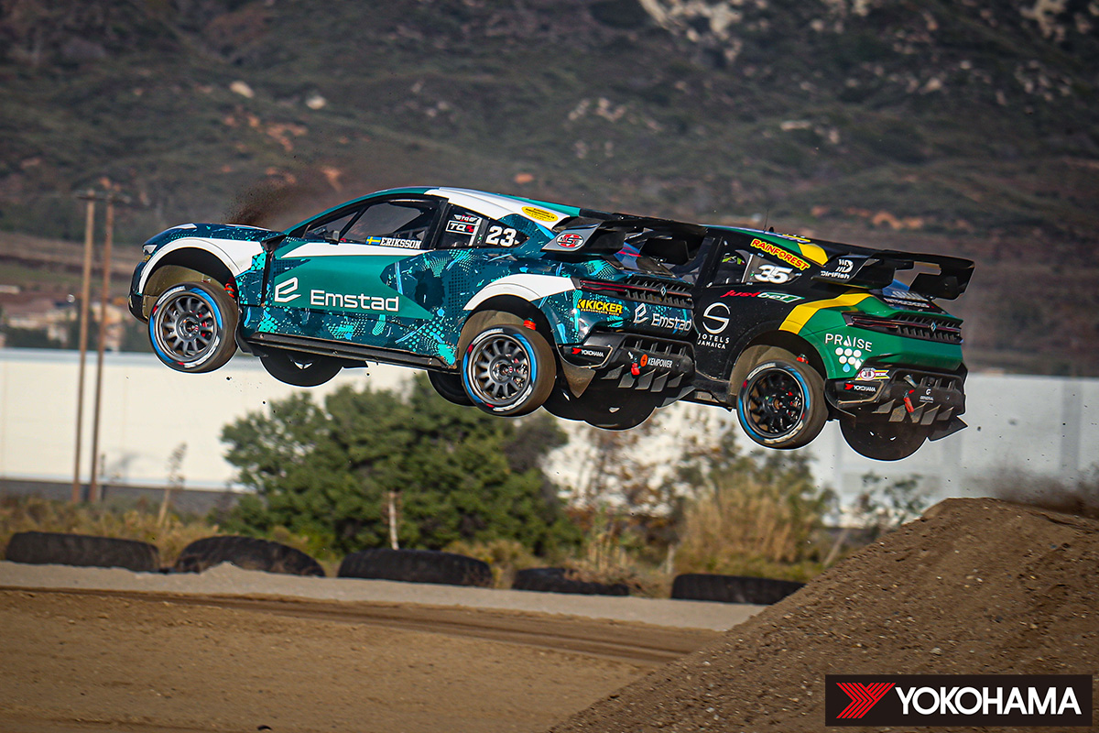Car in flight at a 2023 Nitrocross race

Speed Competitions
All Japan Gymkhana Championship
Last year, cars equipped with YOKOHAMA’s ADVAN NEOVA AD09 and ADVAN A050 high-performance tyres captured the series championship in two classes. This year, YOKOHAMA tyres will again support the aggressive driving of drivers aiming to capture the series championship in many classes.
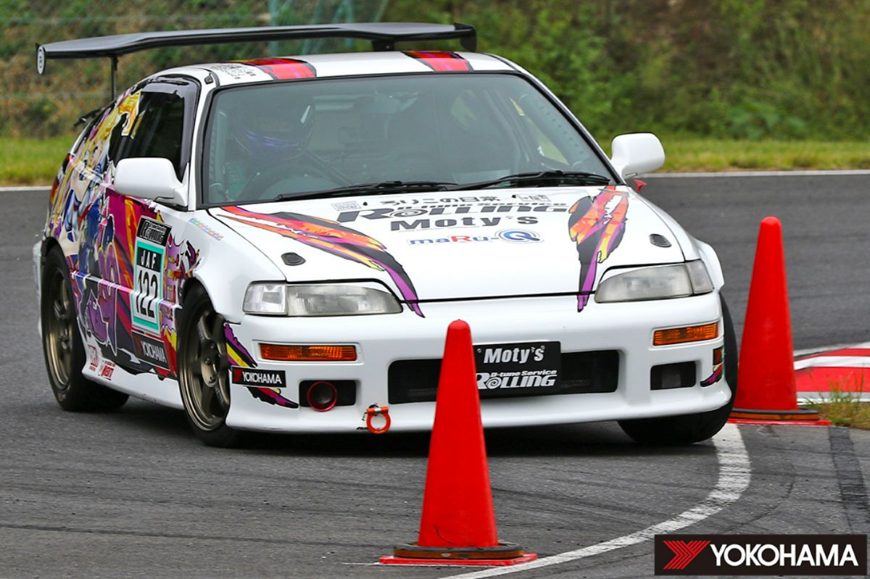Car competing in a 2023 All Japan Gymkhana Championship race

All Japan Dirt Trial Championship
Last year, YOKOHAMA supplied teams competing in several classes with a line-up of tyres that deliver superior performance on various surfaces, starting with ADVAN A053 tyres and including ADVAN A031 tyres for softer surfaces and ADVAN A036 tyres for ultra-hard surfaces. Teams using YOKOHAMA tyres captured series championships in six classes. This year, YOKOHAMA high-performance tyres will again support the aggressive driving of drivers aiming to capture the series championship in many classes.
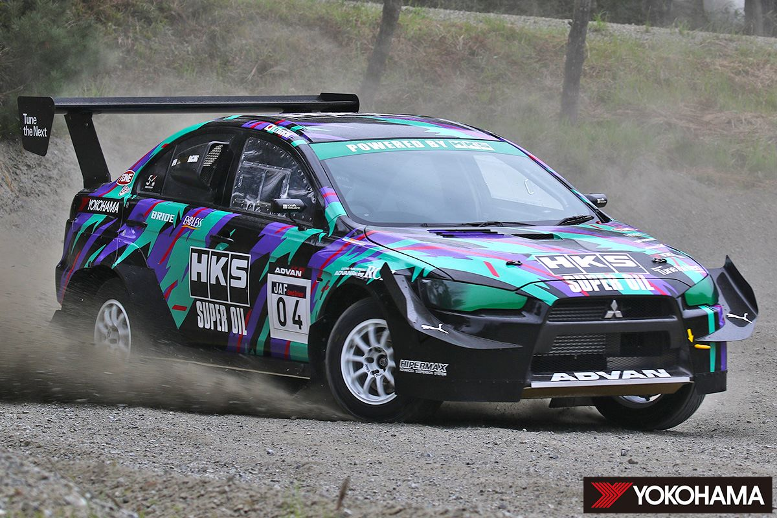Car competing in a 2023 All Japan Dirt Trial Championship race
Yokohama Motorsports Scholarship
As part of the Company’s motorsports promotion activities, the Yokohama Motorsports Scholarship 2024 program supports participants in rally, gymkhana, and dirt trial competitions in Japan. The deadline for applications for this year’s program is 30th April (postmark date). The scholarship program is open to registered users of YOKOHAMA tyres. Details, including eligible competitions, are posted on the program’s website.
Yokohama Motorsports Scholarship 2024 website (Japanese): https://www.y-yokohama.com/cp/motorsports/scholarship/

Participatory Motorsports
YOKOHAMA will supply tyres to drivers participating in the TOYOTA GAZOO Racing Rally Challenge 2024, HONDA N-ONE’s one-make N-ONE OWNER’S CUP races, and other participatory motorsports events being held at circuits around Japan.
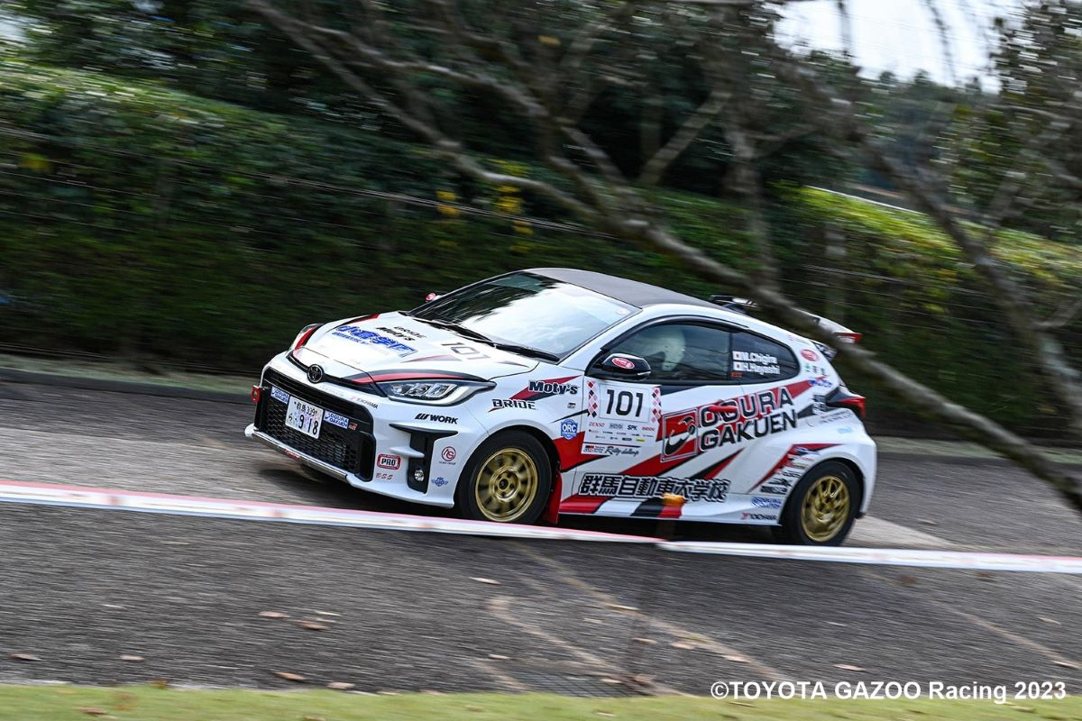TOYOTA GAZOO Racing Rally Challenge Drivers: Masanobu Chiaki / Koji Hayashi Ogura Gakuen Cusco ORC YH GR Yaris (2023)
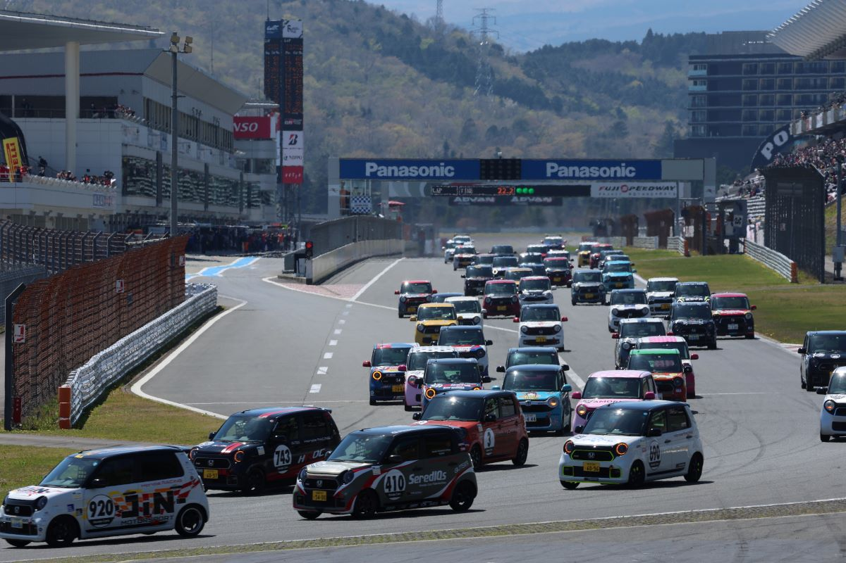
N-ONE OWNER'S CUP (2023)

Off-road Races

Asia Cross Country Rally (AXCR)

YOKOHAMA will again supply its GEOLANDAR M/T G003 to teams participating in this year’s Asia Cross Country Rally, the largest cross country rally in Asia. GEOLANDAR equipped vehicles dominated at AXCR 2023, finishing first, second, and third, and capturing a second-straight overall championship. We are aiming for a third-straight overall championship at AXCR 2024.

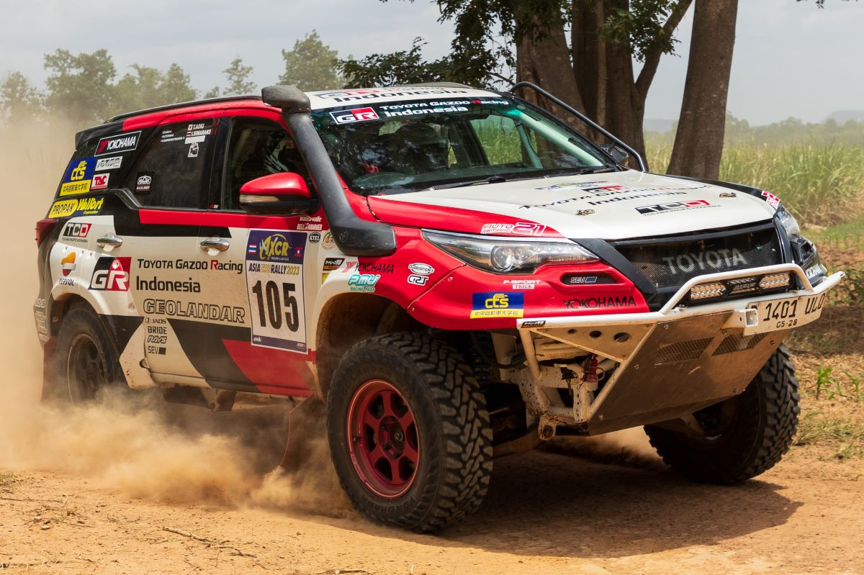
AXCR 2023 overall champion GEOLANDAR equipped Toyota Fortuner

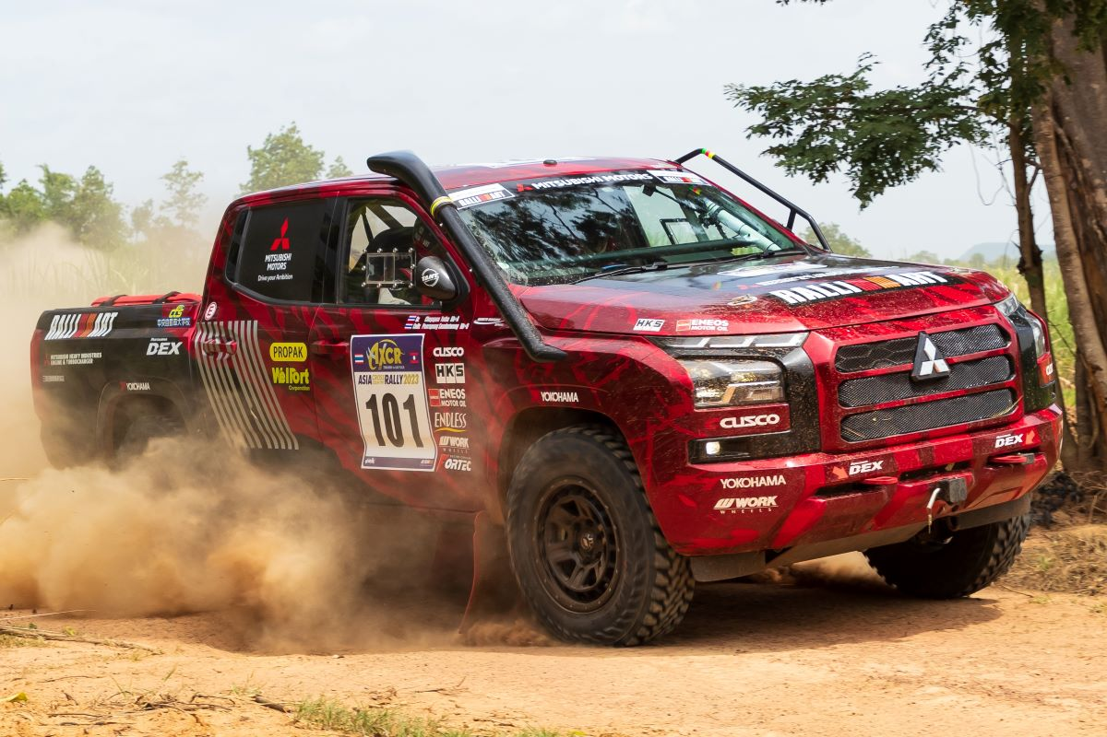
AXCR 2023 third place finisher GEOLANDAR equipped Mitsubishi Triton

Off-road Races in North America
YOKOHAMA will again supply its GEOLANDAR brand tyres for SUVs and pick-up trucks to teams competing in major off-road races in North America, including the Baja 1000, King of the Hammers, and the Mint 400. This year we are aiming for overall championships in several series and are off to a good start, with GEOLANDAR equipped vehicles participating in February’s King of the Hammers finishing first in three classes - 4900 Can-Am Sportsman Stock UTV, 4600 Currie Enterprises Stock, and 4500 Yukon Gear and Axle Modified.
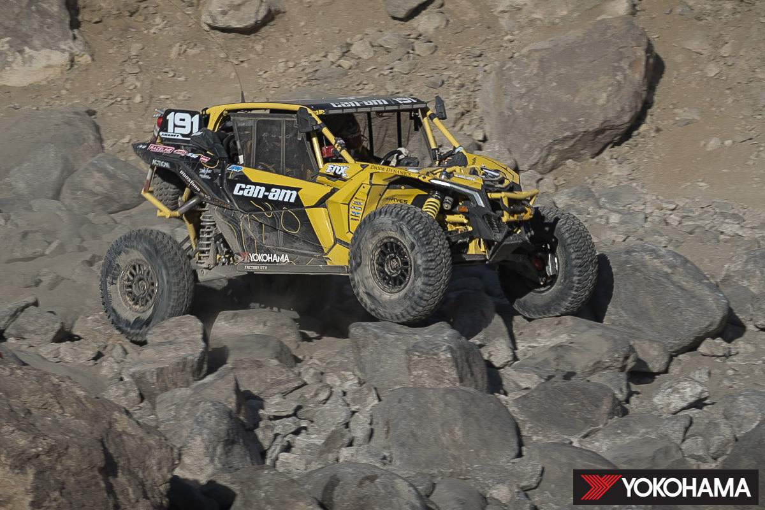2023 King of the Hammers 4900 Can-Am UTV class winner driven by Kyle Chaney

Drift Competitions
FORMULA DRIFT® JAPAN (FDJ)
Following last year’s success, YOKOHAMA will again supply its ADVAN NEOVA AD09 to several teams participating in this year FDJ. We will also supply ADVAN NEOVA AD09 tyres and ADVAN APEX V601 tyres as the control tyres for, respectively, FDJ2 and FDJ3 races.
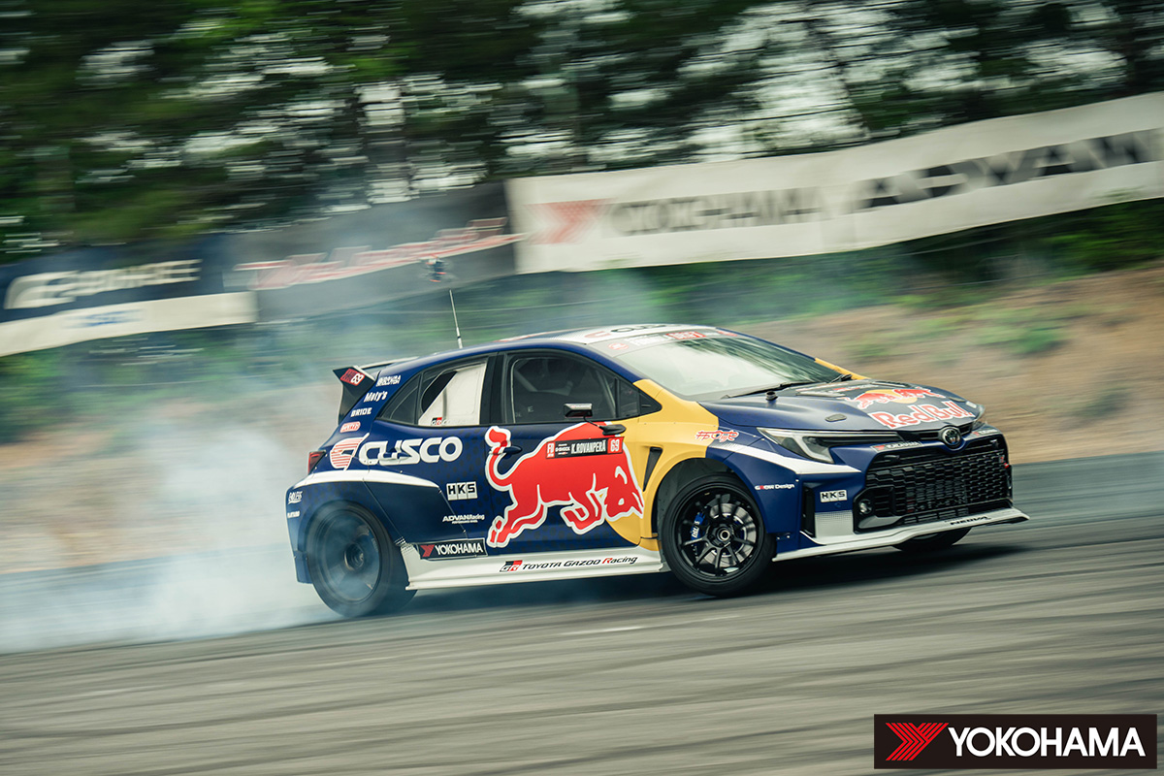ADVAN NEOVA AD09 equipped car driven by FIA World Rally Championship (WRC) champion Kalle Rovanperä on its way to victory in 2023 FDJ 2nd round
[YOKOHAMA Activities Supporting Sustainability in Motorsports in 2023 (video)]
https://www.youtube.com/watch?v=P6Xm1BdXwuM
[YOKOHAMA Motorsports Website (English)]
https://www.y-yokohama.com/cp/global/motorsports/
[Official SNS websites]
Facebook: https://www.facebook.com/YRCmotorsports/
X: https://twitter.com/yokohama_sport
Instagram: https://www.instagram.com/yokohama_motorsports/

