8th August 2023

YOKOHAMA’s ADVAN Sport V107 tyres coming factory-equipped on Porsche’s Cayenne

YOKOHAMA announced today that has begun supplying its ADVAN Sport V107 tyres to Porsche AG as original equipment for the German automaker’s facelift model of Cayenne. The Cayenne is being fitted with 285/40R22 110Y front tyres and 315/35R22 111Y rear tyres.

The ADVAN Sport V107 is an ultra-high performance tyre under the ADVAN brand, YOKOHAMA’s global flagship tyre brand. The tyre is targeted for use on three premium car categories - premium high-performance cars, premium high-performance SUVs, and premium electric vehicles (EVs). The tyres are jointly developed with leading premium car manufacturers and put through rigorous testing at YOKOHAMA’s test center at the Nürburgring, widely considered to be the world's most demanding test course. The ADVAN Sport V107 being fitted on the Cayenne facelift model was jointly developed with Porsche. The tread pattern is designed to deliver a quiet ride, and the tyre’s groove area and a specially developed compound have been adjusted to achieve superior performance in dry and wet road conditions. The application of YOKOHAMA’s proprietary mound profile technology, which evenly distributes surface contact pressure, further enhances the tyres’ dry performance and wear resistance. In addition, the tyres’ carcass material, which forms the tyre’s skeleton, includes a specialized material that helps deliver the excellent steering stability that is essential for high-power premium cars. Porsche has used YOKOHAMA tyres as OE on its Cayenne from the initial model and the tyre’s sidewall bears Porsche’s “NC0” mark, a recognition granted to the select group of the world’s tyre makers that supply OE tyres to Porsche.

Under YOKOHAMA’s three-year (2021–2023) medium-term management plan, Yokohama Transformation 2023 (YX2023), the consumer tyre business aims to maximize the sales ratios of high-value-added YOKOHAMA tyres, namely the global flagship ADVAN brand, the GEOLANDAR brand of tyres for SUVs and pick-up trucks, and various winter tyres. One of the key initiatives under this strategy is expanding the adoption of ADVAN and GEOLANDAR tyres as original equipment on new cars.

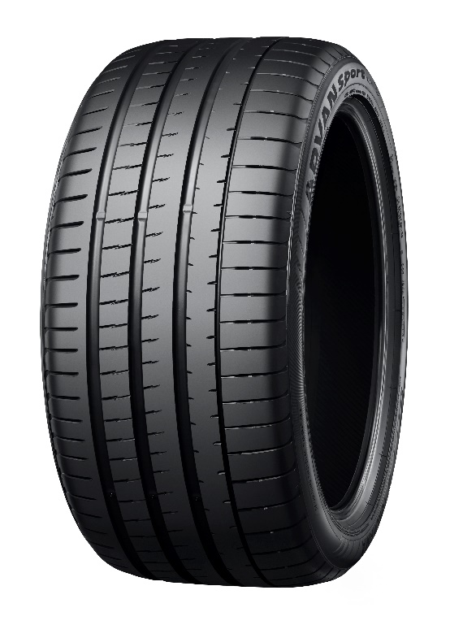
ADVAN Sport V107 *Tyre shown in photo differs in size from those installed on the Cayenne

