27th July 2023

YOKOHAMA’s ADVAN V61 tyres coming factory-equipped on Mazda’s new MAZDA CX-90

YOKOHAMA announced today that it is supplying its ADVAN V61 tyres as original equipment (OE) to Mazda Motor Corporation for use on the car manufacturers´ new crossover SUVs, the MAZDA CX-90, sales of which will be launched in Australia and other markets. The tyre size being supplied is 265/55R19 109V. The MAZDA CX-90 SUVs launched in the U.S. market are being equipped with the GEOLANDAR X-CV tyres for high-performance crossover SUVs.
*The CX-90 is not sold in Japan.

The ADVAN V61 tyre being supplied as OE is a high-performance tyre in YOKOHAMA’s global flagship ADVAN brand. The tyre contributes to the MAZDA CX-90’s superior handling performance while also contributing to a comfortable and quiet ride for everyone in the cabin. In addition, the ADVAN V61 is highly wear resistant and displays exceptional hydroplaning resistance that provides superior wet grip performance. The tyre also achieves low rolling resistance, a feature usually considered incompatible with these other characteristics.

The tyres being supplied as OE for MAZDA CX-90 were developed by utilizing specialized tuning to match their tread pattern, profile, and tyre structure to the vehicle characteristics, while also using YOKOHAMA’s proprietary HAICoLab*, an AI-based development framework that aims to foster new discoveries and digital innovation by merging human inspiration and creativity with AI’s enormous data processing capability. To achieve the highly quiet ride, an optimal pitch sequence was obtained using evolutionary computation (genetic algorithms), one of the technologies incorporated in HAICoLab. The innovative technologies applied in development of the tyres are based on new knowledge obtained by collecting actual data and virtual data generated by simulations and then using AI’s predict, analyse and search functions.
* An acronym for “Humans and AI ColLaborate” for digital innovation

The MAZDA CX-90 is a new three-row crossover SUV that offers a significant evolution in environmental and safety performance and greater joy of driving. In the SUV market where demand is strong globally, the CX-90 represents MAZDA’s new flagship model and it will be launched primarily in North America. Based on the “For the Voyage of your life” concept, the CX-90 offers greater comfort, functionality, and safety performance, making driving more enjoyable and travel with several friends and family more pleasant.

Under YOKOHAMA’s three-year (2021–2023) medium-term management plan, Yokohama Transformation 2023 (YX2023), the consumer tyre business aims to maximize the sales ratios of high-value-added YOKOHAMA tyres, namely the global flagship ADVAN brand, the GEOLANDAR brand of tyres for SUVs and pick-up trucks, and various winter tyres. One of the key initiatives under this strategy is expanding the adoption of ADVAN and GEOLANDAR tyres as original equipment on new cars.

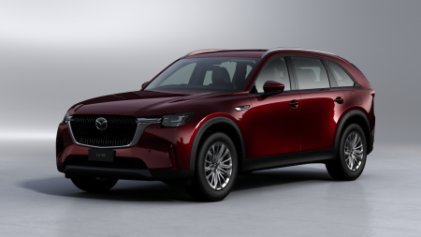
New MAZDA CX-90 (Australian specifications) *The above photo is used with the permission of Mazda Motor Corporation. Reprint or other usage of this image without prior permission from Mazda Motor Corporation is strictly prohibited.
ADVAN V61

