6th October 2022

YOKOHAMA’s ADVAN and GEOLANDAR tyres coming factory-equipped on Mazda’s new MAZDA CX-60

YOKOHAMA announced today that it is supplying its ADVAN V61 and GEOLANDAR X-CV tyres as original equipment (OE) to Mazda Motor Corporation for use on the car manufacturer´s new crossover SUV, the MAZDA CX-60, sales of which were launched in Europe, Japan and other markets in September 2022. The tyre sizes being supplied include 235/60R18 103V and 235/60R18 107V ADVAN V61 tyres and 235/60R18 103H GEOLANDAR X-CV tyres.

The ADVAN V61 tyre being supplied as OE is a high-performance tyre in YOKOHAMA’s global flagship ADVAN brand. The tyre contributes to the MAZDA CX-60’s superior handling performance while also contributing to a comfortable and quiet ride for everyone in the cabin. In addition, the ADVAN V61 is highly wear resistant and displays exceptional hydroplaning resistance that provides superior wet grip performance. The tyre also achieves low rolling resistance, a feature usually considered incompatible with these other characteristics.

The GEOLANDAR X-CV represents a new dimension in highway terrain tyres that YOKOHAMA developed to meet the M+S (mud & snow) standard for high-performance crossover SUVs, which have increasingly focused on high-speed performance and manoeuvrability in recent years. In addition to providing superior handling and comfortable ride, the GEOLANDAR X-CV is capable of tackling the most difficult road conditions.

The tyres being supplied as OE for MAZDA CX-60 were developed by utilizing specialized tuning to match their tread pattern, profile, and tyre structure to the vehicle characteristics, while also using YOKOHAMA’s proprietary HAICoLab*, an AI-based development framework that aims to foster new discoveries and digital innovation by merging human inspiration and creativity with AI’s enormous data processing capability. To achieve the highly quiet ride, an optimal pitch sequence was obtained using evolutionary computation (genetic algorithms), one of the technologies incorporated in HAICoLab. The innovative technologies applied in development of the tyres are based on new knowledge obtained by collecting actual data and virtual data generated by simulations and then using AI’s predict, analyze and search functions.
* An acronym for “Humans and AI ColLaborate” for digital innovation

Having outstanding environmental and safety performance that meet the standards of modern society, the MAZDA CX-60 is a two-row, mid-sized SUV that allows the driver to enjoy not only everyday driving but also long-distance drives on the expressway. Furthermore, the team at Mazda took on the challenge of taking Kodo – Soul of motion design to new heights, expressing toughness and sophistication in its form utilizing the Japanese sense of design that values harmony with nature.

Under YOKOHAMA´s three-year (2021–2023) medium-term management plan, Yokohama Transformation 2023 (YX2023), the consumer tyre business aims to maximize the sales ratios of high-value-added YOKOHAMA tyres. One of the key initiatives under this strategy is expanding sales of ADVAN and GEOLANDAR tyres as original equipment on new cars.

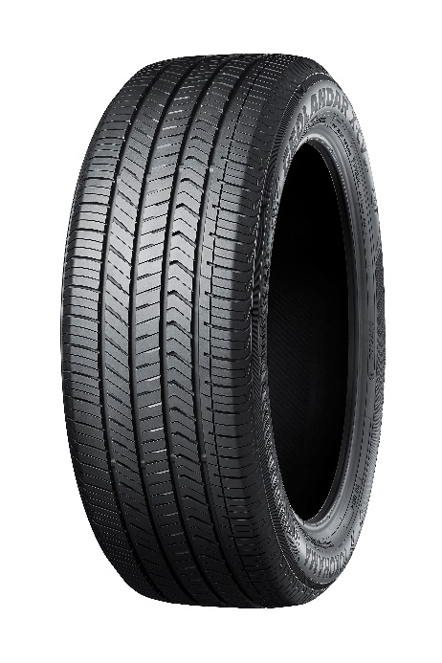
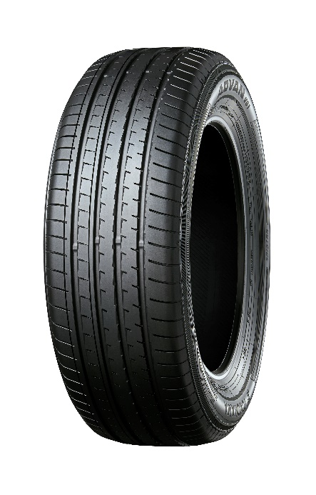

ADVAN V61 GEOLANDAR X-CV
The GEOLANDAR X-CV tyre shown in photo differs in
size from those installed on the new MAZDA CX-60

HAICoLab conceptual diagram

