17th November 2022

YOKOHAMA’s ADVAN tyres coming factory-equipped on Honda’s new SUV the ZR-V

YOKOHAMA announced today that it has begun supplying its ADVAN dB V552 tyres as original equipment (OE) to Honda Motor Co., Ltd., for use on its new SUV, the ZR-V. The new SUV will go on sale in Japan and overseas. The new SUVs are being fitted with 215/60R17 96H and 225/55R18 98H size tyres.

The ADVAN dB V552 is a premium comfort tyre developed based on the concept of “an unprecedentedly* silent tyre that changes the in-car atmosphere.” The tyre realizes an amazingly calm in-vehicle atmosphere that helps provide a more pleasant in-car experience to drivers. The ADVAN dB V552 delivers the high manoeuvrability and quietness demanded by Honda’s ZR-V, while reducing rolling resistance.
*Note：Use of “unprecedentedly” here refers to tyres developed and marketed to date by YOKOHAMA

Under YOKOHAMA’s current medium-term management plan, Yokohama Transformation 2023 (YX2023), the consumer tyre business aims to maximize the sales ratios of high-value- added YOKOHAMA tyres, namely the global flagship ADVAN brand, the GEOLANDAR brand of tyres for SUVs and pick-up trucks, and various winter tyres. One of the key initiatives under this strategy is the expansion of ADVAN and GEOLANDAR tyres as original equipment on new cars.
In 2022, YOKOHAMA has introduced a new ADVAN Sport V107 and the ADVAN NEOVA AD09 high-performance street tyre as part of its effort to also expand sales of ADVAN tyres in the replacement tyre market.

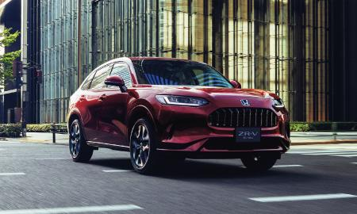
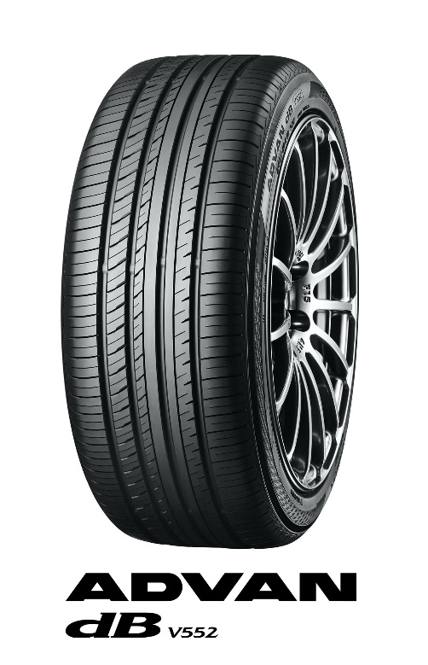
Honda’s new ZR-V *The above photo is used with the permission of Honda Motor Co., Ltd. Reprint or other usage of this image is strictly prohibited.
Tyre shown in photo differs in size from those installed on the new ZR-V (wheel shown is not standard equipment)

