29th November 2022

YOKOHAMA’s ADVAN tyres coming factory-equipped on Nissan’s ELGRAND

YOKOHAMA announced today that it is supplying its ADVAN V51 tyres as original equipment (OE) to Nissan Motor Co., Ltd., for use on the automaker’s ELGRAND MPV, which was recently launched with some specification enhancements. The MPV is being fitted with 225/55R18 98V size tyres.

The ADVAN V51 is a high-performance tyre in YOKOHAMA’s global flagship ADVAN brand. The tyres being supplied feature a high level of quietness that befits the ELGRAND, achieved by applying specialized tuning to their tread pattern and compound. In addition, their high structural rigidity can demonstrate exceptional steering stability.

The ELGRAND is a premium minivan with a spacious interior that includes features similar to those in a luxury sedan. The ELGRAND comes with advanced safety technologies, such as "Nissan Safety Assist 360," a multidirectional drive support system that includes an intelligent emergency braking function and a system prevents collisions in the event of the driver accidentally stepping on the gas pedal. The ELGRAND also features excellent handling stability achieved by a low centre of gravity platform and the stable driving performance that has been highly evaluated by owners of previous ELGRAND models for many years.

Under YOKOHAMA’s current medium-term management plan, Yokohama Transformation 2023 (YX2023), the consumer tyre business aims to maximize the sales ratios of high-value-added YOKOHAMA tyres, namely the global flagship ADVAN brand, the GEOLANDAR brand of tyres for SUVs and pick-up trucks, and various winter tyres. One of the key initiatives under this strategy is the expansion of ADVAN and GEOLANDAR tyres as original equipment on new cars. In 2022, YOKOHAMA has introduced a new ADVAN Sport V107 and the ADVAN NEOVA AD09 high-performance street tyre as part of its effort to also expand sales of ADVAN tyres in the replacement tyre market.

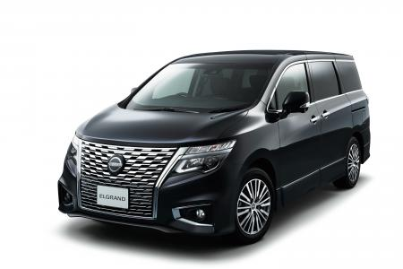
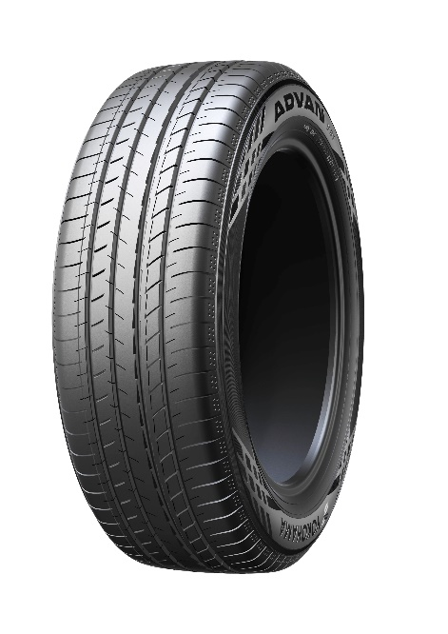
The ELGRAND
*The above photo is used with the permission of Nissan Motor Co., Ltd.
Reprint or other usage of this image without prior permission from Nissan Motor is strictly prohibited.
ADVAN V51

