2nd December 2022

YOKOHAMA’s ADVAN tyres to come factory-equipped on the new Lexus RX

YOKOHAMA announced today that it is supplying its ADVAN V61 tyres to Lexus for use as original equipment (OE) tyres on the fifth-generation RX. The luxury SUV has undergone a complete renewal, pursuing the Lexus Driving Signature performance and next-generation Lexus design. Launched in Japan and overseas, including Europe, from this November, the new RX is being fitted with 235/60R19 103V size ADVAN V61 tyres.

The ADVAN V61 is a high-performance tyre under the ADVAN brand, YOKOHAMA’s ultimate tyre brand. The ADVAN V61 tyres being installed on the RX feature a specially designed structure that delivers the comfortable ride and stable handling befitting a luxury SUV such as the RX. The tyre also features a highly rigid cover material that contributes to an exceptionally quiet ride and a compound that reduces the tyre’s heat generation and enhances its environmental performance.

Under YOKOHAMA’s three-year (2021–2023) medium-term management plan, Yokohama Transformation 2023 (YX2023), the consumer tyre business aims to maximize the sales ratios of high-value-added YOKOHAMA tyres. One of the key initiatives under this strategy is expanding sales of ADVAN and GEOLANDAR tyres as original equipment on new cars.

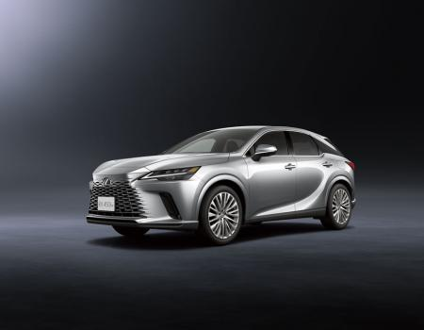
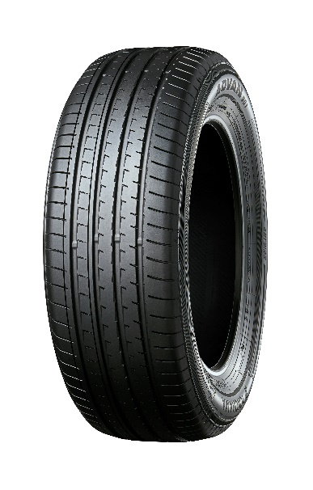
The new RX *This photo is used with the permission of Lexus. Reprint or other usage of this image without prior permission from Lexus is strictly prohibited
ADVAN V61
*Tyre shown in photo differs in size
from those installed on the new RX

