10th April 2023

YOKOHAMA’s ADVAN tyres to come factory-equipped on the new Lexus RZ BEV

YOKOHAMA announced today that it is supplying its ADVAN V61 tyres to Lexus for use as original equipment (OE) tyres on the new RZ, the Lexus brand’s first dedicated battery electric vehicle (BEV), which was launched in Japan and other countries, including in Europe and Asia, from this March. The RZ is being fitted with 235/60R18 103H front tyres and 255/55R18 105V rear tyres.

The ADVAN V61 is a high-performance tyre under the ADVAN brand, YOKOHAMA’s ultimate tyre brand. ADVAN V61 tyres contribute to the intuitive connection between car and driver to realize the exhilarating driving sensation the RZ is designed to deliver to drivers. In addition to contributing to a comfortable and stable ride, ADVAN V61 tyres are highly wear resistant and display exceptional hydroplaning resistance. The tread pattern contributes to a smooth and quiet ride by suppressing noise and significantly reducing rolling resistance. The ADVAN V61 was developed using YOKOHAMA’s proprietary HAICoLab^{*1}, an AI-based development framework that aims to foster new discoveries and digital innovation by merging human inspiration and creativity with AI’s enormous data processing capability. In particular, to achieve the highly quiet ride demanded of EVs, an optimal pitch sequence was obtained using evolutionary computation (genetic algorithms), one of the technologies incorporated in HAICoLab. The innovative technologies applied in development of the ADVAN V61 are based on new knowledge obtained by collecting actual data and virtual data generated by simulations and then using AI’s predict, analyze and search functions.

Under YOKOHAMA’s three-year (2021–2023) medium-term management plan, Yokohama Transformation 2023 (YX2023), the consumer tyre business aims to maximize the sales ratios of high-value-added YOKOHAMA tyres. One of the key initiatives under this strategy is expanding sales of ADVAN and GEOLANDAR tyres as original equipment on new cars. YOKOHAMA also believes that adoption of its tyres as OE on premium EVs will require that its tyres be based on highly reliable technologies. Accordingly, the Company will continue responding to the dynamic changes in automobiles by leveraging its involvement in motorsports and EV race car development to develop more advanced tyre technologies.

*1 An acronym for Humans and AI collaborate for digital innovation

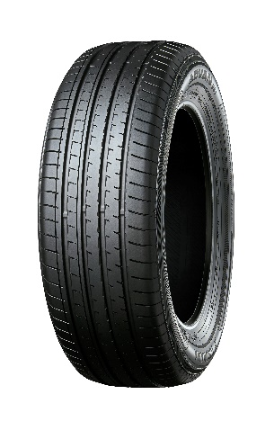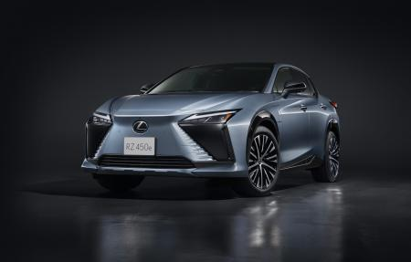
ADVAN V61
The new RZ *This photo is used with the permission of Lexus. Reprint or other usage of this image without prior permission from Lexus is strictly prohibited.

HAICoLab conceptual diagram

