18th October 2023

YOKOHAMA’s BluEarth AE-01 tyres coming factory-equipped on Honda’s new N-BOX

YOKOHAMA announced today that it is supplying its BluEarth AE-01 tyres as original equipment (OE) to Honda Motor Co., Ltd. for use on the automaker’s new mini-vehicle, N-BOX, which was launched in Japan in October 2023. The N-BOX is being equipped with155/65R14 75S size tyres.

The BluEarth AE-01 is a fuel-efficient standard tyre in the BluEarth, a YOKOHAMA’s global tyre brand based on the concept of being “environmentally, human, and socially friendly”. It demonstrates excellent fuel-efficiency and a high level of balance between basic performance properties such as quietness, comfortable performance, a comfortable ride, and long life.

YOKOHAMA is aggressively developing tyres employing its leading-edge BluEarth tyre technology, and many of these tyres are now coming factory-equipped on gasoline-powered vehicles, hybrid cars and EVs such as a wide variety of new car models, including the latest-model sedans, SUVs, sports cars, and compact cars.

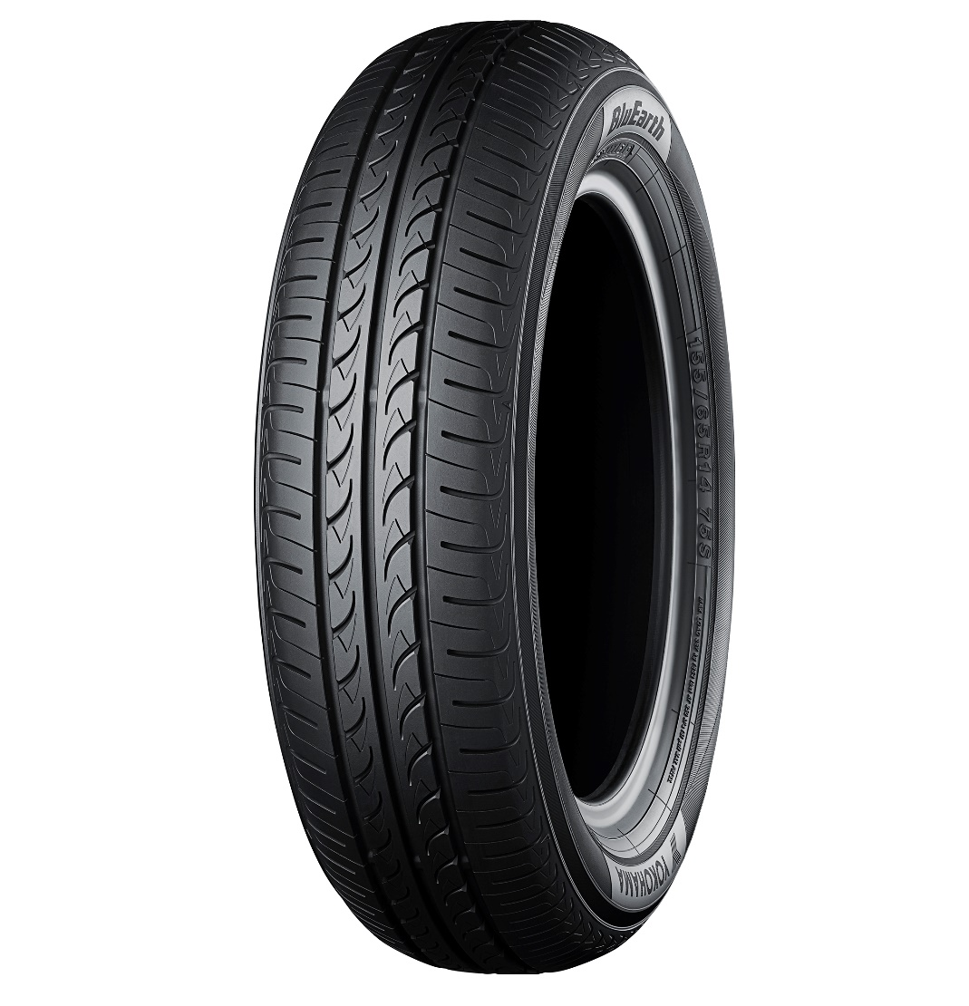

BluEarth AE-01

