05th June 2023

YOKOHAMA’s BluEarth tyres coming factory-equipped on FAW Toyota’s new EV sedan bZ3

YOKOHAMA announced today that from this February it has begun delivering its BluEarth-GT AE51 tyres as original equipment (OE) for the new bZ3 electric vehicle (EV) sedan being sold in China by FAW Toyota Motor Co. Ltd. (FAW Toyota). The tyre sizes are 215/65R16 98H and 225/50R18 95V. The bZ3 was jointly developed by BYD TOYOTA EV TECHNOLOGY CO., LTD. - a joint venture established by Toyota Motor Corporation and BYD Company Ltd. - and FAW Toyota.

The BluEarth-GT AE51 incorporates the basic design and materials technology used in the BluEarth brand, and their superior driving, comfortable and environmental performance make them outstanding grand touring tyres. The BluEarth-GT AE51 tyres being supplied as OE for the bZ3 feature a highly rigid cover material that contributes to an exceptionally quiet ride and highly stable handling. The tyres’ structural components also include a low-heat generating compound that reduces rolling resistance. Additional structural tuning contributes to a highly comfortable ride on BluEarth-GT AE51 tyres.

Under YOKOHAMA’s three-year (2021–2023) medium-term management plan, Yokohama Transformation 2023 (YX2023), the consumer tyre business aims to maximize the sales ratios of high-value-added YOKOHAMA tyres, namely the global flagship ADVAN brand, the GEOLANDAR brand of tyres for SUVs and pick-up trucks, and various winter tyres. Toward that end, the business has been making efforts to expand use of ADVAN and GEOLANDAR brand tyres as original equipment and strengthen sales in the replacement market.

In addition to strengthening its marketing of tyres to be used as OE on EVs, which require tyres made using the most advanced technologies, YOKOHAMA is utilizing the feedback received from EV makers in its development of replacement tyres as it seeks to expand its product line-up and improve the performance of all its tyres to meet new requirements in this era of dynamic change.

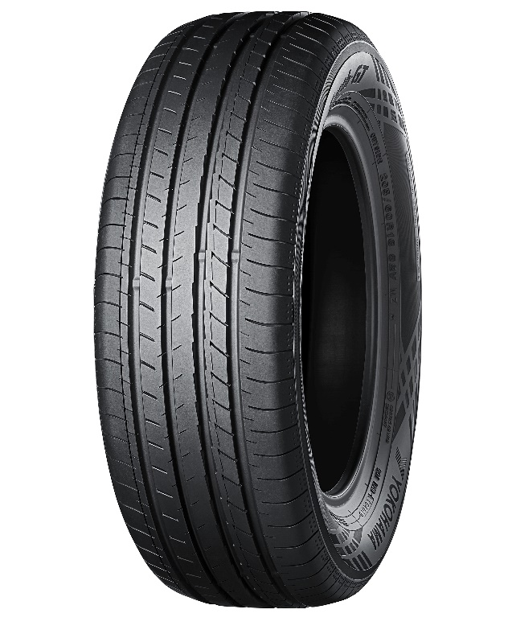
BluEarth-GT AE51
*Tyre shown in photo differs in size from those installed on the bZ3.

