13th July 2023

YOKOHAMA's GEOLANDAR A/T G015 tyres coming factory-equipped on the new Subaru Crosstrek Wilderness SUV for North America

YOKOHAMA announced today that it is supplying its GEOLANDAR A/T G015 to be used as original equipment (OE) tyres on the new Crosstrek Wilderness SUV for North America, which was announced by Subaru Corporation in April 2023. The Crosstrek Wilderness is being fitted with 225/60R17 99T size tyres.

The GEOLANDAR A/T G015, fitted on the Crosstrek Wilderness, is an all-terrain tyre for SUVs that demonstrates excellent fuel efficiency, comfort, and safety performance, as well as utility performance on a variety of road surfaces, and offers a tyre design that is stylish yet decidedly off-road.

The Crosstrek Wilderness features genuine SUV performance in a compact body. Retaining the value of the Crosstrek as a crossover SUV that can be used in a wide range of situations from urban to the outdoors, the Crosstrek Wilderness further accentuates its character with a tougher, more rugged design that hints at its strong off-road performance and enhanced mobility and functionality.
* See Subaru’s April 6, 2023 news release “Subaru Debuts the All-New Crosstrek Wilderness at the New York International Auto Show” (https://www.subaru.co.jp/news-en/2023_04_06_123923/)

Under YOKOHAMA’s three-year (2021–2023) medium-term management plan, Yokohama Transformation 2023 (YX2023), the consumer tyre business aims to maximize the sales ratios of high-value-added YOKOHAMA tyres, namely the global flagship ADVAN brand, the GEOLANDAR brand of tyres for SUVs and pick-up trucks, and various winter tyres. The initiatives taken to achieve this goal include expanding the adoption of ADVAN and GEOLANDAR tyres as original equipment on new cars, expanding product line-ups, and strengthening its marketing of tyres that respond to specific trends in each regional market. In particular, in 2023, the focus is on expanding sales of the GEOLANDAR brand and accelerating the launch of new products and the introduction of new sizes.

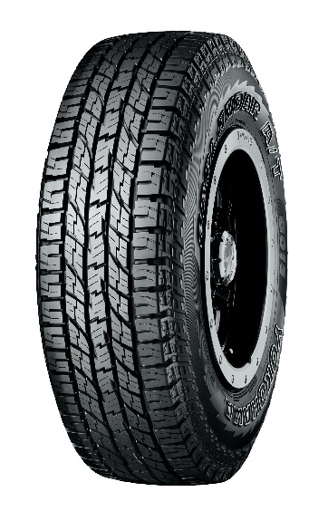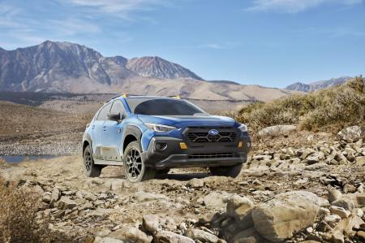
The new Crosstrek Wilderness *This photo is used with the permission of Subaru Corporation. Reprint or other usage of this image without prior permission from Subaru Corporation is strictly prohibited
GEOLANDAR A/T G015 * Tyre shown in photo differs in size from those installed on the new Crosstrek Wilderness. (wheels shown in the photo are not standard equipment)

