26th January 2024

YOKOHAMA’s GEOLANDAR G91 tyres coming factory-equipped on Subaru’s new Forester

YOKOHAMA announced today that it is supplying its GEOLANDAR G91 tyres as original equipment (OE) to Subaru Corporation for use on the car manufacturer´s new SUV, the 2025 Forester (US model), which was unveiled in November 2023. The SUV is being fitted with 225/60R17 99H size tyres.

GEOLANDAR G91 tyres combine the utility performance of SUV tyres with the fuel-efficiency, safety, and comfortable performance demanded of SUVs. These GEOLANDAR G91 tyres being supplied on the new Forester employ a highly rigid carcass, allowing them to demonstrate agile steering stability that befits the Forester.

The tyres being supplied as OE for the new Forester were developed by utilizing specialized tuning to match their tread pattern, profile, and tyre structure to the vehicle characteristics, while also using YOKOHAMA’s proprietary HAICoLab^{*1}, an AI-based development framework that aims to foster new discoveries and digital innovation by merging human inspiration and creativity with AI’s enormous data processing capability. To achieve the highly quiet ride, an optimal pitch sequence was obtained using evolutionary computation (genetic algorithms), one of the technologies incorporated in HAICoLab. The innovative technologies applied in development of the GEOLANDAR G91 tyres are based on new knowledge obtained by collecting actual data and virtual data generated by simulations and then using AI’s predict, analyse and search functions.

Since its debut in 1997, the Forester has been embraced by a wide range of global customers and occupies with a key role in the Subaru product portfolio. This sixth generation Forester has been enhanced its functionality and practicality with excellent driving performance that makes it enjoyable, advanced safety features that provide peace of mind, and utility that can be used to the fullest.^{*2}

YOKOHAMA’s consumer tyre business aims to maximize the sales ratios of high-value-added YOKOHAMA tyres, namely the global flagship ADVAN brand, the GEOLANDAR brand of tyres for SUVs and pick-up trucks, and various winter tyres. The initiatives taken to achieve this goal include expanding the adoption of ADVAN and GEOLANDAR tyres as original equipment on new cars, expanding product line-ups, and strengthening its marketing of tyres that respond to specific trends in each regional market.

*1: An acronym for “Humans and AI ColLaborate” for digital innovation
*2: See Subaru’s November 17, 2023, news release “World Premier of All-New Subaru Forester” (https://www.subaru.co.jp/news-en/2023_11_17_174709/)

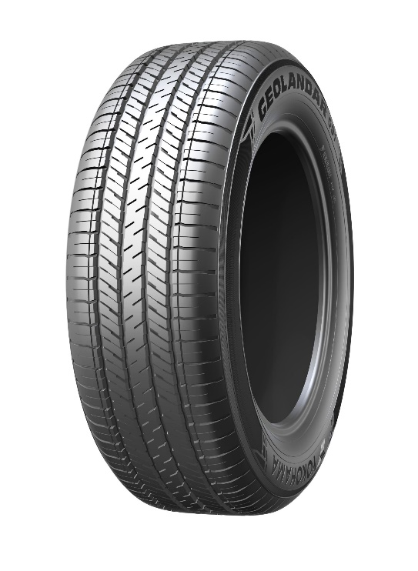
GEOLANDAR G91

HAICoLab conceptual diagram

