20th December 2021

YOKOHAMA’s GEOLANDAR X-CV now coming factory-equipped on Mitsubishi Motors’ Outlander

YOKOHAMA announced today that it is now supplying its GEOLANDAR X-CV (Pattern No. G99B) as original equipment (OE) for Mitsubishi Motors Corporation’s new Outlander SUVs. YOKOHAMA began supplying the GEOLANDAR X-CV tyres used on Outlander gasoline models sold overseas in July 2021, and shipments of the tyres for PHEV models to be introduced in Japan, Australia and other countries began in November this year. The SUVs are being fitted with 235/60R18 103H size tyres.
*The gasoline model is not sold in Japan.

While contributing to the Outlander’s maneuverability, the GEOLANDAR X-CV (Pattern No. G99B) tyres deliver the high steering stability and sharply reduced rolling resistance that further enhance the environmental benefits of PHEVs. In addition, a newly optimized tyre pattern helps improve fuel efficiency.

GEOLANDAR is YOKOHAMA’s global brand of tyres for SUVs and pick-up trucks, and the Company is accelerating the expansion of the brand’s line-up to meet increasingly diversified needs in the SUV market. The GEOLANDAR X-CV being supplied for Outlanders is based on the previously developed GEOLANDAR X-CV tyre sold on the replacement tyre market. The GEOLANDAR X-CV represents a new dimension in highway terrain tyres developed for high-performance crossover SUVs that have increasingly focused on high-speed performance and manoeuvrability in recent years.

Mitsubishi Motors seeks to expand global sales of its new Outlander crossover SUV which accounts for about 20% of the company’s annual unit sales. Equipped with a unique new-generation PHEV system that “delivers a more powerful performance and greater driving range,” the new Outlander PHEV realizes safe, secure and comfortable driving in various weather and road conditions.

Under YOKOHAMA’s current medium-term management plan, Yokohama Transformation 2023 (YX2023), the consumer tyre business aims to maximize the sales ratios of high-value-added YOKOHAMA tyres, namely the global flagship ADVAN brand, the GEOLANDAR brand of tyres for SUVs and pick-up trucks, and various winter tyres. One of the key initiatives being implemented under this strategy is the expansion of ADVAN and GEOLANDAR tyres as original equipment on new cars.

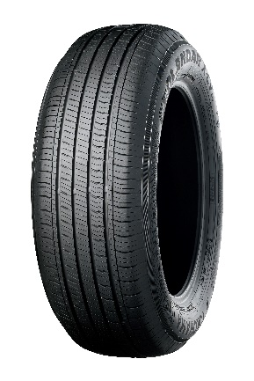
YOKOHAMA’s GEOLANDAR X-CV now coming factory-equipped on Mitsubishi Motors’ Outlander

