09th June 2023

YOKOHAMA’s GEOLANDAR tyres coming factory-equipped on Mazda’s new MAZDA CX-90

YOKOHAMA announced today that it is supplying its GEOLANDAR X-CV tyres as original equipment (OE) to Mazda Motor Corporation for use on the car manufacturers´ new crossover SUV, the MAZDA CX-90, sales of which were launched in the United States in April 2023. The CX-90 is being fitted with 265/55R19 109V size tyres.
*The CX-90 is not sold in Japan.

The GEOLANDAR X-CV represents a new dimension in highway terrain tyres that YOKOHAMA developed to meet the M+S (mud & snow) standard for high-performance crossover SUVs, which have increasingly focused on high-speed performance and manoeuvrability in recent years. In addition to contributing to superior handling performance and a comfortable ride, the tyre also achieves low rolling resistance.

The tyres being supplied as OE for MAZDA CX-90 were developed by utilizing specialized tuning to match their tread pattern, profile, and tyre structure to the vehicle characteristics, while also using YOKOHAMA’s proprietary HAICoLab*, an AI-based development framework that aims to foster new discoveries and digital innovation by merging human inspiration and creativity with AI’s enormous data processing capability. To achieve the highly quiet ride, an optimal pitch sequence was obtained using evolutionary computation (genetic algorithms), one of the technologies incorporated in HAICoLab. The innovative technologies applied in development of the tyres are based on new knowledge obtained by collecting actual data and virtual data generated by simulations and then using AI’s predict, analyse and search functions.
* An acronym for “Humans and AI ColLaborate” for digital innovation

The MAZDA CX-90 is a new three-row crossover SUV that offers a significant evolution in environmental and safety performance and greater joy of driving. In the SUV market where demand is strong globally, the CX-90 represents MAZDA’s new flagship model and it will be launched primarily in North America. Based on the “For the Voyage of your life” concept, the CX-90 offers greater comfort, functionality, and safety performance, making driving more enjoyable and travel with several friends and family more pleasant.

Under YOKOHAMA’s three-year (2021–2023) medium-term management plan, Yokohama Transformation 2023 (YX2023), the consumer tyre business aims to maximize the sales ratios of high-value-added YOKOHAMA tyres, namely the global flagship ADVAN brand, the GEOLANDAR brand of tyres for SUVs and pick-up trucks, and various winter tyres. One of the key initiatives under this strategy is the expansion of ADVAN and GEOLANDAR tyres as original equipment on new cars.
GEOLANDAR X-CV *The tyre shown in photo differs in size from those installed on the new MAZDA CX-90
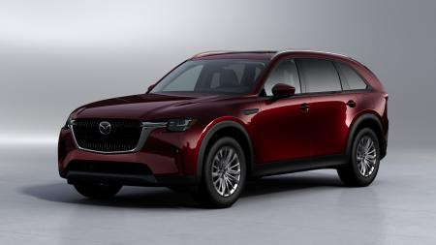
New MAZDA CX-90 *The above photo is used with the permission of Mazda Motor Corporation. Reprint or other usage of this image without prior permission from Mazda Motor Corporation is strictly prohibited.

HAICoLab conceptual diagram

