5th April 2021

YOKOHAMA’s “ADVAN Sport V107” Coming Factory-Equipped on Leading German Automotive Manufacturer’s Premium Cars

YOKOHAMA announced today that it is supplying “ADVAN Sport V107” tyres for use as original equipment on BMW’s new iX3, the first Sports Activity Vehicle (SAV) with an all-electric-drive system from the BMW brand. YOKOHAMA began shipping the tyres to the BMW Group in September 2020, supplying three sizes for the new all-electric drive SAV - 245/50R19 105W, 245/45R20 103W and 275/40R20 106W.

“ADVAN Sport V107” tyres are the ultimate high-performance tyres in YOKOHAMA’s premier ADVAN brand. The tyres being supplied for the BMW iX3 were jointly developed with the BMW Group. They feature a special compound developed to reduce tyre heat generation to an unprecedented level that lowers the tyres’ rolling resistance, which is indispensable for electric vehicles. As a result, the tyres have been assigned the EU labelling system’s highest “A” grade. In addition, in a response to the United Nations Economic Commission for Europe’s regulation on vehicle noise emissions (UN-ECE R51-03), the tyre profile and tread pattern have been specially designed to achieve a more uniform road contact pressure that contributes to lower noise emission when the vehicle is accelerating. Developed with consideration for environmental impact as well as driving performance, the “ADVAN Sport V107” tyres are undoubtedly the most appropriate tyre for BMW’s first EV SAV, the iX3. The tyres accordingly feature the German automaker’s star mark symbol of approval on their sidewall.

The consumer tyre business in YOKOHAMA’s new three-year (2021–2023) medium-term management plan, Yokohama Transformation 2023 (YX2023), aims to maximize the sales ratios of high-value-added YOKOHAMA tyres, namely the global flagship ADVAN brand, the GEOLANDAR brand of tyres for SUVs and pickup trucks, and various winter tyres. One of the key initiatives being implemented under this strategy is the expansion of ADVAN and GEOLANDAR tyres as original equipment on new cars.

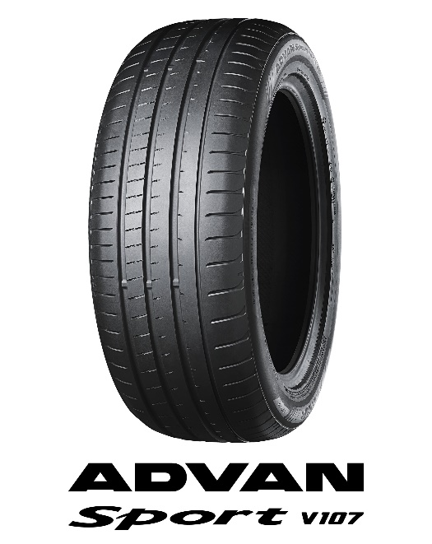 ADVAN Sport V107 in 245/50R19 105W

