16th June 2023

YOKOHAMA’s first truck/bus tyre to be used as OE on an EV

YOKOHAMA announced today that it has begun supplying its RY01C tyres to Mitsubishi Fuso Truck and Bus Corporation for use as original equipment (OE) on its new model eCanter all-electric light-duty truck, which went on sale in Japan. The eCanter was first launched in 2017 as Japan’s first series-produced all-electric light-duty truck. The new eCanter is the first full model change. YOKOHAMA is supplying 205/70R17.5 115/113N LT size RY01C tyres for use as OE on the truck. This is the first time YOKOHAMA has supplied one of its truck/bus tyres as OE on an electric vehicle (EV).

The RY01C is a standard rib tyre for light trucks that was developed with an emphasis on wear resistance. In addition to the low rolling resistance required by EVs and superior wear resistance demanded of light truck tyres, the RY01C delivers excellent wet performance, thus providing the environmental, safety, and handling performance demanded of an OE tyre for the new eCanter.

EV tyres must deliver higher levels of environmental, safety, and comfort performance than ordinary tyres. For example, lower rolling resistance is needed to extend the EV’s driving range, greater durability is needed to hold up under the higher load from the battery’s weight and the quick rise to maximum torque generated by electric motors, and the tyres also must deliver a quiet ride to complement the lack of engine noise from EVs. YOKOHAMA passenger car tyres that meet these EV-specific performance requirements have been adopted as OE for use on many EVs, from premium cars to mini-vehicles. The company is now applying its accumulated know-how in EV tyres to advance the development and sophistication of EV-compatible technologies for truck and bus tyres. By providing EV tyres for trucks and buses, YOKOHAMA will meet diverse logistics needs and contribute to environmental management efforts of transportation companies.

In addition to strengthening its marketing of tyres to be used as OE on EVs, which require tyres made using the most advanced technologies, YOKOHAMA is utilizing the feedback received from EV makers in its development of replacement tyres as it seeks to expand its product line-up and improve the performance of all its tyres to meet new requirements in this era of dynamic change.

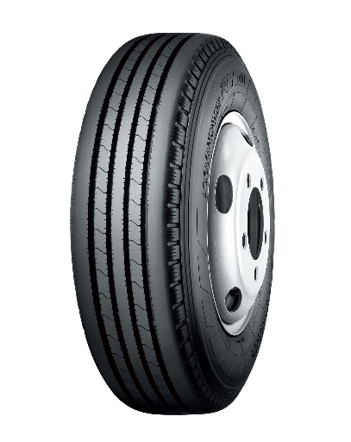
RY01C *Tyre shown in photo differs in size from those installed on the eCanter (wheels shown in the photo are not standard equipment)

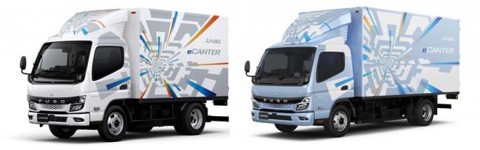New eCanter *The above photos are used with the permission of Mitsubishi Fuso Truck and Bus Corporation. Reprint or other usage of these images without prior permission from Mitsubishi Fuso is strictly prohibited.

